MotoSimEG-VRC for Education software package 170723-3 is bundled with a red network hardware license key. This hardware key is user configurable so that the end user can impose additional access restrictions to the MotoSimEG-VRC software that suite their needs.
The following must be performed on a PC with MotoSimEG-VRC Education package installed, along with the Sentinel LDK License Manager Software, and the red network hardware key plugged into a USB port.
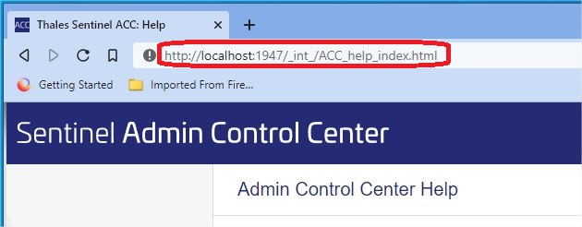
In the address bar of a web browser type the following. ‘localhost:1947’
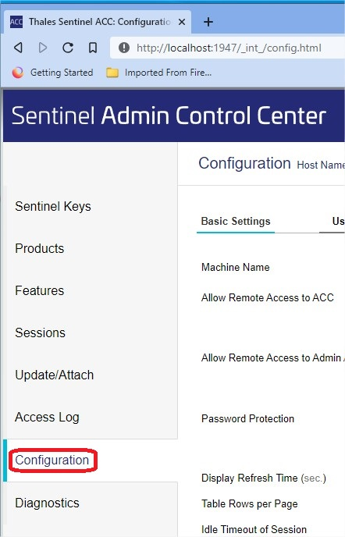
Select ‘Configuration’ along the left side.

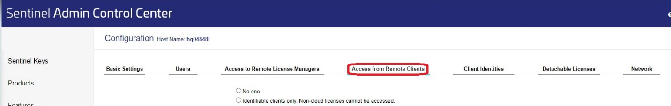
Select the ‘Access from Remote Clients’ tab along the top.
In the Access Restrictions box enter the data in the following format:
NOTE: The hardware key is shipped with ‘allow=all’
Allow =[item] and/or deny=[item], where [item] is an IP address or a machine name. IP addresses can include a wildcard (‘*’) or a range of addresses. The value of [item] can also be ‘all’ or ‘none’. Each entry must be on a separate line. The entries are evaluated in the order in which they are specified.

Example:
Allow=10.24.2.18 single address
Allow=10.24.2.10-50 range of addresses
Allow=10.24.2.* class C subnet
Allow=10.24.*.* class B subnet
Allow=10.*.*.* class A subnet
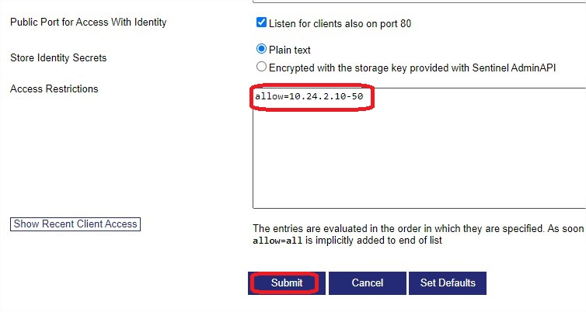
After Access restrictions are configured select the ‘Submit’ button.

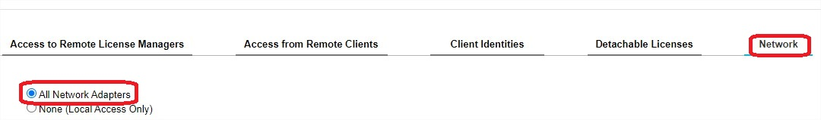
Select the ‘Network’ tab along the top and make sure that the ‘All Network Adapters’ radio button is selected.

