Introduction
The Manual Operation function allows the user to pause the playback operation at a specific position and hand guide the HC robot from that position. The user can pause the playback operation by a signal or program the job to pause every time in a specific position. Once the user is finished hand guiding, the user can resume playback operation of the HC robot, by a signal.
Overview
One application where the Manual Operation function can be used is in a power-assisted application where the HC robot can carry the load of a workpiece and hand guided it to a specific location. This will help relief an operator from carrying the load of the workpiece and have the HC robot carry that load.
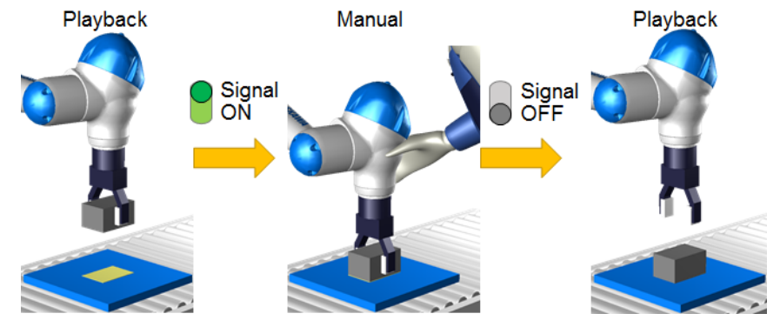
In the image below, is an example of the Manual Operation function being used in a power-assisted application. The HC robot pauses with the workpiece and then the operator places the workpiece on the conveyor.

As mentioned in the Introduction, the user can program a job to always enable the Manual Operation Function in a specific position of the job or to be enabled by a signal in the same specific position. In the Setup below, it will describe how to enable the Manual Operation by a signal. In the Collaborative Operation Manual (181437-1CD), this setup is described as 3.9.2 Configuration for Correction Work. To enable the Manual Operation Function in every work cycle, this is referenced in section 3.9.1 Configuration for Work in a Cycle in the Collaborative Operation Manual (181437-1CD).
The Manual Operation Function is available for the Standard Pendant and Smart Pendant. Setting up the Manual Operation Function, the user would need to edit the Ladder Program of the HC robot controller and would require for the user to be familiarized on how to add rungs and edit the Ladder Program of the robot controller. This is done to connect the button’s output signal to the robot controller’s input signal that the controller recognizes to enable the Manual Operation Function. The signal to request the Manual Operation Function can be internal or external signal. In the example below, the signal used to request the Manual Operation Function is an internal signal. This internal signal is tied into the Interface Panel of the Smart Pendant or I/F Panel of the Standard Pendant, depending on which pendant the user has. The Manual Operation Function request button will be shown in greater detail in the Setup section.
The user can choose what type of jogging mode to hand guide the HC robot when the Manual Operation is enabled. The user would need to select a jogging mode, or the HC robot will not be able to move by the operator. This will be described more in detail later in the article.

**VIDEO**

Setup
Software
The Manual Operation Function is available on YRC1000, with controller software YAS4.20 or higher, or on YRC1000micro, with controller software YBS2.44 or higher. The user can verify the YRC controller software version, by going in the Main Menu → SYSTEM INFO → VERSION, in the Standard Pendant. In the Smart Pendant, it’s by going to the Main Menu → System Settings → Controller.
Interface Panel & I/F Panel
As mentioned earlier in the Overview section, instead of using a physical toggle button or an external button, the Interface Panel or I/F Panel is used to illustrate the button to request the Manual Operation Function. Two other buttons are also setup to set the jogging mode when Manual Operation Function is requested. In total there will be 3 buttons on the Interface Panel or I/F Panel:
•Button #1: Manual Operation Request
•Button #2: Manual Op – JOINT
•Button #3: Manual Op – XYZ
The signal used for the Manual Operation Request is General Purpose Output #3993 or Relay Signal #15000. Relay Signal #15000 is a signal that was available/open in the robot controller to be used.
The signals to select the jogging mode for the Manual Operation Function are:
•General Purpose Output #4069, Relay Signal #15094, “ManualOp JOINT”
•General Purpose Output #4070, Relay Signal #15095, “ManualOp TRANS”
The user would need to select one of the jogging mode or the Manual Operation Function will not work. There is a third jogging mode for the Manual Operation Function, which is ROTATE, but this is not used in this specific setup.
In the Smart Pendant to create an Interface Panel the user navigates to the Main Menu → Interface Panels → Panel List. The following images are how each button was setup in the Interface Panel of the Smart Pendant.
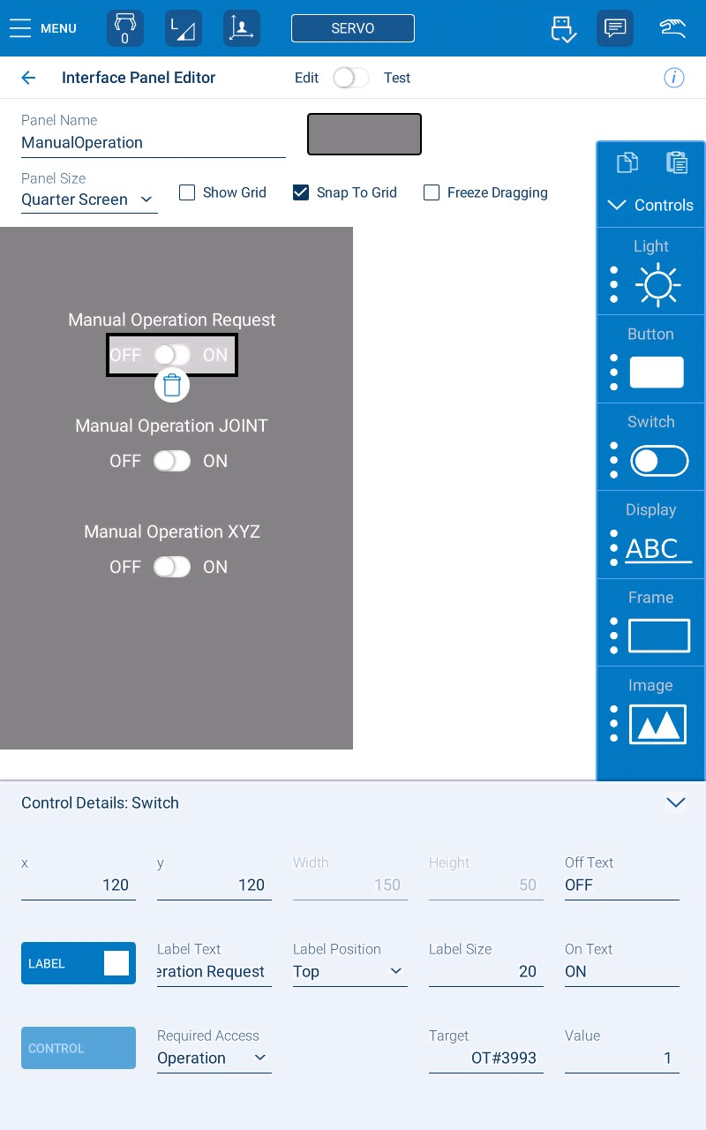
Manual Operation Request button is created as a switch. The target value is OT#3993 and the value is set to 1.
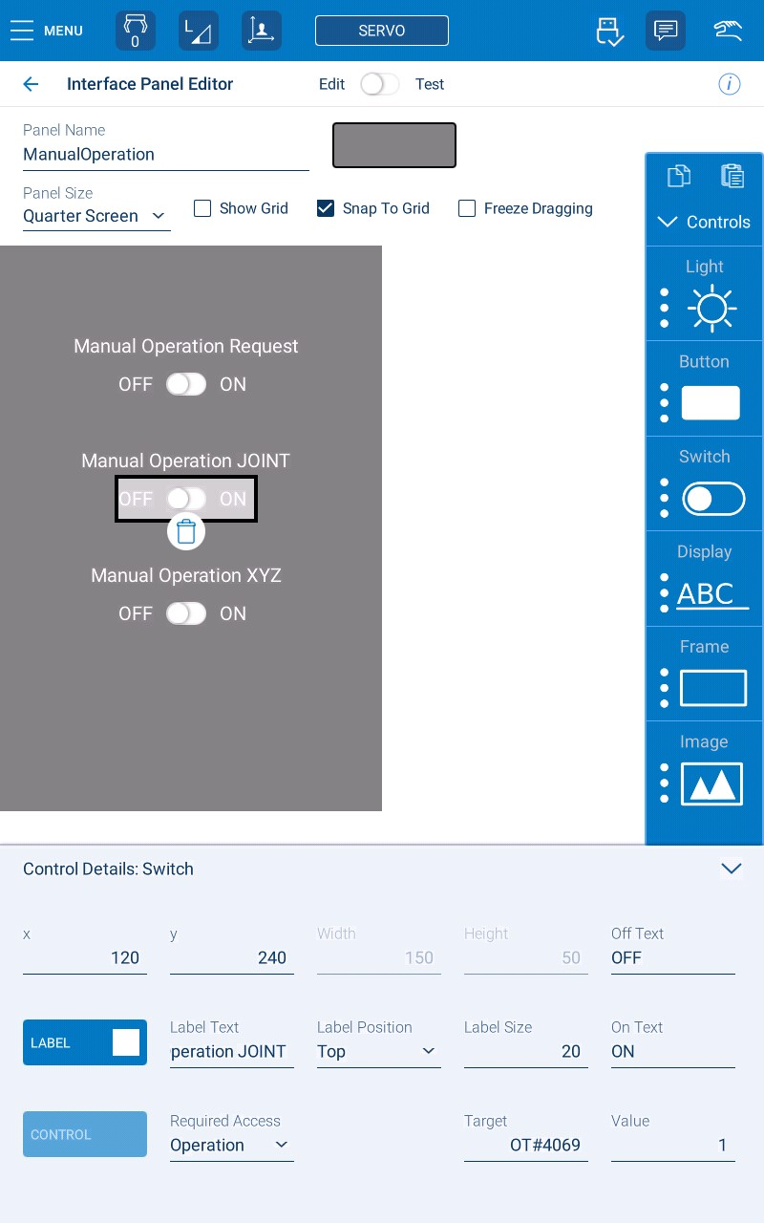
JOINT jogging mode button for Manual Operation Function. The button was created as a switch. The Target is set to OT#4069 and the value is set to 1.
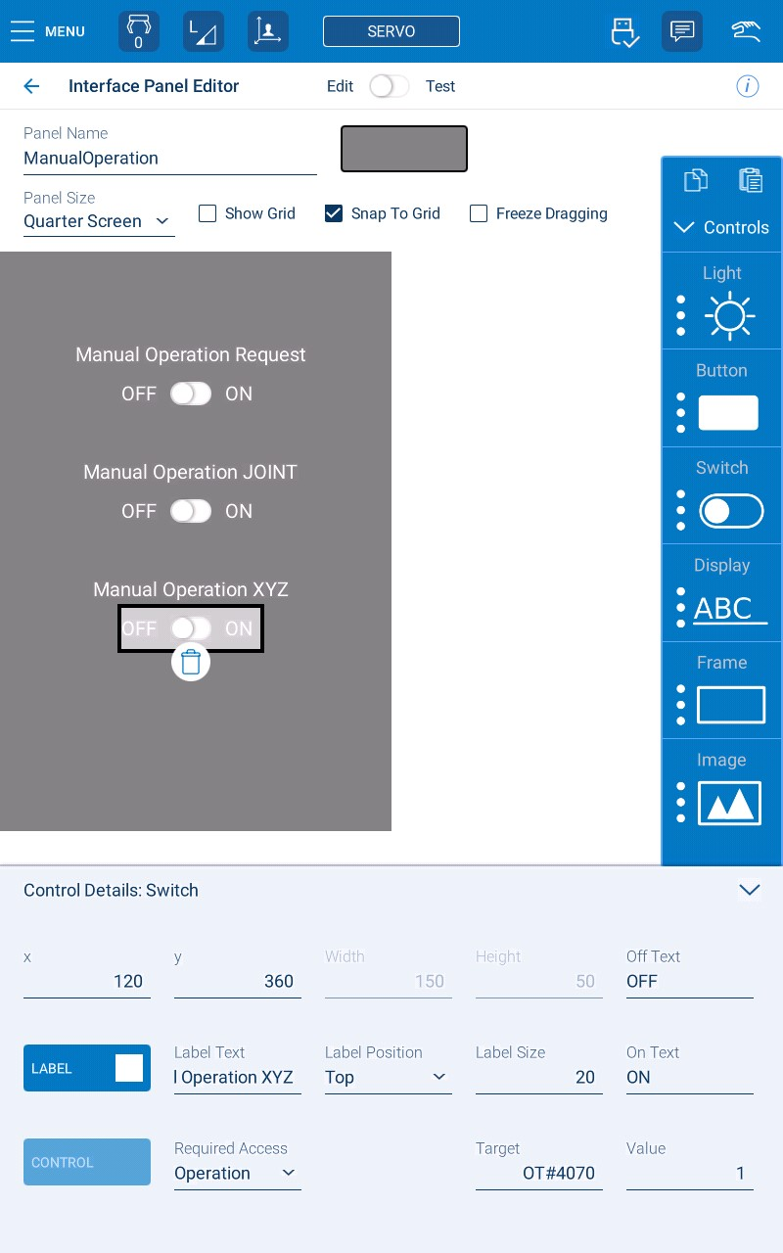
XYX + Tool jogging mode button for Manual Operation Function. The button was created as a switch. The Target is set to OT#4070 and the value is set to 1.

In the Standard Pendant, to edit the I/F Panel, the user needs to navigate in the Main Menu → SYSTEM INFO → I/F PANEL SETUP. Make sure to be in Management Mode or higher security level to access this screen. The following images are how each button was setup in the I/F Panel.
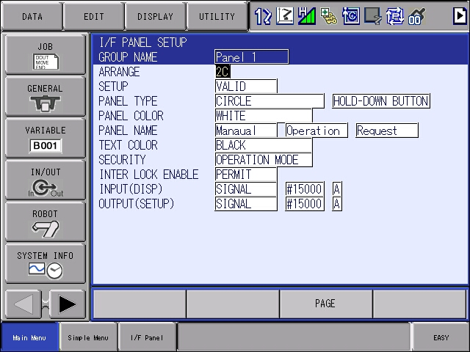
Setup for Manual Operation Request Button.
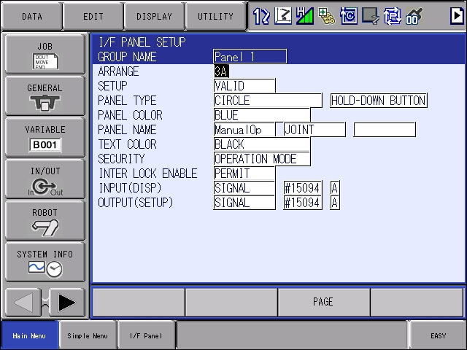
Setup for JOINT jogging mode when Manual Operation Function is requested.
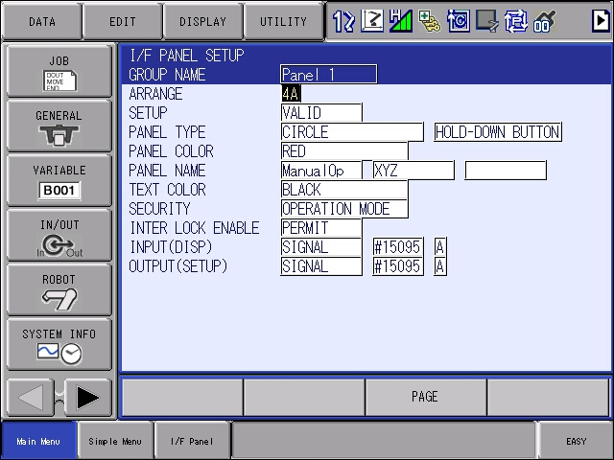
Setup for XYX + Tool jogging mode when Manual Operation Function is requested.
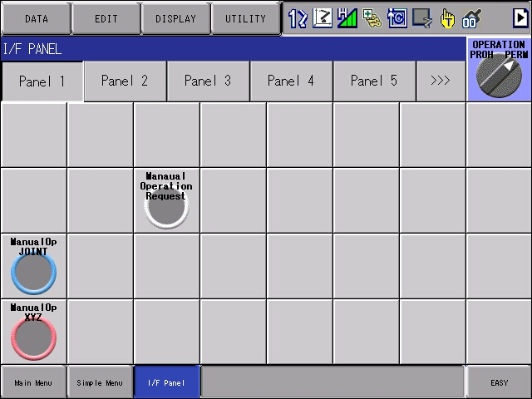
How the 3 buttons look like in the I/F Panel of the Standard Pendant.
Ladder Program
As mentioned in the Overview, the Ladder Program needs to be edited, to add the rungs that enable the button created in the I/F Panel or Interface Panel to Function as the Manual Operation Function request button/signal. The Ladder Program, at the time of this publication, can only be edited using a Standard Pendant or by the Classic Interface of the Smart Pendant.
To navigate into the Classic Interface on the Smart Pendant, the user goes in the Main Menu → System Settings → Classic Interface. The user needs to turn the key to Remote Mode to be able to press “START CLASSIC INTERFACE”. Once that is pressed, a new screen appears and then the user press “Connect” to be in the Standard Pendant user interface. Once on the main screen of the Standard Pendant user interface, make sure to change the pendant key back to Teach and change security level to Management or higher.
To edit the Ladder Program, the user needs to navigate to the Main Menu → IN/OUT → LADDER PROGRAM. Then press the PAGE key on the pendant to navigate to the User Ladder Program, then press EDIT on the top menu and then press END LINE, to add the rungs for the Manual Operation Function.
The image below illustrates the 2 rungs that were added in the User Ladder Program.
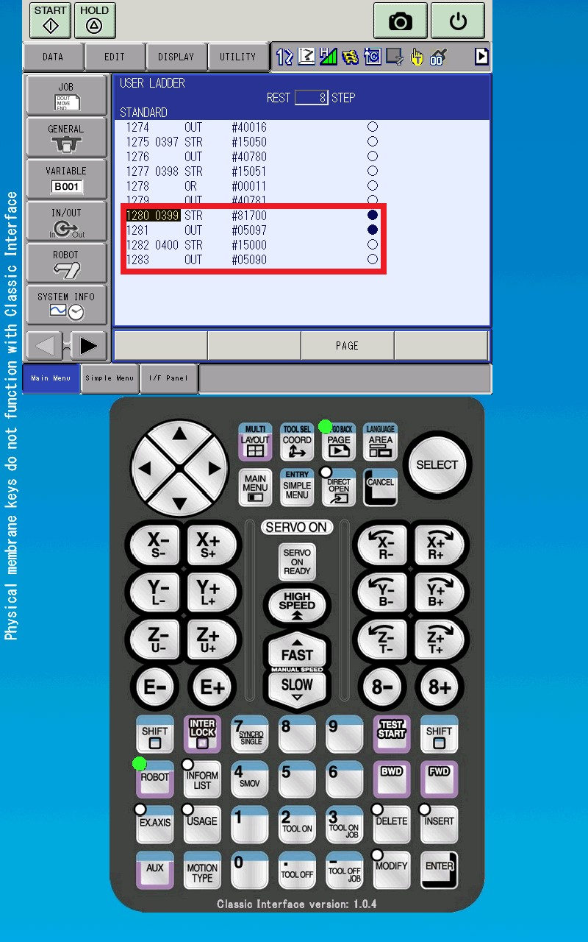
Relay Signal #81700 is a Control Status Signal that tells the robot controller that the robot is in Collaborative Mode and PFL is enabled. Relay Signal #05097 is General Purpose Input #4072. Relay Signal #15000 is the button that was created in the Interface Panel or I/F Panel to request for the Manual Operation Function. Relay Signal #05090 is the Manual Operation Signal that tells the robot controller to enable the function.
The logic of the 1st rung is when Collaborative Mode (Relay Signal #81700) is ON, the robot controller turns ON General Purpose Input #4072 (Relay Signal #05097). The general purpose input will be monitored in the job where the Manual Operation Function is requested. This rung might not make sense now, but reading the Job Structure section might connect the dots.
The logic of the 2nd rung is when the Manual Operation Request Button is ON, the robot controller turns ON General Purpose Input #4065 (Relay Signal #05090). This input signal is recognized internally by the controller software to pause playback operation and let the user hand guide when a jogging mode is selected.
If a physical button is connected to the YRC1000 or YRC1000micro controller as the Manual Operation Request button, instead of using Signal Relay #15000 on the second rung, use the Relay Signal number that the physical button is connected to.
Job Structure
After adding the rungs mentioned earlier, a IFTHEN statement needs to be added to the job where the Manual Operation Function will be requested. Inside the IFTHEN statement, inform instructions are added to turn ON a specific output and then for the robot controller to wait for 2 input signals to be ON/OFF to resume playback operation. This special IFTHEN statement to enable the Manual Operation Function can be seen below:
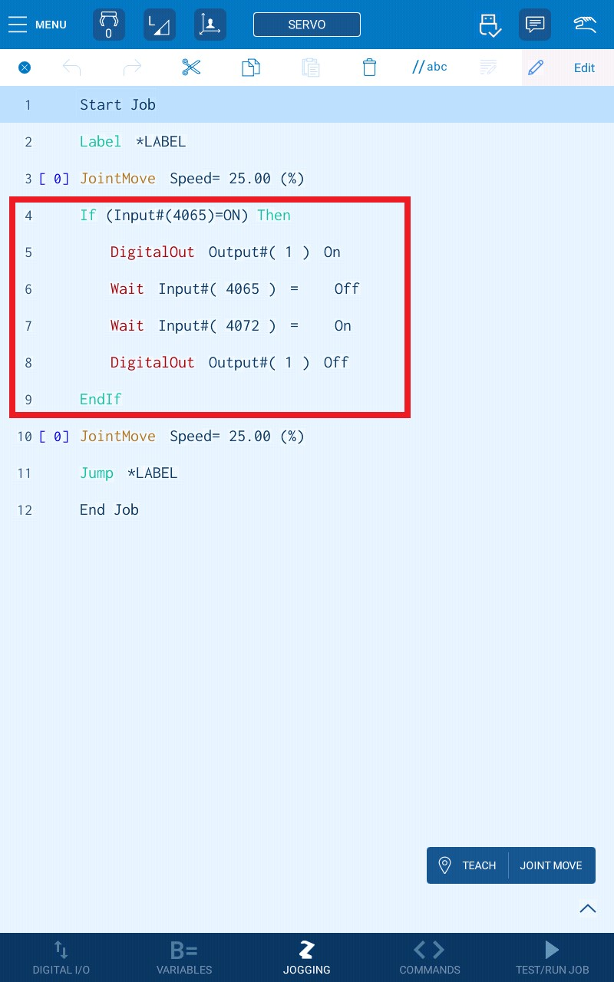

IFTHEN statement inside the job, on the Smart Pendant for Manual Operation Function.
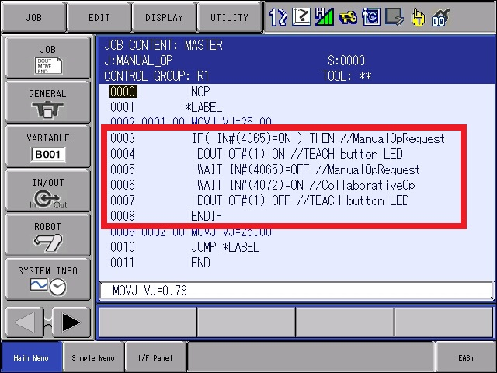
IFTHEN statement inside the job, on the Standard Pendant for Manual Operation Function.
Essentially what’s happening inside the IFTHEN statement, when the Manual Operation Button (Relay Signal #05090 or Input #4065) is ON:
1.)Turns ON the LED lights (Output #1) on the Direct Teach buttons on the B/T axis of the HC robot.
2.)Then allows the user to hand guide the HC robot. Once the user turns OFF the Manual Operation Request Button (Relay Signal #05090 or Input #4065), it continues the job sequence.
3.)Verifies if Input #4072 is ON, which is tied to the Ladder Program, essential the robot controller is monitoring if the HC robot is in Collaborative Mode. If the HC is not in Collaborative Mode, the robot controller pauses in this line until collaborative mode is enabled. Essentially this Wait inform instruction is a safety precaution to verify the HC robot is in collaborative mode.
4.)Turns OFF the LED lights (Output #1) on the Direct Teach buttons on the B/T axis of the HC robot. This is where the IFTHEN statement ends.
Position Points
Position points can be taught inside the IFTHEN inform instruction to have the HC robot move to a specific location for the user to hand guide, every time the Manual Operation Function is requested. This is seen in the Video attached in this article. One thing to keep in mind is programming the position points with the correct tool data and nowhere near any singularity position points that can cause the torque sensor to trip up and cause a PFL alarm.
Conclusion
When adding the Manual Operation Function rungs in the Ladder Program the special IFTHEN inform instruction to the job, the user can request the Manual Operation Function. As mentioned earlier a physical button can be used to portray as the Manual Operation Request button, or the user can use the Interface Panel or I/F Panel, depending on what pendant is available.
The user can reference section 3.9 Configuring the Manual Operation Function in the Collaborative Operation Manual (181437-1CD) for more details. As mentioned in the Overview section, this setup is based on section 3.9.2 Configuration for Correction Work of the Collaborative Operation Manual (181437-1CD). There are differences between the setup from this article to the setup in section 3.9.2 in the Collaborative Operation Manual. One major difference is the 1st rung that was added to the Ladder Program. Following the setup from the Collaborative Operation Manual, the HC robot wouldn’t resume playback operation. Changing the rung to what’s reference in this article allowed the HC robot to resume playback operation.
Another thing to keep in mind is the taught position point before and after the Manual Operation Function is requested. Verify that the position points are in a good location that there will be nothing in its path, when playback operation is resumed. There’s a potential risk that the robot can crash to something in its surrounding area if the position points are verified before and after the Manual Operation Function is requested.
Actual implementation of the Manual Operation Function may vary and shall be based upon, but not limited to the results of a comprehensive Risk Assessment, all applicable regulations, industry standards, and manufacturer specifications.

