YRC1000 new “Standard” macro function:
General Overview:
With software version YAS4.90, a “New Macro Job” function was released. The “New Macro Job” function eliminates the need for a corresponding “MACRO.DAT” file that contains the variable type and text used in the macro job. With the “New Macro Job” function, variable types and text are contained within the Macro job itself. This is especially helpful in cases where multiple robots and multiple macro jobs are used. The issue used to be that of the 32 or 64 (depending on parameter setting) macro jobs available, we could run out of available macro slots within the system and then we would have to manage what jobs got loaded and make sure a corresponding entry in the MACRO.DAT was available before the job could be successfully loaded and used. Essentially macro jobs data was spread over between two locations. The JBI itself and the MARCO.DAT file.
“Legacy Method” File Structure:
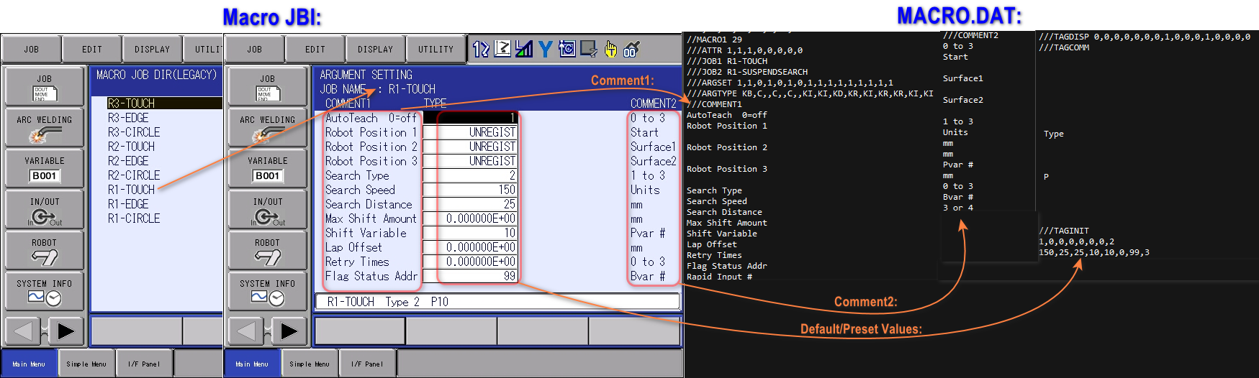
“Standard Macro Job Function” File Structure: 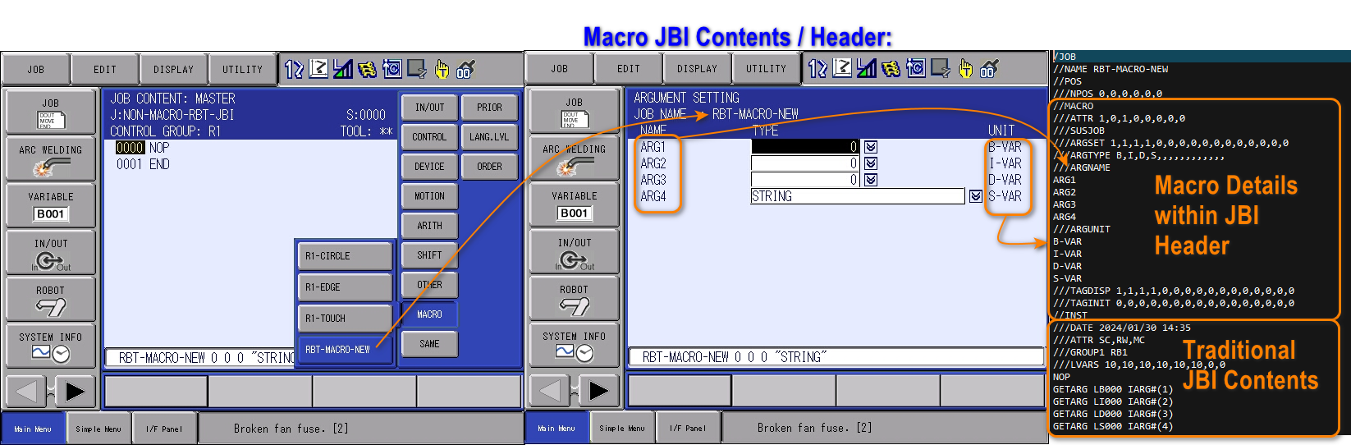
- With the “Standard Macro Job” function, all macro job details are contained within the macro JBI itself.
Macro Function Parameters:
Parameter: | Setting: | Setting Meaning/Impact:
S2C1857 | 0  1  3 | “Legacy” macro function only  “Legacy” AND “Standard” macro functions  “Standard” macro function
S2C438 | 0  1  2 | Do not display contents of macro job & restart from top of macro job  Do display contents of macro job & restart from stopped line  Do not display contents of macro job & restart from stopped line
S2C449 | 0  1 | Stop after CALL execution  Do not stop after CALL

Steps to setting up a “Standard” macro job:
- Choose “JOB” “SELECT MACRO JOB” (this is after having created a macro job using “Create New Job” function to create a new “Robot Macro Job” or “Concurrent Macro Job”, not shown!)
- Use the “Page” to toggle between “Legacy” and “Standard” macro jobs (based on parameter setting!). Choose “Standard” and select the desired job.
- Once the desired “Standard” macro job is selected, from the “DISPLAY” menu choose “JOB HEADER”
- From the “DISPLAY” menu choose “MACRO ARG”
- Now you can enter your various variables (up to 16) to be displayed in the macro command and define variable types on the “(define 1” screen)
- Using the “Page” key you can get to the “(define 2)” screen you can further specify “EXPRES’N” (expressions) that will be displayed in the calling job & if the “EXPRES’N” is displayed in the calling Job.
- Once all details for the macro have been entered, press “COMPLETE”
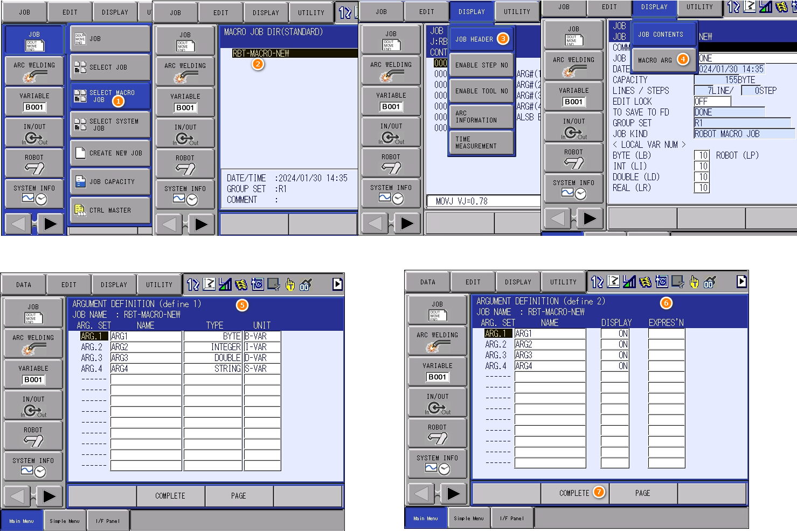

Resulting Macro & Macro Detail Screen:
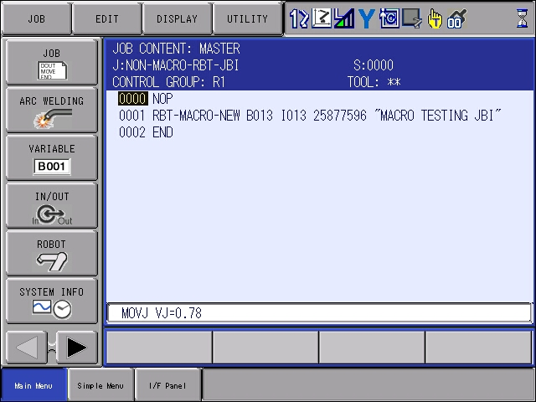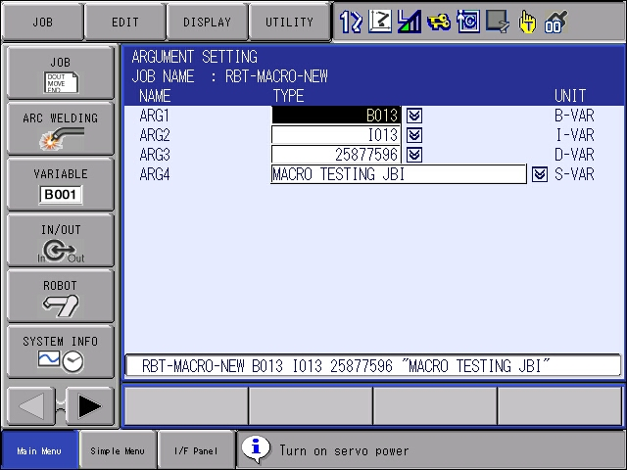
Resulting JBI file:
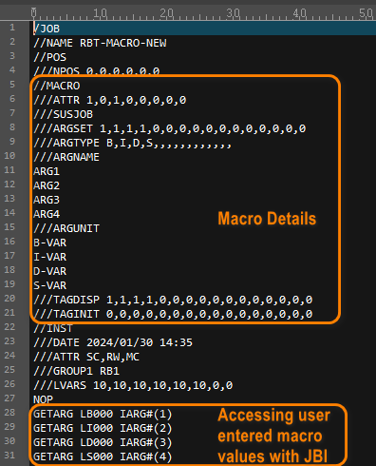

Converting “Legacy” to “Standard”:
There is no utility available to convert a “Legacy” macro to the new “Standard”. Instead, careful cutting-and-pasting can be done from the MACRO.DAT into the header of the macro of the “legacy” macro JBI itself. Below we’re converting the “R1-TOUCH” macro job from one format to the other:
- Open the “R1-Touch.JBI” (shown on the right-side below)
- Open the “MACRO.DAT” file and search for the corresponding “R1-TOUCH” name (shown on the left-side below)
- Carefully cut-and-paste the contents of the MACRO.DAT into the header of the “R1-TOUCH.JBI” noting the differences highlighted below.
- Once done, save the newly modified JBI & load it into the controller
- If the macro previously existed as a “Legacy” macro on the controller, the “legacy” macro will be deleted and replaced with the new “Standard” macro but the “MACRO.DAT” will not be modified
