**Fronius ROB5000 Analog Interface & “Process Active” signal:**

**General Overview:**

The ROB5000 interface used on older TP (TransPuls) & TPS (TransPulsSyneric) welders makes use of the robot controller’s analog interface card. The robot analog interface cards have a 34-pin cable connector that transfers signals between the ROB5000 to the robot controller. The signals consist of a combination of analog inputs and output along with discrete inputs and outputs. In most cases the signals that get passed into the robot’s analog board align with the intended purpose of the dedicated input or output. There is however one signal which does not align with the intended purpose of the robot’s analog card. That one particular signal is identified as “Process Active” by the Fronius hardware but gets wired into an input on the robot called “Arc Shortage”. The following will further detail the interconnections between the robot controller(s) and the Fronius ROB5000 interface. We’ll also discuss implications of the Fronius “Process Active” signal and the resulting ladder change needed to allow operation of the welder.

**Fronius Interfaces as they relate to various generations of Yaskawa robots:**

|  |  |  |  |
| --- | --- | --- | --- |
| **Robot Controller:** | **Primary Interface:** | **Alternative Interface:** | **Example drawing package:** |
| XRC / XRC2001 | ROB5000 (analog w/ XEW0*) |  | NA |
| DX100 | ROB5000 (analog w/ YEW0*) | WELDCOM (special robot software required) | Analog = 156704-*  WeldCom = NA |
| DX200 | WeldCom | ROB5000 (analog w/ YEW0*) |  |
| YRC1000 | WeldCom II | ROB5000 (analog w/ YEW0*) |  |

**Hardware Overview:**

The following photos are of the associated hardware used between the robot and weld controller.

**Fronius ROB 5000 Interface:** **YEW01 Analog card**

(Typically mounted in robot cabinet) (Typically mounted in robot cabinet)

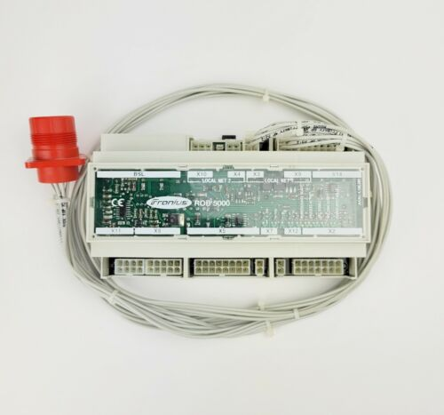 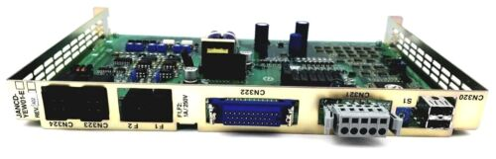

**Interconnections:**

See attached/linked Fronius “I-Kit Cable Tree” for detailing wiring between the Yaskawa robot and ROB5000 interface.

**Required Ladder Change:**

When using a ROB5000 interface wired according to the connections provided in the Fronius provided “Cable Tree” the following ladder change is required to allow operation of the system. Without the following ladder change, a “ARC SHORTAGE[*]” alarm will occur every time an arc is struck. This is because the “Process Active” signal is wired to the “Arc Shortage” input on the analog weld board. The “Process Active” signal generated by the ROB5000 indicates that the welder is in the midst of its programmed weld routine or performing a pre-or-post weld step such a “preflow” or “post-flow” that might be programmed via the robot or within the synergic line of the welder itself.

// R1 PROCESS ACTIVE INPUT FROM FRONIUS WELDER

**STR #21272**

**OUT #70112**

// R2 PROCESS ACTIVE INPUT FROM FRONIUS WELDER

**STR #21252**

**OUT #70113**

To aid in robot response, the following ladder changes are typically made to ensure that the robot remains stationary during pre-flow/post-flow and crater-fill times. Typically, the robot will move to the next position in the weld sequence once “ARCOF” is issued. In the case of aluminum welding, this can lead to post-flow gas coverage and crater conditions occurring while the robot moves. Adding the bold contact below to the rungs below will ensure the robot remains stationary during post-flow and crater fill conditions:

// R1 WORK END RESPONSE

STR #70081 // R1 NO STICKING (STICKING CHECK COMPLETE)

OR-NOT #70072 // R1 ARC OCCURANCE MEMORY

AND #50771 // R1 WORK END REQUEST

STR-NOT #79696 // R1 WLD DONE = RBT MOV DISABLED

STR #79696 // R1 WLD DONE = RBT MOV ENABLED

**AND-NOT #70112 // R1 PROCESS ACTIVE OUTPUT FROM WELDER (FRONIUS SPECIFIC)**

OR-STR

AND-STR

OUT #40571 // R1 WORK END RESPONSE

//

//R2 WORK END RESPONSE

STR #70281 // R2 NO STICKING (STICKING CHECK COMPLETE)

OR-NOT #70272 // R2 ARC OCCURANCE MEMORY

AND #50831 // R2 WORK END REQUEST

STR-NOT #79686 // R2 WLD DONE = RBT MOV DISABLED

STR #79686 // R2 WLD DONE = RBT MOV ENABLED

**AND-NOT #70113 // R2 PROCESS ACTIVE OUTPUT FROM WELDER (FRONIUS SPECIFIC)**

OR-STR

AND-STR

OUT #40631 // R2 WORK END RESPONSE

// R1 WORK END RESPONSE

STR #70081 // R1 NO STICKING (STICKING CHECK COMPLETE)

OR-NOT #70072 // R1 ARC OCCURANCE MEMORY

AND #50771 // R1 WORK END REQUEST

**AND-NOT #70112 // R1 PROCESS ACTIVE OUTPUT FROM WELDER (FRONIUS SPECIFIC)**

AND-STR

OUT #40571 // R1 WORK END RESPONSE

//

//R2 WORK END RESPONSE

STR #70281 // R2 NO STICKING (STICKING CHECK COMPLETE)

OR-NOT #70272 // R2 ARC OCCURANCE MEMORY

AND #50831 // R2 WORK END REQUEST

**AND-NOT #70113 // R2 PROCESS ACTIVE OUTPUT FROM WELDER (FRONIUS SPECIFIC)**

AND-STR

OUT #40631 // R2 WORK END RESPONSE