Muting Light Beacons:
General Overview:
The Simple Connect light beacons/towers are equipped with an audible alarm that will sound in the event of alarms or errors with the system. It is often desirable at times to silence or mute the audible alarm while issues with the system are being resolved.

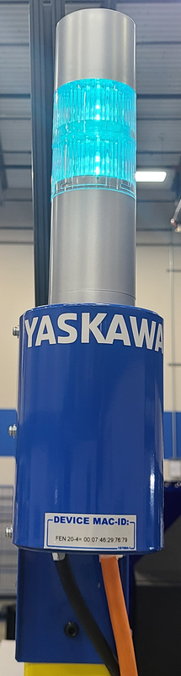
Muting Beacon(s) with CIO/Ladder version 1.2.3 or higher (Register M435=123 or higher):
With CIO/Ladder version 1.2.3 or higher (Register M435=123 or higher) this muting of the audible alarm can be accomplished via activation of PSEUDO input 87200. Since PSUDO input’s state is maintained through a power cycle, the state of the muted beacon will remain following a power cycle. While the audible alarm is muted a message is displayed on the pendant indicating the fact that the beacon has been intentionally muted.
To mute the audible alarm:
- In TEACH mode & “Management” level security chooose “IN/OUT”
- Choose “PSEUDO INPUT SIG”
- Use to the PAGE key to highlight “87200” and press “INTERLOCK”+”SELECT”. Doing so will toggle between muted and unmuted.
- Notice the message on the bottom of the screen indicating that the alarm was intensionally muted
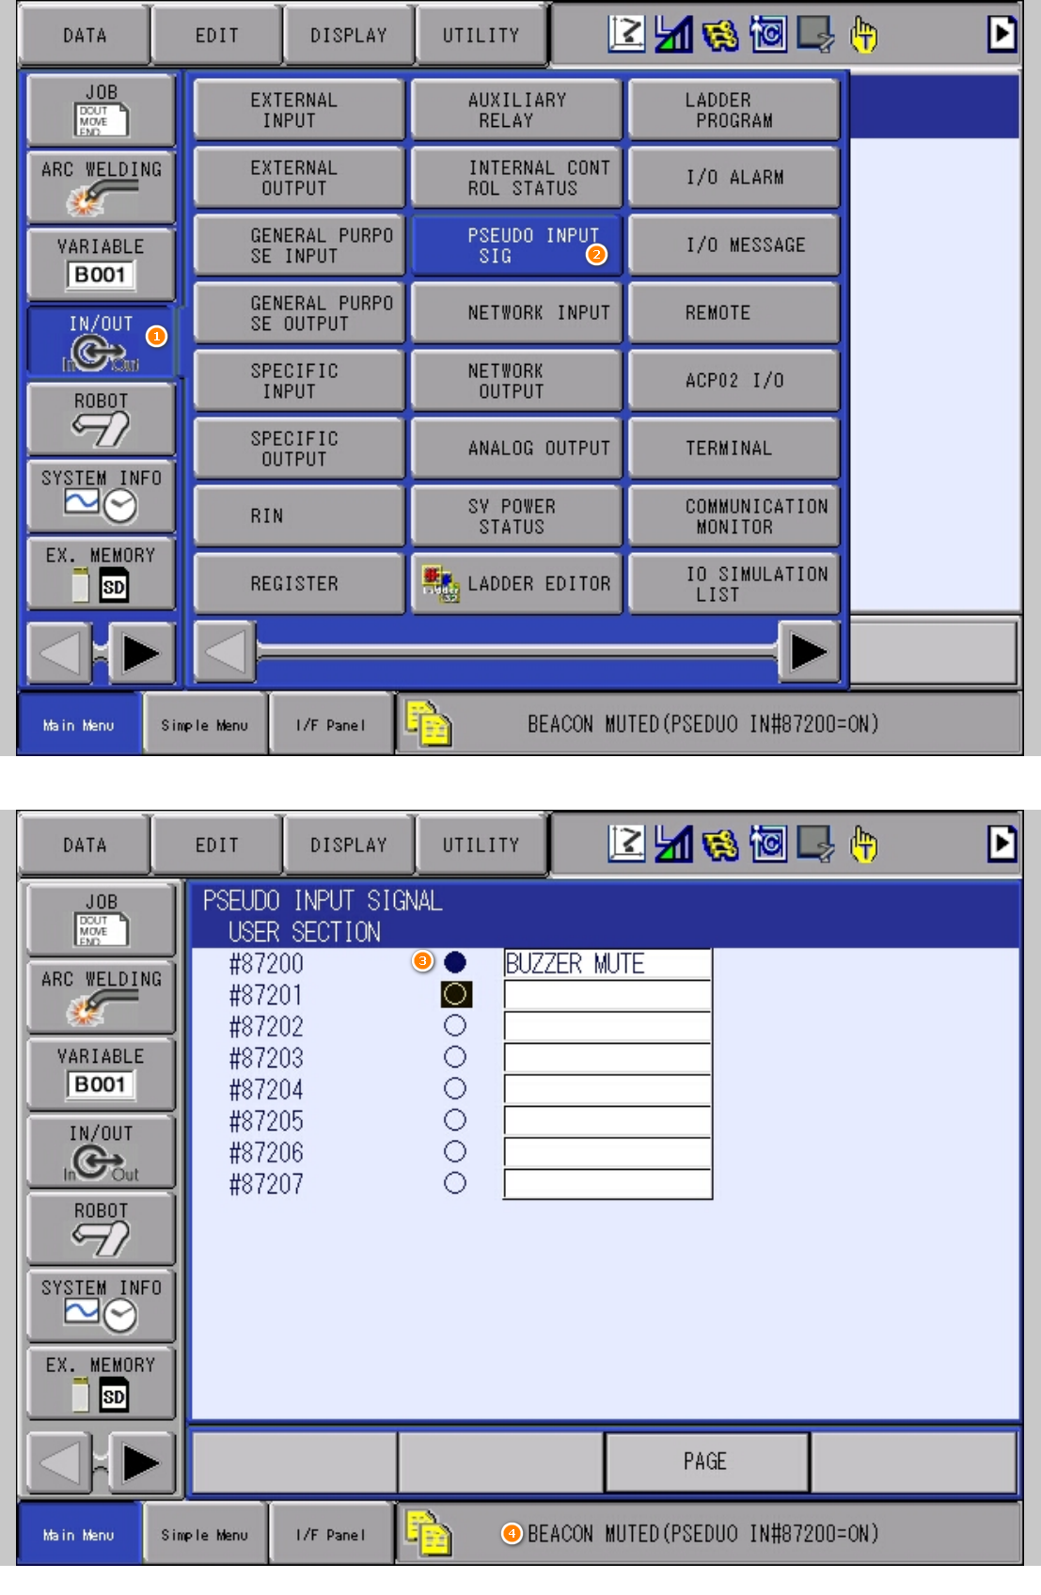
Muting Beacon(s) with CIO/Ladder version 1.2.2 & below (Register M435=122 or lower):
For systems older than CIO/Ladder version 1.2.2 (Register M435=122 or less) modifications to the CIO/Ladder need to be made and the level of changes required is not trivial. Yaskawa can assist with making these changes and do so using an in-house tool that will force the updates onto your existing ladder. For this to occur Yaskawa needs the following files from your system:
- CIOPRG.LST (saved under: “EX MEMORY””SAVE””I/O DATA”CIOPRG.LST)
- PSEDUOIN.DAT (saved under: “EX MEMORY””SAVE””I/O DATA”PSEUDOIN.DAT)
Send these two files and a brief explanation of wanting to mute the audible alarm on an early version of Simple Connect beacons to:
- Techsupport@motoman.com
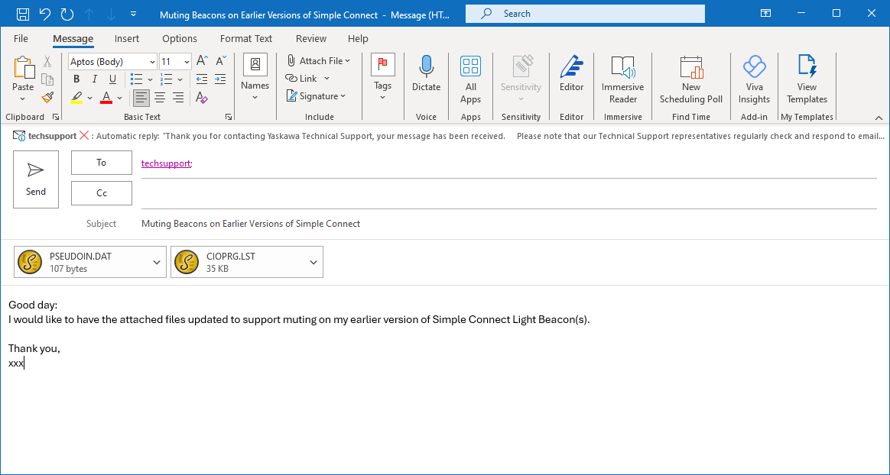

The Tech Support team will address the request as time permits. Please understand that some time may be required as this request will be treated as a lower priority than most immediate service requests.

