**Connection Guide: Omron NJ/NX Series to Yaskawa YRC1000 Robot Controller by EtherCAT**

This guide is intended to help customers to get communication working by following the specific examples in this guide. While the exact Omron hardware, IO sizes, and node addresses may not be used by each customer the screenshots and techniques should be applicable to all Omron processors in the NJ/NX series when integrated with Sysmac Studio software.

The EtherCAT card for the YRC1000 below has a PCIE interface, this board is also used in a YRC1000micro. The approach and screenshots for a YRC1000micro are nearly identical, the only variation would be in the concurrent I/O ladder. (That is an advanced topic for another guide.)

**Exact Testing Configuration:**

***Robot:***

* YRC1000 Software version: YAS3.04.00A-00
  + officially this board has supported since YAS2.01.00A-00
* PCIE EtherCAT card
  + Yaskawa part # 182697-1 (INpact board)
  + Yaskawa kit # 182721-1 (board + manual)
* Supporting manual: 182741-1CD

***PLC Configuration:***

* Omron PLC Processor: NJ101-1020
* Omron PLC Firmware: 1.13.00
* Sysmac Studio version: Standard Edition 1.24.3

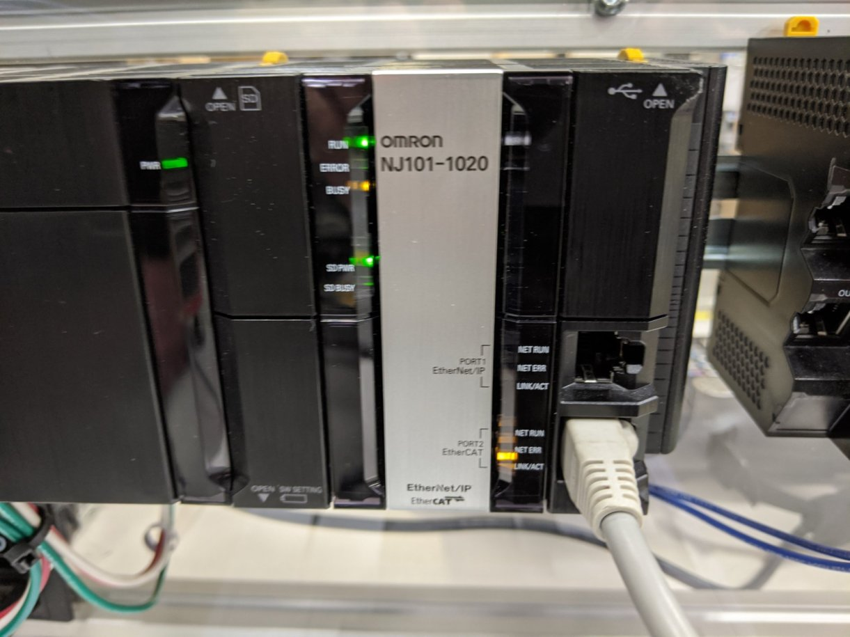

**YRC1000 Configuration:**

1. Start the robot controller in maintenance mode.
2. Login as management with all 9’s password:  
   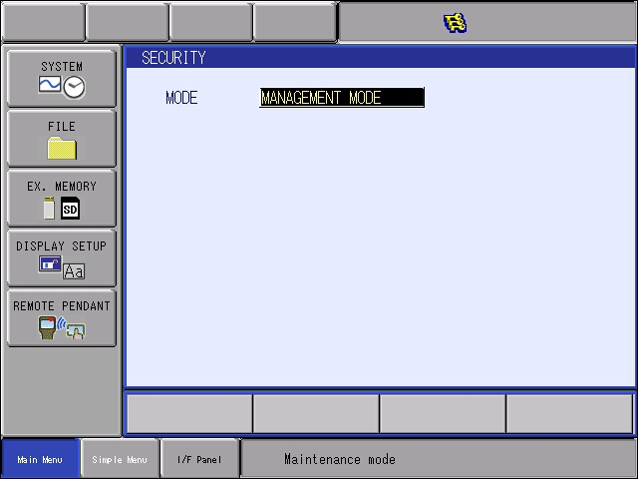
3. Select the SYSTEM button, then SETUP button.
4. Select OPTION BOARD and press the Enter key.  
   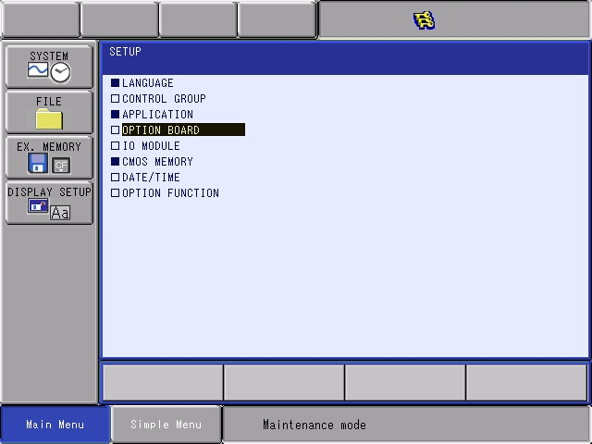
5. At ‘Option Board’ menu, ensure that INPACT board is listed. Press Enter to move to next screen.   
   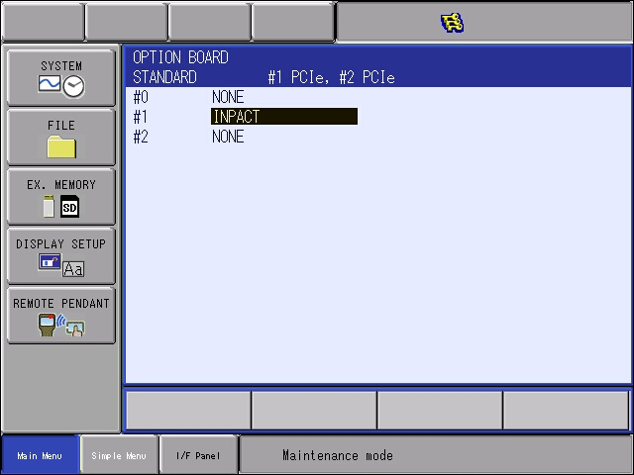
6. Confirm all settings below match. Pay attention that the board is listed as “EtherCAT” and then confirm the rest of the settings on this screen match. Set the board up for 5 dwords = 20 bytes.   
   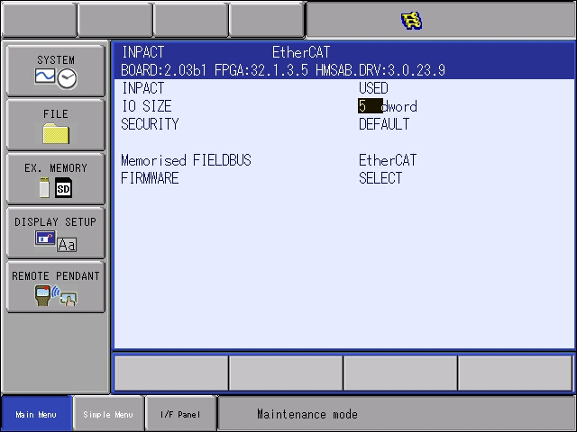
7. Press enter at this screen to receive the modify prompt. Press Yes to continue.  
   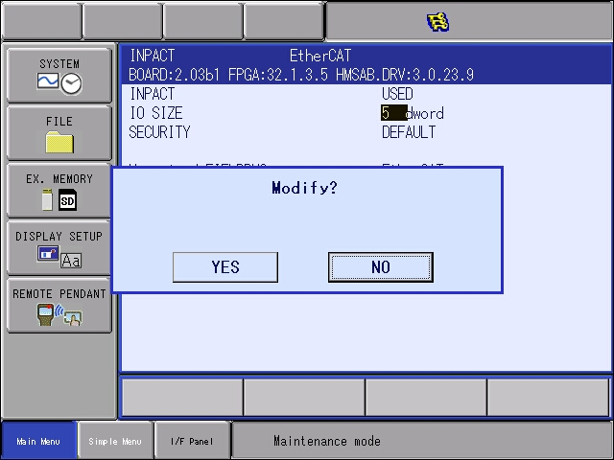
8. Press enter twice to see this screen. Ensure INPACT is the only board listed. When other IO Modules are listed, the I/O allocation may not match the values tested later in the document. If your setup is different, contact Yaskawa Customer Support for advanced assistance.  
     
   The INPACT cards occupy (allocated byte size + 1 byte) times 8 to show bit size used. Remember to convert dwords to bytes. (20+1 bytes x 8 = 168 bits)  
   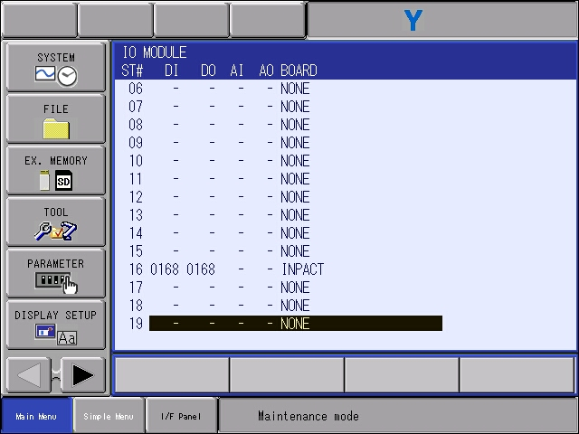
9. Press the enter key again to see the final modiy prompt. Select YES.  
   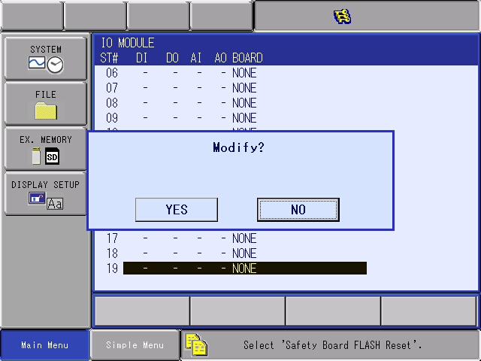
10. Keep pressing Enter key and accept yes at all other modify problems (for YRC1000 and YRC1000micro there will be several IO Allocation prompts).
11. Flash reset the board if required. (Message will be displayed on the bottom of the pendant.)
12. THE SETUP ON ROBOT SIDE IS DONE, REBOOT IN NORMAL MODE.

**Omron PLC Configuration using Sysmac Studio:**

1. Yaskawa has created several standard ESI files, which are available in a variety of sizes. These files are attached in the ZIP file that follows in the following sizes (20, 100, 500, and 504 bytes). If different sizes are required, then manual text editing maybe required following the XML formats already established in the files.  
   
2. Select one of the Yaskawa INpact ESI files above. ONLY one! Copy this file to the ESI directory of Sysmac Studio:   
   "**C: \ Program Files (x86) \ OMRON \ Sysmac Studio \ IODeviceProfiles \ EsiFiles \ UserEsiFiles**"

**NOTE:** *If another Yaskawa INpact file already exists in this directory please delete it! The Sysmac software will report that no ‘Yaskawa Robot’ files are available if more than 1 exists. It can cause a lot of confusion!*

1. First change the robot’s security to Management Mode first. For YRC1000 this was required to allow the Omron software to push changed into the EtherCAT card.
2. Connect the EtherCAT card in the Robot Controller to the EtherCAT network of the Omron PLC.
3. Configure a new project in Sysmac Studio with the appropriate processor type.
4. Go online with the NJ PLC (via USB or Ethernet connection) and run a Compare and Merge

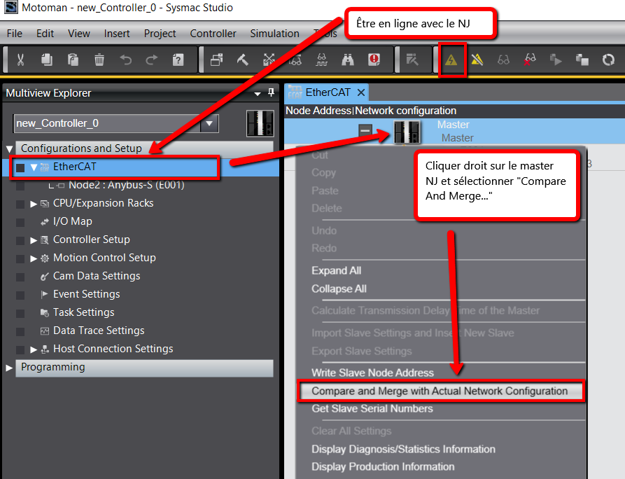

Right click on the Master NJ PLC and select “Compare and Merge…”

Go online with the NJ PLC

1. If the EtherCAT card in the robot controller has never been commissioned before the error below should display.  
   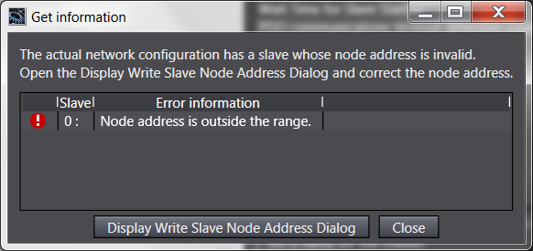
2. Press the button “Display Write Slave Node Address Dialog”. The dialog window below appears. It shows the current value (0) and lets us set a new value. For the purpose of this guide, we will use a node value of 10 – but any value can be picked if it is different from others in the network.
   1. Press the “Write” button on this dialog.

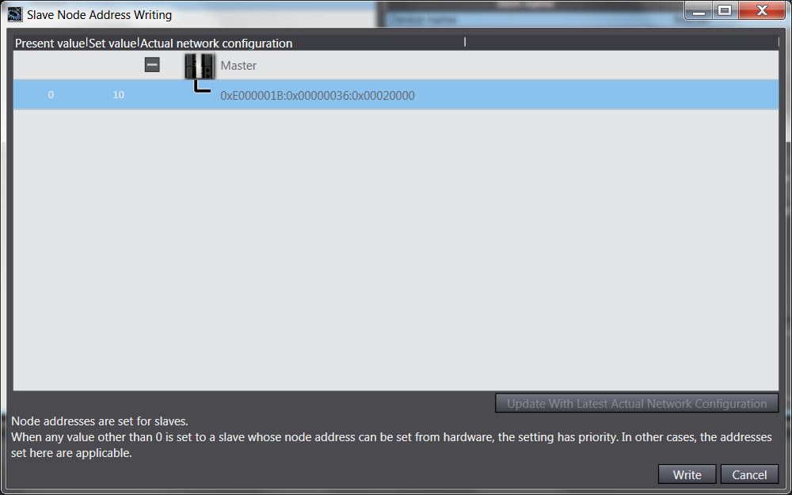

1. After pressing Write at the large dialog, another confirmation dialog appears. Press the “Write” button on this dialog.

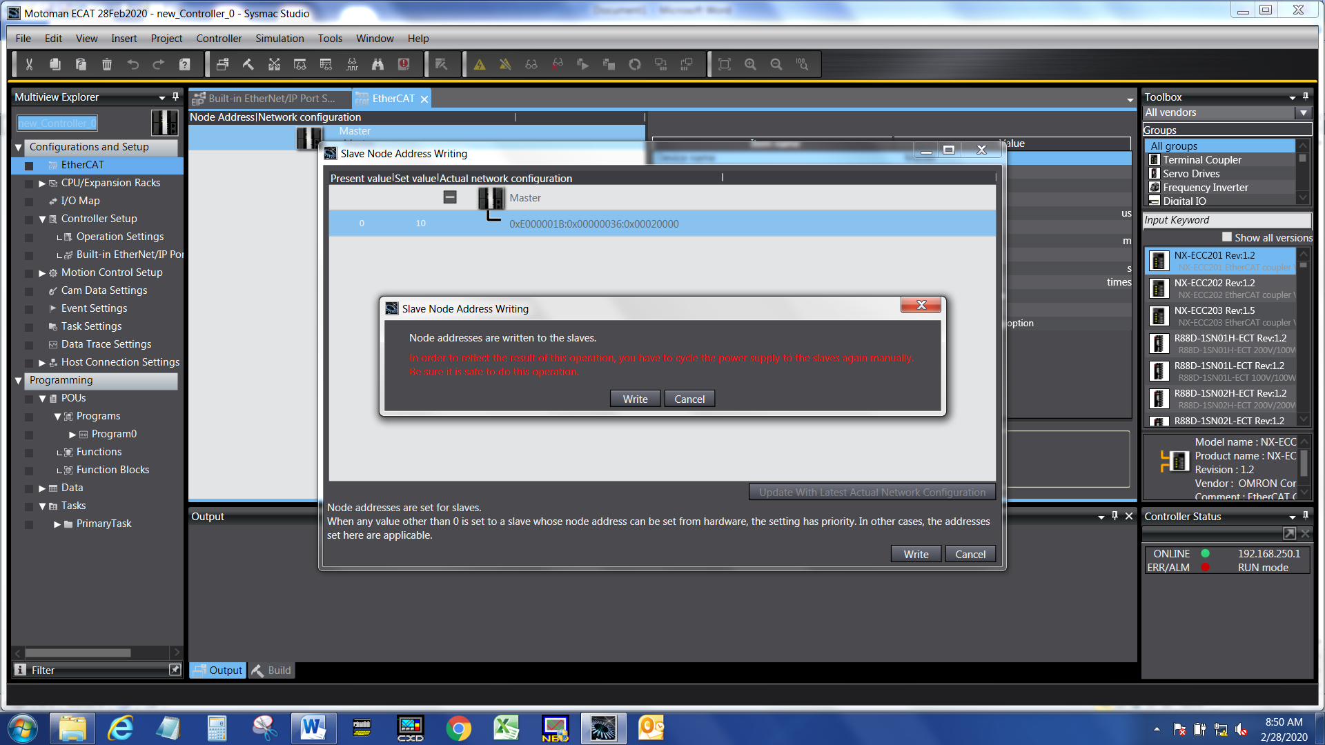

1. This message appears. Press Close button.  
   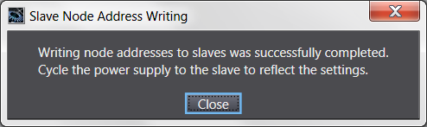
2. Now cycle power to the robot controller.
3. After the controller completes its full boot up, do a Compare and Merge again. The difference should be with the Network Configuration:
   1. Press “Apply actual network configuration

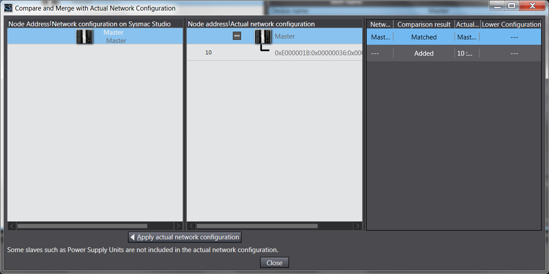

1. Change to offline mode. Open EtherCAT configuration and Setup.
2. On the right side of the software, in the ‘Toolbox’ window set to “All Groups”, then navigate the window below it until you find “Yaskawa Robot”. Grab this file, drag and drop it into the EtherCAT network diagram.
   1. In the center of the software, there is a field for “Node Address” set it to 10.

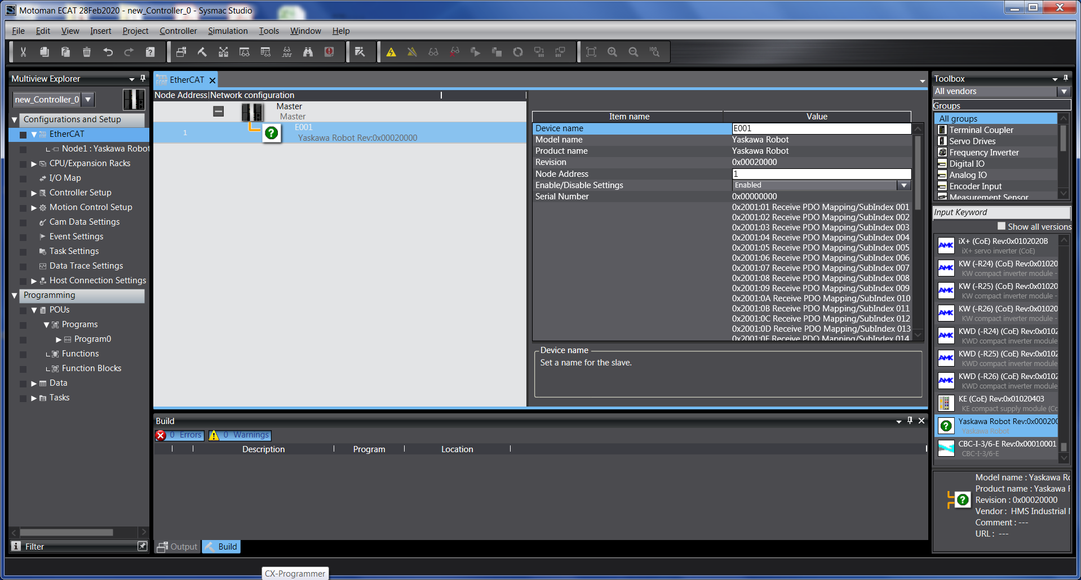

1. Go online again.
   1. Then synchronize.
   2. When asked, Transfer to Controller.

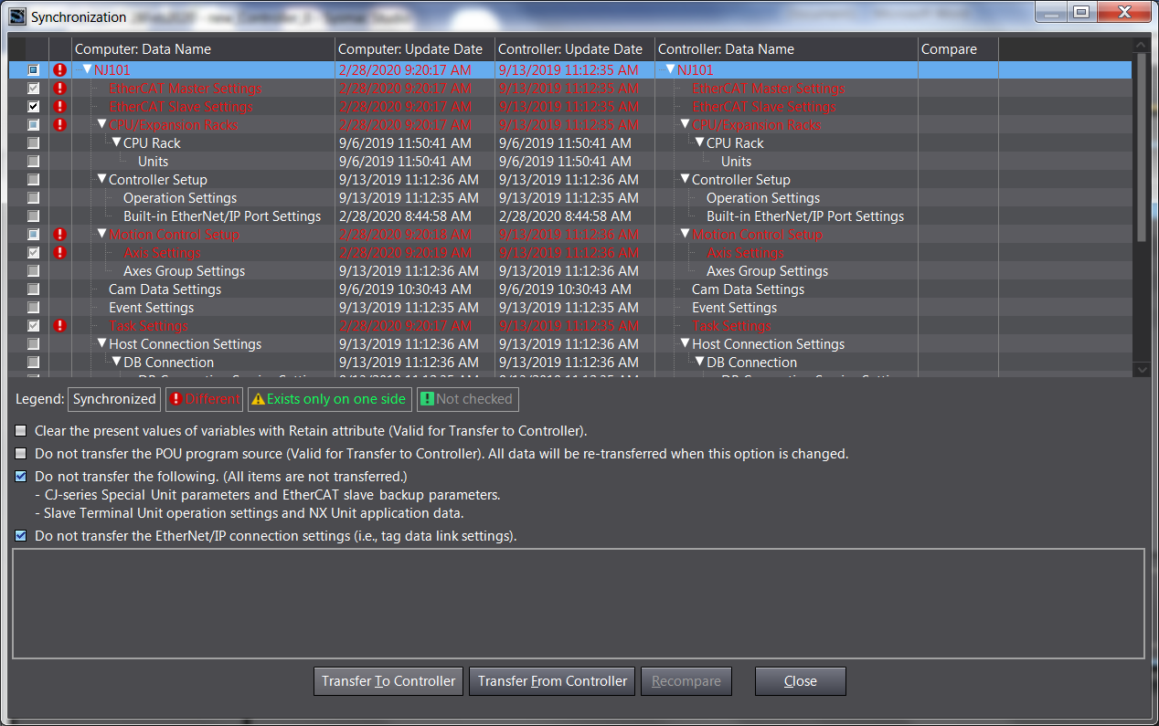

1. This concludes the setup in Sysmac Studio.

**Communication Testing:**

1. On the robot teach pendant, change to General Purpose Input screen. Change until Inputs 25-32 are shown. This the status byte for the EtherCAT board.
   1. When there are no communication errors, all inputs 28-32 will be OFF.
   2. When there are some communication errors, some inputs 28-32 will be ON. 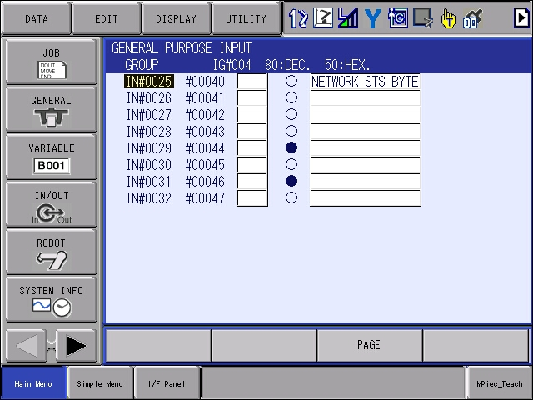
      1. Looking in the manual the exact meaning of each bit can be deciphered:

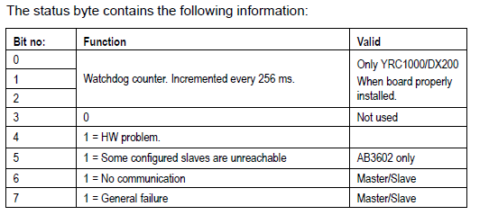

* 1. A communication failure can be quickly duplicated by disconnecting and reconnecting the EtherCAT cable.

1. Set an output through the robot controller and witness as input on the Omron PLC:
   1. On the robot controller, change to General Purpose Outputs
      1. Hit the page key until OUT 33-40 is shown. This is the start of the EtherCAT outputs.
      2. In this case decimal value 42 was sent over the first byte. This pattern is achieved by setting:
         1. Out 34 = ON
         2. Out 36 = ON
         3. Out 38 = ON
      3. The Decimal value can be double checked in the “header” bar area.

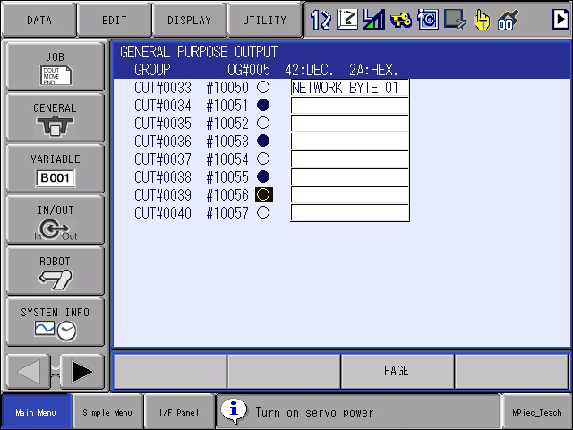

* 1. In Sysmac Studio, open the I/O Map window. Navigate the EtherCAT Network Configuration as shown.
     1. Read a value through the first byte.
     2. Looking at Transmit.PDO.Mapping_SubIndex 001 a value of “42” is read/displayed

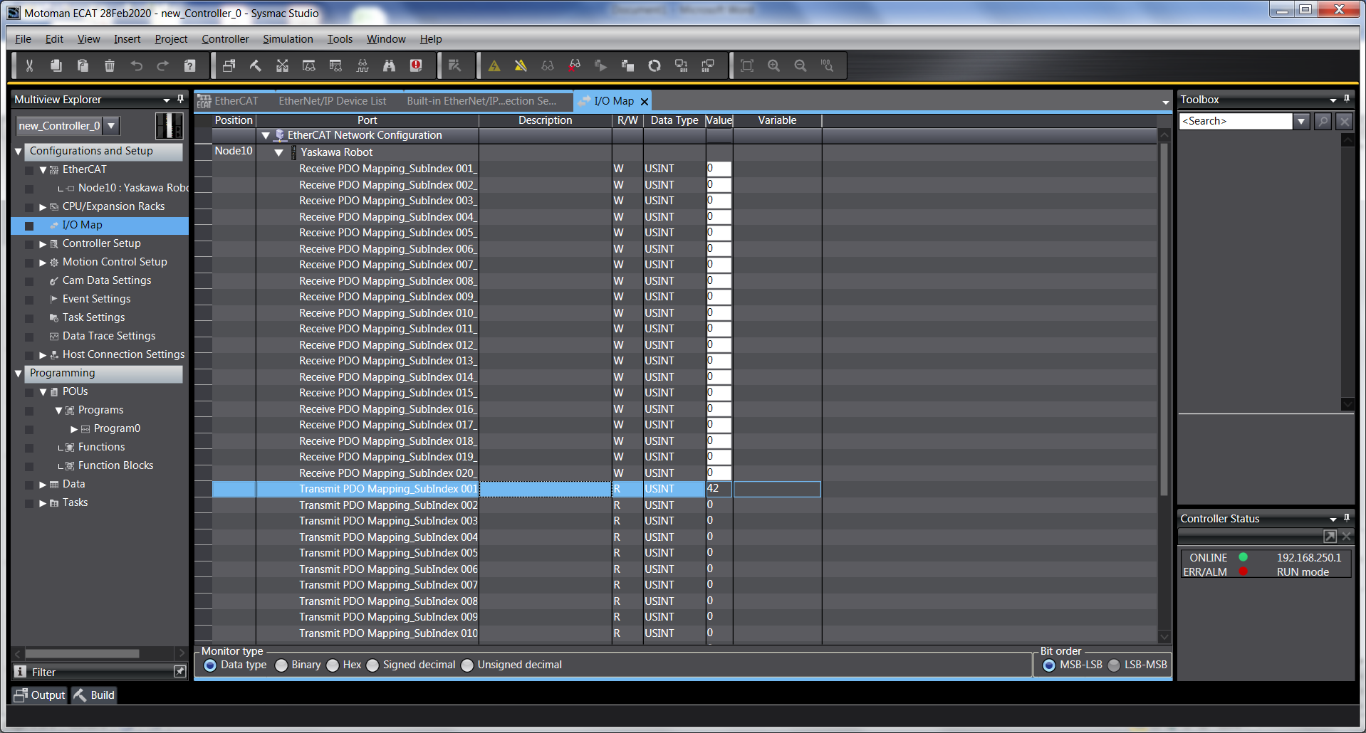

1. Next we’ll verify communication in the other direction. Set an output through the Omron software and witness as input in the Robot Controller:
   1. In Sysmac Studio, open the I/O Map window. Navigate the EtherCAT Network Configuration as shown.
      1. Write a value to the first byte.
      2. Set Recieve.PDO.Mapping_SubIndex 001 to “123”

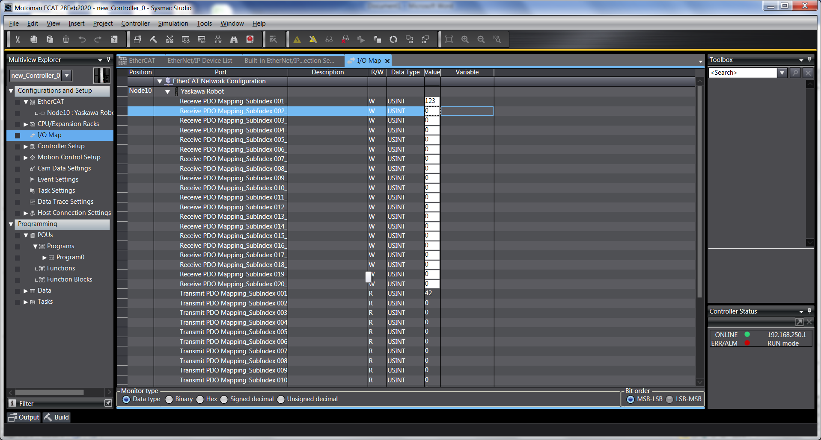

* 1. On the robot controller, change to General Purpose Inputs
     1. Hit the page key until IN 33-40 is shown. This is the start of the EtherCAT inputs.
     2. In this case decimal value 123 was sent over the first byte. The Decimal value can be double checked in the “header” bar area.

