Connection Guide: Omron NJ/NX Series to Yaskawa YRC1000 Robot Controller by EtherNet/IP
This guide is intended to help customers to get communication working by following the specific examples in this guide. While the exact Omron hardware, IO sizes and IP addresses may not be used by each customer the screenshots and techniques should be applicable to all Omron processors in the NJ/NX series when integrated with Sysmac Studio software.
The EtherNet/IP protocol implemented in the YRC1000 below is also used in a YRC1000micro. The approach and screenshots for a YRC1000micro are nearly identical, the only variation would be in the concurrent I/O ladder. (That is an advanced topic for another guide.)

Exact Testing Configuration:
Robot:
- YRC1000 Software version: YAS3.04.00A-00
  - officially the EtherNet/IP option has supported since YAS1.05.00A-00
- Supporting manual: 178651-1CD
PLC Configuration:
- Omron PLC Processor: NJ101-1020
- Omron PLC Firmware: 1.13.00
- Sysmac Studio version: Standard Edition 1.24.3
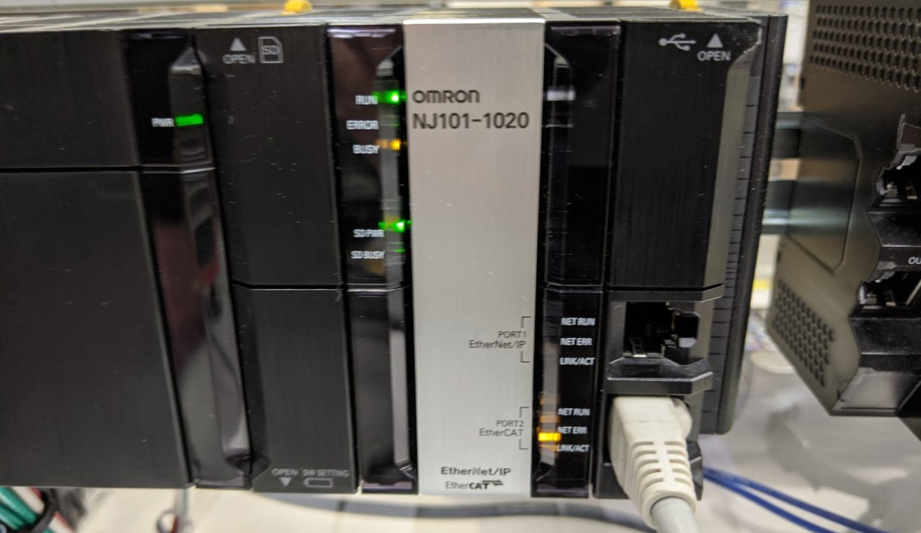

YRC1000 Configuration:
- Start the robot controller in maintenance mode.

- Login as management with all 9’s password:
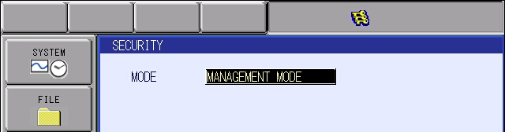

- Select the SYSTEM button, then SETUP button.

- Select OPTION FUNCTION and press Enter key.
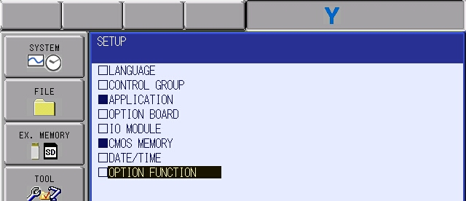

- Cursor down to LAN INTERFACE SETTINGS and press SELECT key.
(Screen may not include numbers before each option selection)
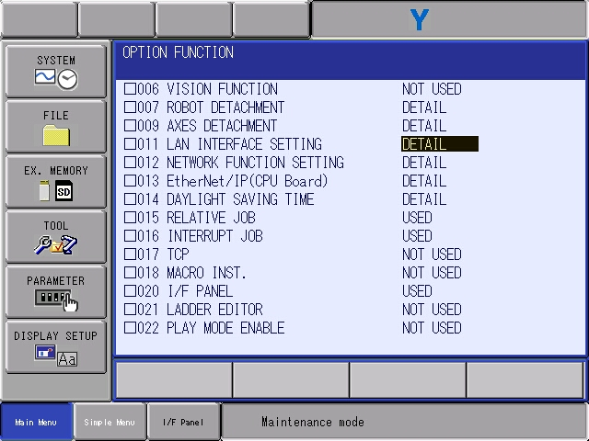

- Scroll down to IP Address under LAN2. In this case set the IP address to 192.168.250.31.
NOTE: Other IP addresses can be used, as long as corresponding subnets and networking techniques are used in the PLC settings that follow. This comment will not be addressed again in this document.
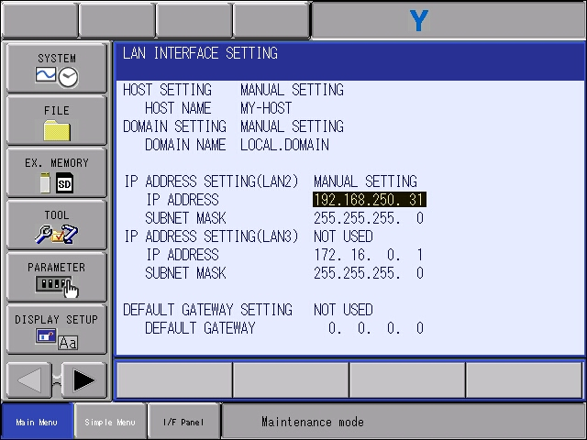

- Press the ENTER key to save the setting. At the MODIFY prompt, select YES to continue.
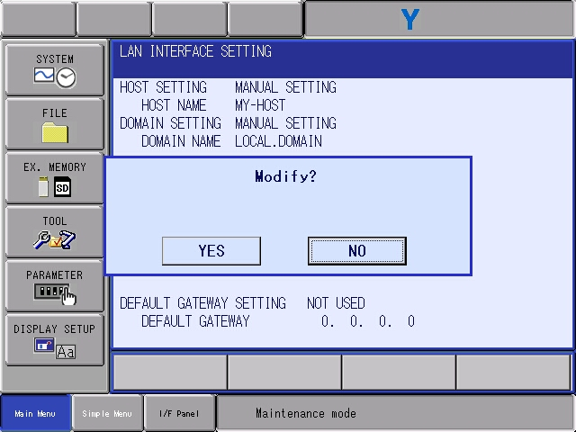

- Select the SYSTEM button, then SETUP button.

- Select OPTION FUNCTION and press the Enter key.
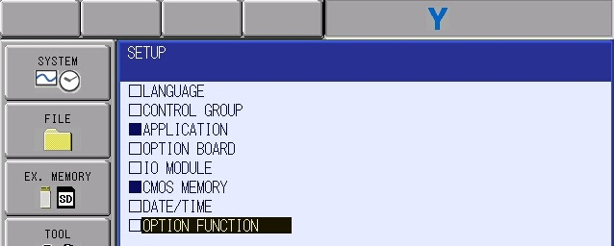

- Cursor down to the EtherNet/IP (CPU Board) and press SELECT key while DETAIL is highlighted.
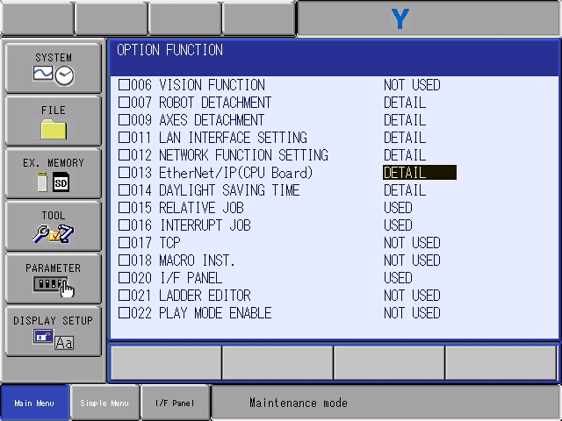

- With DETAIL of “Ethernet/IP(CPU Board)” highlighted, press “SELECT”.
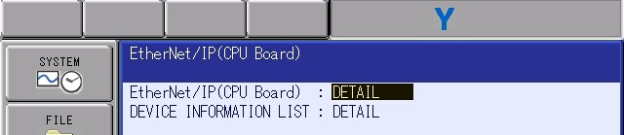

- Press “ENTER”. Highlight DETAIL for “ADAPTER” and press “SELECT”.
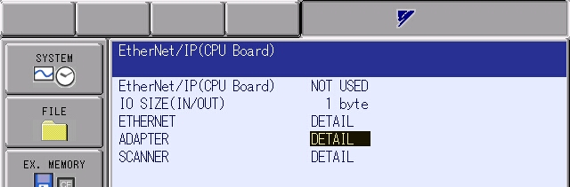

- Change all values below to match this screen. Then press the Enter key to continue. These values are critical to successful integration with the rest of the document.
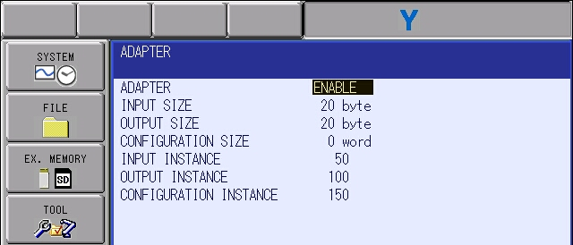

- Confirm that the top line on this screen shows “USED” and the “IO SIZE” now shows 20 bytes.
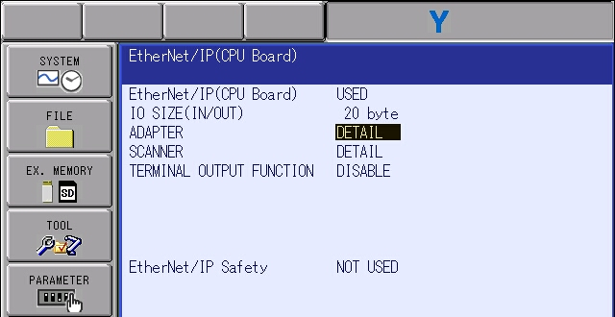

- When everything matches, press enter at this screen to receive the modify prompt. Press Yes to continue.

- Press enter twice to see this screen. Ensure “EtherNet/IP CPU” is the only IO MODULE listed. When other IO Modules are listed, the I/O allocation may not match the values tested later in the document. If your setup is different, contact Yaskawa Customer Support for advanced assistance.

The ‘EtherNet/IP CPU’ option occupy (allocated byte size + 1 byte) times 8 to show bit size used. For example. (20+1 bytes x 8 = 168 bits)
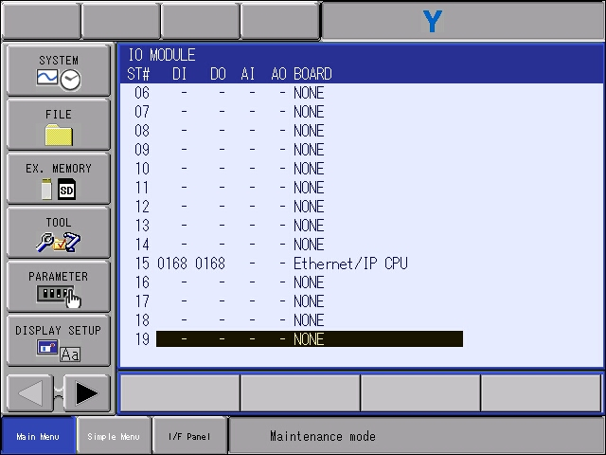

- Press the enter key again to see the final modify prompt. Select YES.
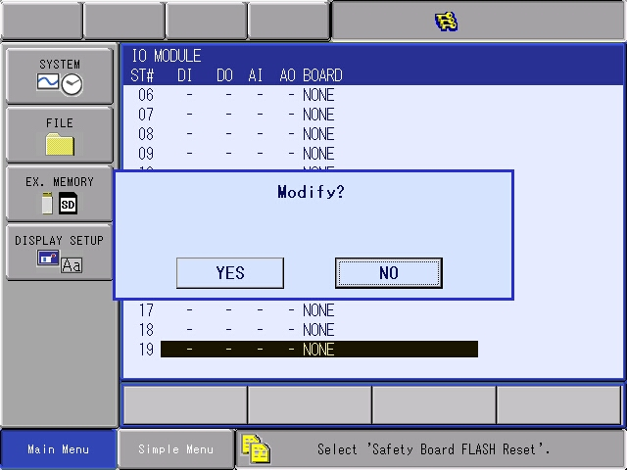

- Keep pressing Enter key and accept yes at all other modify problems (for YRC1000 and YRC1000micro there will be several IO Allocation prompts).

- Flash reset the board if required. (Message will be displayed on the bottom of the pendant.)

- Finally save the EDS file
  - Insert a USB drive into the teach pendant.
  - Press the button EX MEMORY SAVE
  - From the SAVE menu, pick EDS/GDS FILE SAVE and press the Enter key.
  - From the submenu “EDS/GDS FILE LIST” highlight “EtherNet/IP CPU” and press the Select Key. Then press the Enter Key.
  - When asked to Save? Press YES to continue.
  - When the EDS file is successfully created, the “bubble” will be filled solid on the FILE LIST screen:

- THE SETUP ON ROBOT SIDE IS DONE, REBOOT IN NORMAL MODE.

Omron PLC Configuration using Sysmac Studio:
- Copy the robot’s EDS file saved earlier into the EDS directory of Sysmac Studio:
"C: \ Program Files (x86) \ OMRON \ Sysmac Studio \ IODeviceProfiles \ EipConnection \ EDS"
NOTE: If another Yaskawa “ST15_EIP” file already exists in this directory please delete it! The Sysmac software could report that no ‘YRC1000 EtherNet/IP’ files are available if more than 1 exists. It can cause a lot of confusion!

- Connect the LAN2 port of the Robot Controller to the Ethernet network of the Omron PLC. An ethernet switch is probably necessary to work with PC software at the same time.

- Configure a new project in Sysmac Studio with the appropriate processor type.

- From the Tools menu, select “EtherNet/IP Connection Settings”
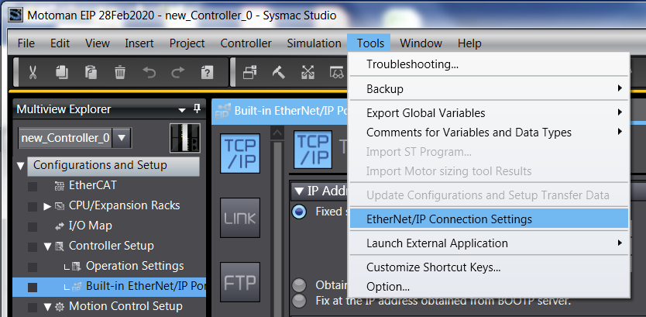

- Add the robot controller:
  - First press the “+” button:
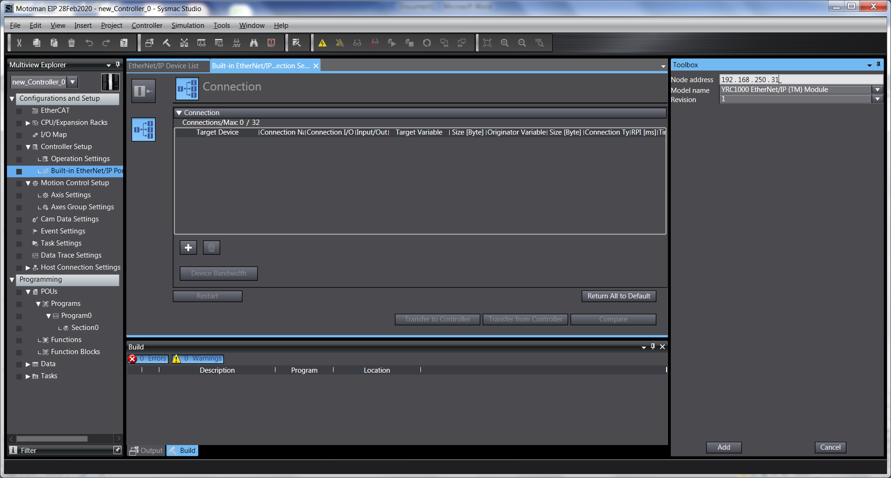
  - Then define the robot properties in the “Toolbox” window in the right side.
    - Node Address = 192.168.250.31
    - Pick the EDS file for the robot from the “Model name” dropdown box, it should be “YRC1000 EtherNet/IP (TM) Module”.
    - Only one revision should be listed, set to 1.
    - Once all settings match, press “Add” at the bottom right corner of the software.

- Create a 2 Global Variables to hold data.
  - In this case, the variables are named “RobotIn” and “RobotOut”.
  - Both are defined as: ARRAY[0..19] OF BYTE type.
  - It was also important to set the network publish properties.
    - RobotIn = Network Publish Input
    - RobotOut = Network Publish Output
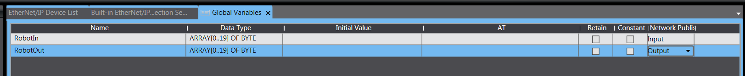
- Configure the Global Variables for use with the EtherNet/IP interface.
  - Change to the tab for “Built-in EtherNet/IP…”
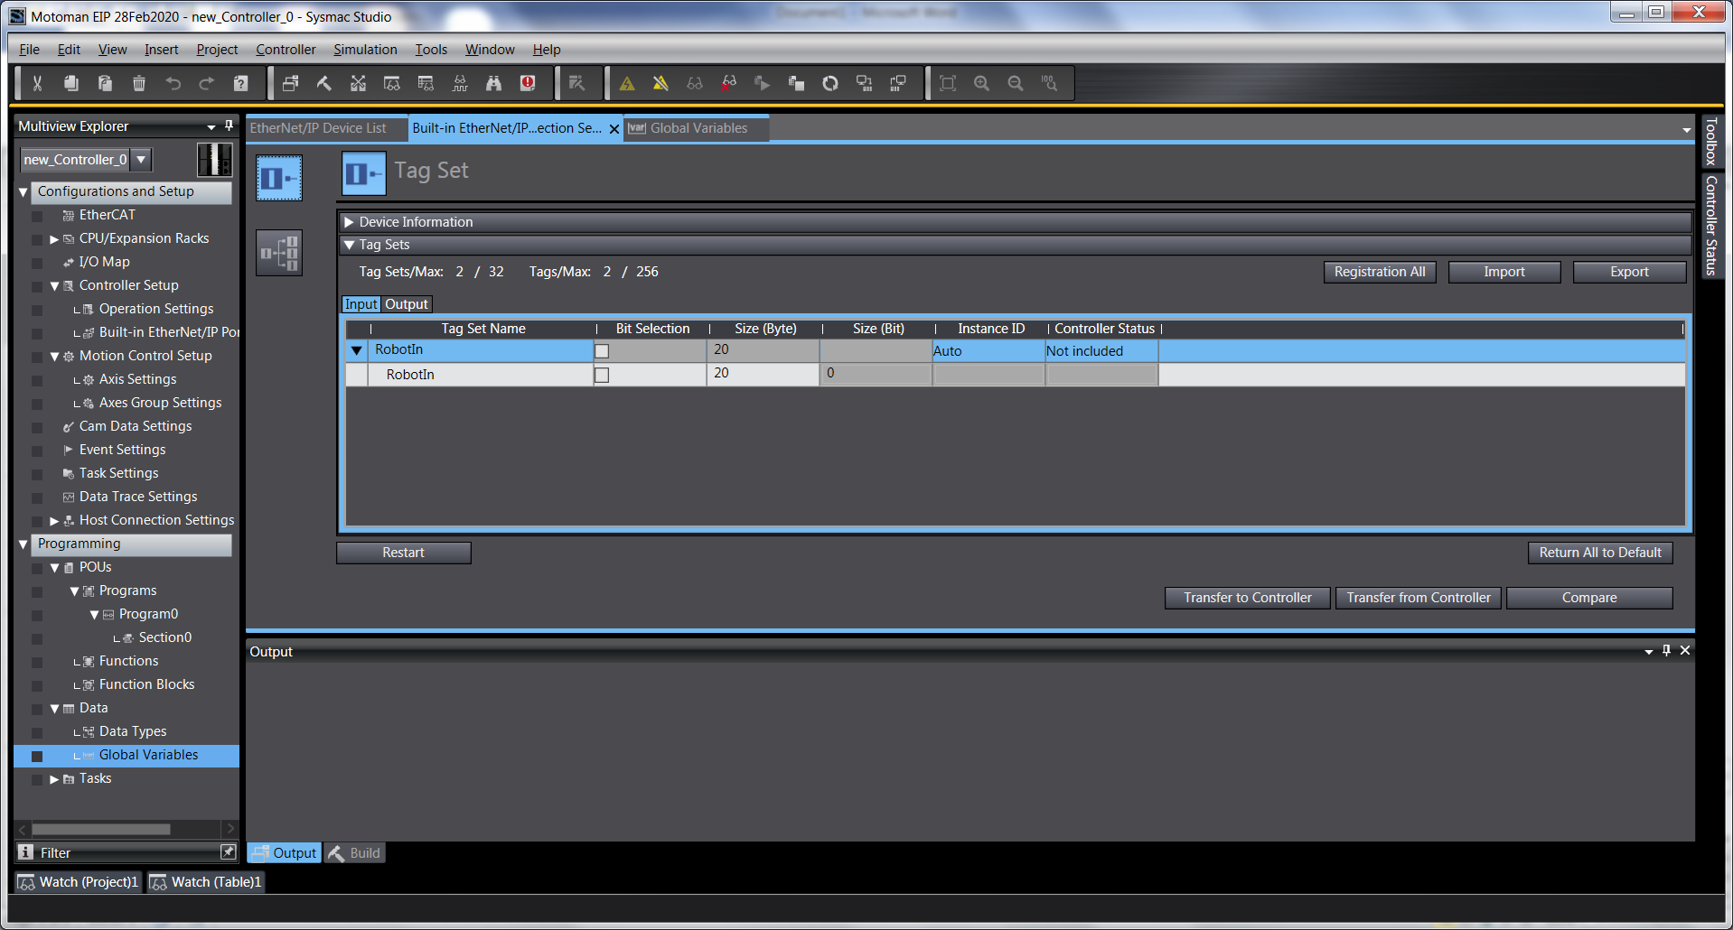
  - Press the button for “Tag Set”:
  - Now press the button “Registration All”. Some data will auto populate.

- Press the button for “Connection”.
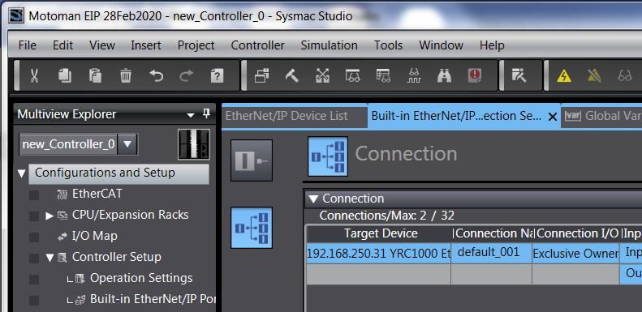

- Confirm the settings below:
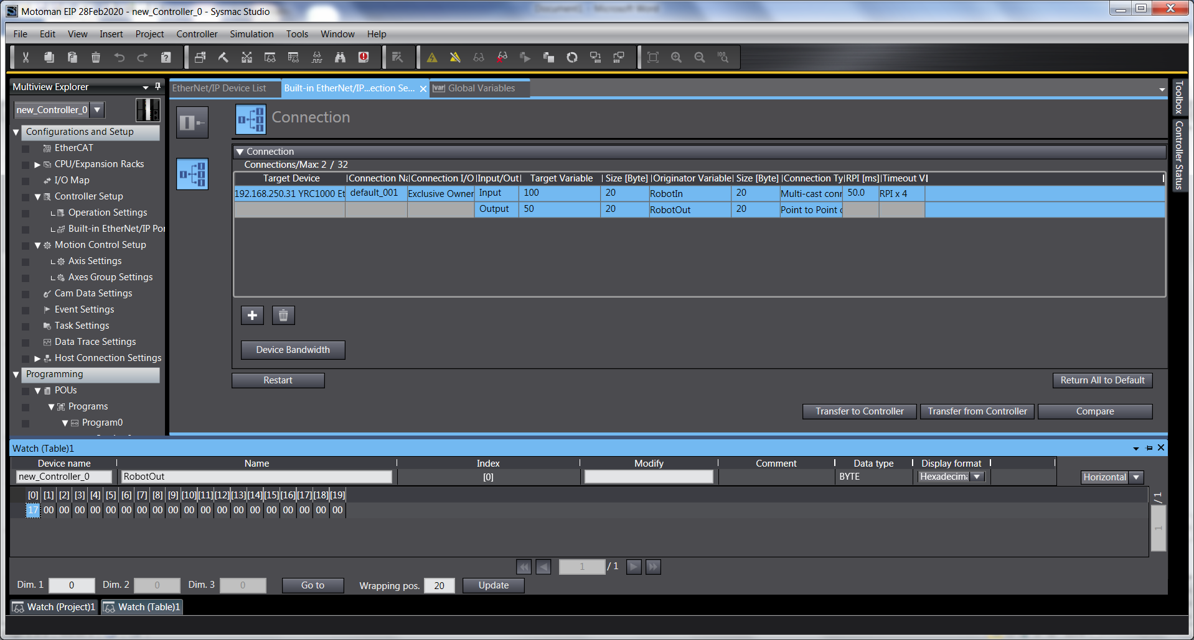

- Press “Transfer to Controller”
- Go online.
  - Then synchronize.
  - When asked, Transfer to Controller.

- A power cycle of the Omron PLC is usually needed if the IP address is changed on the processor.
  - If this impacts the subnet of the PC, change settings as needed and reconnect so that monitoring and value changes can be done in the next section.

- This concludes the setup in Sysmac Studio.

Communication Testing:
- On the robot teach pendant, change to General Purpose Input screen. Change until Inputs 25-32 are shown. This the status byte for the EtherCAT board.
  - When there are no communication errors, all inputs 28-32 will be OFF.
  - When there are some communication errors, some inputs 28-32 will be ON. 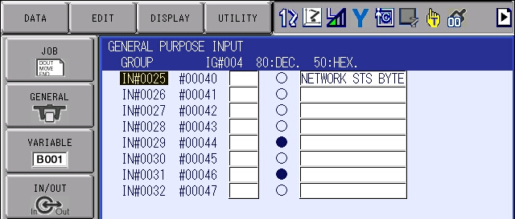
    - Looking in the manual the exact meaning of each bit can be deciphered:
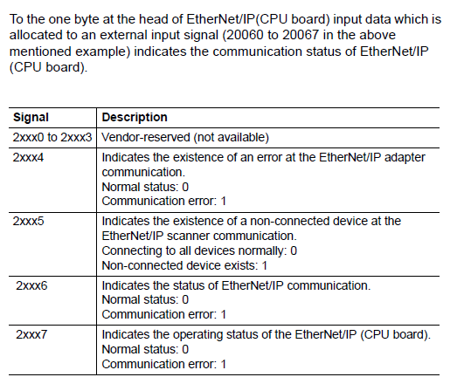

  - A communication failure can be quickly duplicated by disconnecting and reconnecting the EtherNet/IP cable.

- Set an output through the robot controller and witness as input on the Omron PLC:
  - On the robot controller, change to General Purpose Outputs
    - Hit the page key until OUT 33-40 is shown. This is the start of the EtherCAT outputs.
    - In this case decimal value 7 was sent over the first byte. This pattern is achieved by setting:
      - Out 33 = ON
      - Out 34 = ON
      - Out 35 = ON
    - The Decimal value can be double checked in the “header” bar area.
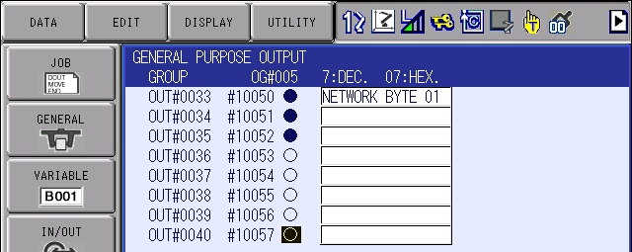

  - In Sysmac Studio, open a Watch Table.
    - Set the Device name to the Omron PLC in the project
    - Set the tag name to “RobotIn”
    - Set Display format to “Decimal”
    - Now confirm value 7 is visible in array index [0]
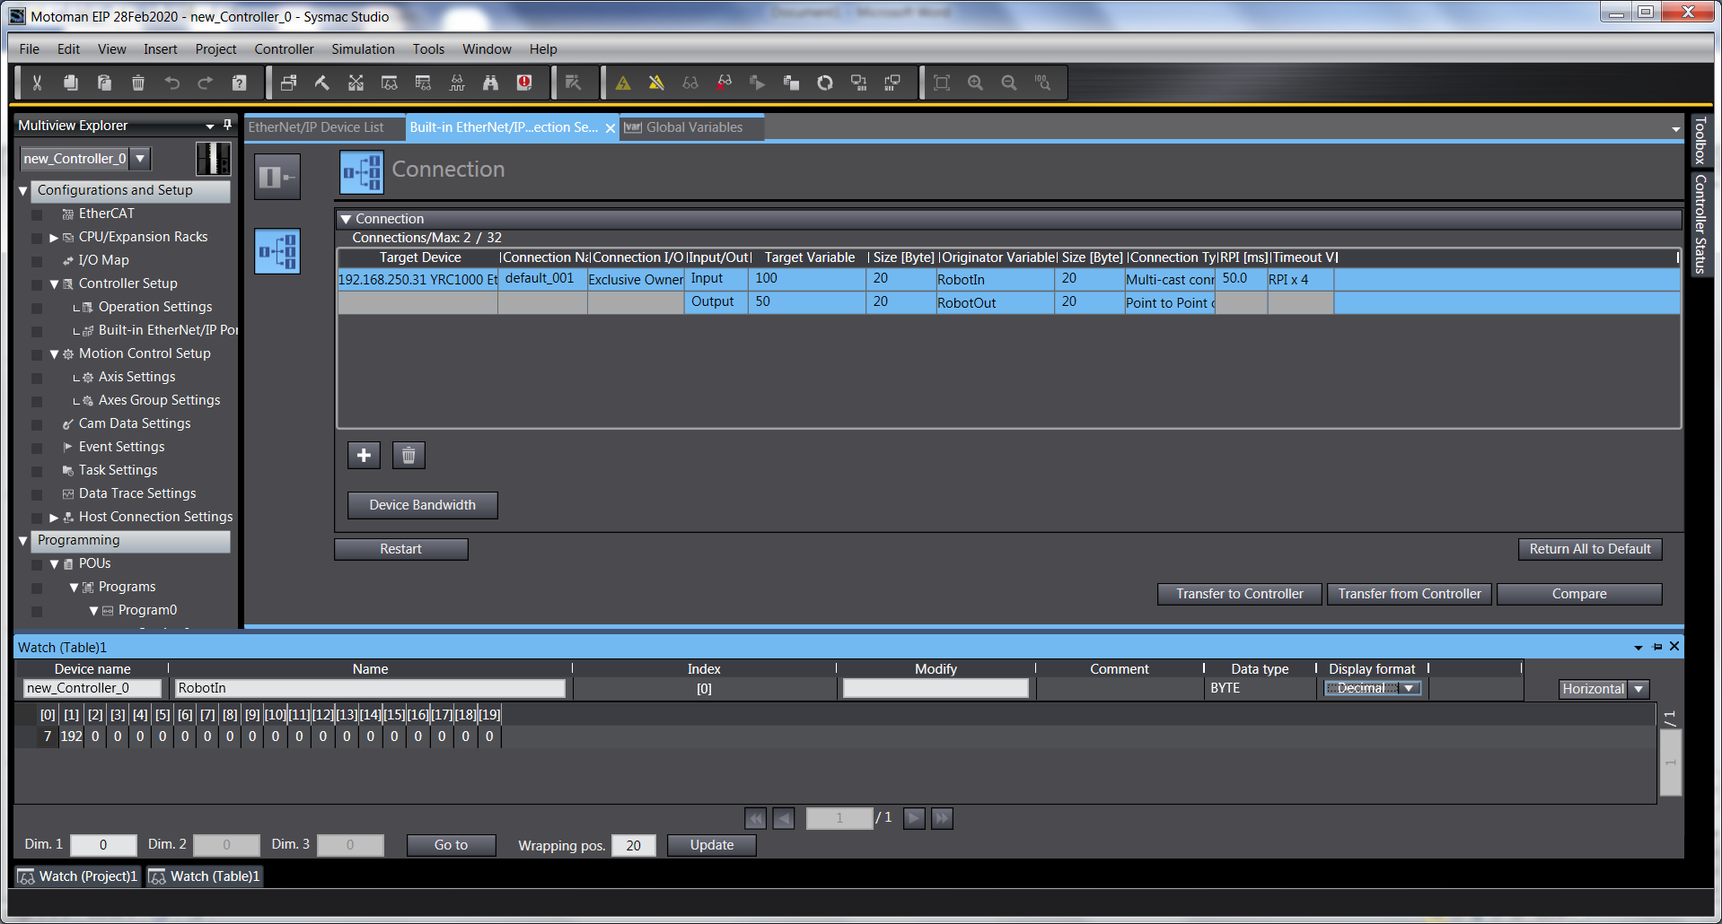

- Next we’ll verify communication in the other direction. Set an output through the Omron software and witness as input in the Robot Controller:
  - In Sysmac Studio, open a Watch window.
    - Set the Device name to the Omron PLC in the project
    - Set the tag name to “RobotIn”
    - Set Display format to “Hex” (Just to be different)
    - Now confirm value 7 is visible in array index [0]

  - On the robot controller, change to General Purpose Inputs
    - Hit the page key until IN 33-40 is shown. This is the start of the EtherCAT inputs.
    - In this case decimal value 123 was sent over the first byte. The Decimal value can be double checked in the “header” bar area.
