Establishing EtherNet/IP Communication:
- Beckhoff TwinCAT XAE 3.1.4020.10 – EtherNet/IP Scanner (master)
- DX200 (firmware DN2.06) – EtherNet/IP Adapter (slave)

This document will highlight the settings required to achieve successful communication between a Beckhoff PLC and DX200 robot controller. In this case the Beckhoff PLC is the scanner, and the robot controller is the adapter. A companion project is provided on SharePoint, which was developed in TwinCAT version 3.1. Compatibility with other versions cannot be guaranteed.

A few notes:
- All testing was done without Beckhoff hardware. Instead the software installed in a VMware instance of Windows 7, 32 bit. This allowed the software to run without interference from the host O/S’s virus scanner. The Beckhoff software allows real time simulation of the hardware, this is expected to yield the same results and performance as hardware.
- It was challenging to establish EtherNet/IP settings which would allow the robot controller and TwinCAT environment to communicate appropriately. It will be very important that the steps, logic, and approach documented here are followed – especially with respect to the transmission of outputs.
  - In particular TwinCAT / Beckhoff is allocating 4 bytes which will always be present and the robot controller will be unable to use these for data exchange. This will covered in detail later.
- Turning off wireless communication in the host operating system, was a great solution to getting communication working in the VM. Once pings can be achieved between VM and Robot, the wireless connection can be restored.
  - This caused several hours of delay, by not understanding the priority of adapter and IP address assignment to the VM.

IP Addresses: (these are arbitrarily picked to avoid conflict)
- Host PC 192.168.1.20
- Robot Controller 192.168.1.31
- VM PC 192.168.1.50
- Beckhoff/TwinCAT Scanner 192.168.1.111

DX200 Settings:
First, establish the DX200 robot controller settings. The settings are made in maintenance mode, if you are not familiar with the procedure, reference the provided manuals.
- From the ETHERNET -> HOST SETUP screen set the IP to “192.168.1.31”:
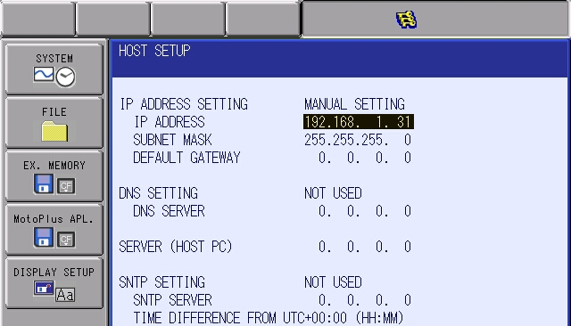
- Return to the EtherNet/IP(CPU Board) menu. Select DETAIL, next to ADAPTER and press SELECT.

- Set to “ENABLE” and enter the numeric values shown:
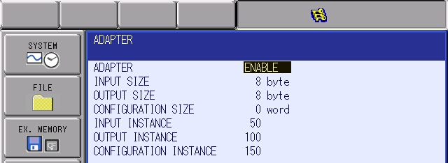

- Back at the EtherNet/IP (CPU Board) screen – confirm the values look like this:
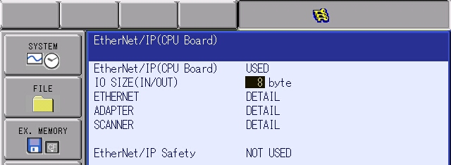

- Press enter several times to register the EtherNet/IP settings. Press enter at every Modify prompts, and keep pressing Enter until returning to the “OPTION FUNCTION” screen.

Beckhoff / TwinCAT Settings
Next, we will look at the important corresponding settings in the Beckhoff / TwinCAT software environment. These steps show how to add a EtherNet/IP scanner to a project. Alternatively, you can start with the project linked to the iNet and adjust settings appropriately.
- Add item: EtherNet/IP Scanner
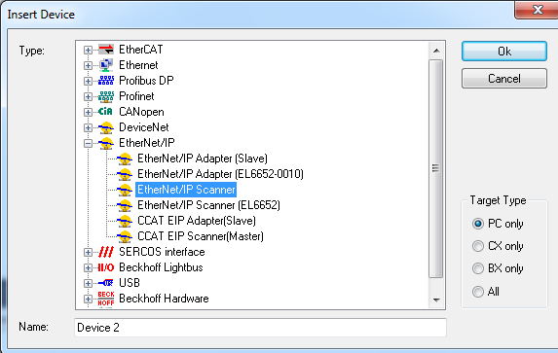

- Select the Scanner just added. Go to the “Adapter” tab and configure for the correct device. (In this case the IP address of the VM.)
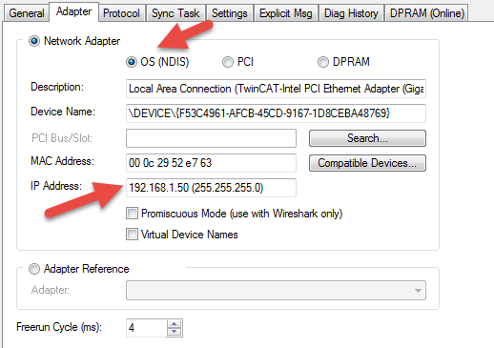

- Remain with the Scanner. Change to “Settings” tab. Expand the F800:0 tree. Change the “IP Address” value to a IP address that is different from anything else on the network. For example:
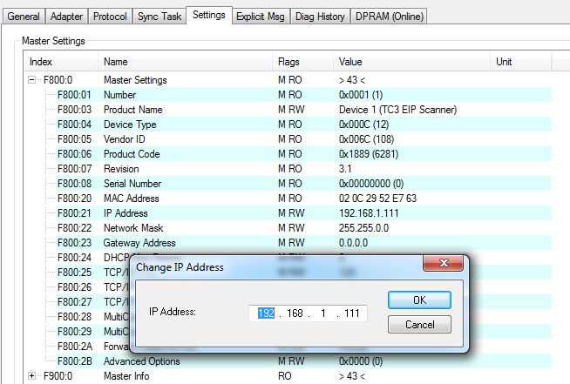

- Remain with the Scanner. Change to “Sync Task” tab.
  - Press the button “Create new I/O Task” – give it a name (IO_Task_Example)
  - Change Sync Task values in the 2nd half of the window:
    - Name – this matches the name created/added
    - Cycle ticks – change to 10 --- this will be for 10 ms RPI (requested packet interval)
    - Priority – change to 25 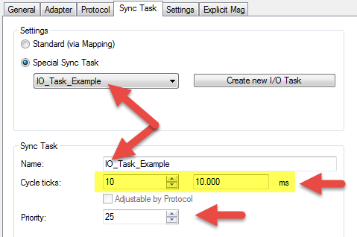

- Right click on the scanner just added, and select “Add New Item…”. Pick “Generic EtherNet/IP Slave”.
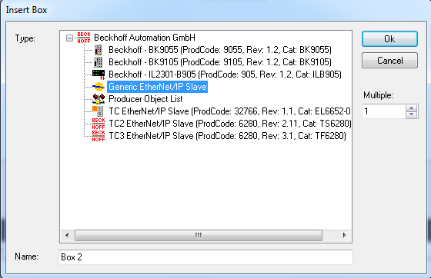

- Click on the Slave added, change to the Settings tab, and enter the IP address of the DX200.
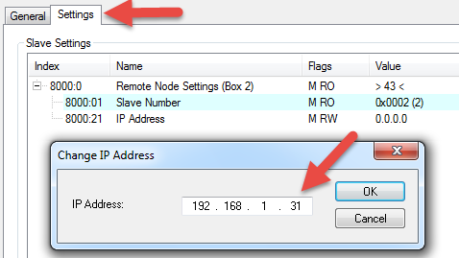

- Again, right click on the Slave, and select “Append IO Connection -> Default (without eds)”. A Connection (Input/Output) is added to the tree.

- Now for the “Inputs” defined under the new Connection, right click and select “Add New Item…”
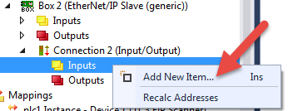

- This next step is one of the most important parts of the integration. In my opinion it is the largest challenge. This property or setting is different from any other PLC system I’ve used. Now that this is understood, we can work around it.

- Define the variation to hold the input signals (outputs from the robot controller). In this case we will only define 4 bytes. (If larger transfer size is required, this should be robot OUTPUT size minus 4.) This is because the Beckhoff software appears to allocate 4 bytes which we cannot change.
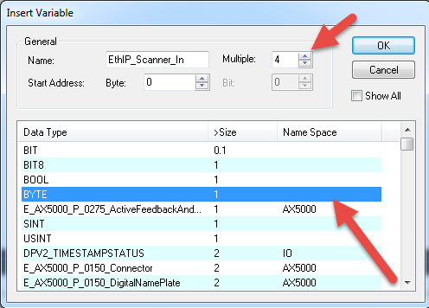

- Repeat the process for Outputs – add 8 bytes. This size requires no adjustment, this should match the INPUT byte size defined at the robot controller.
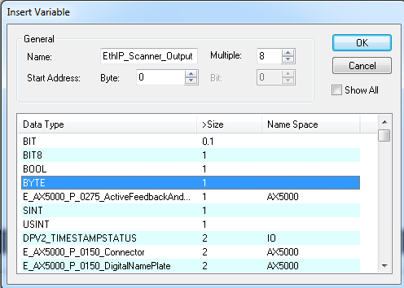

- The Connection definition should look like this:
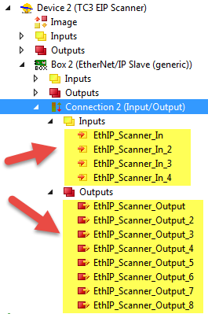

- Now, click on Connection, and change to the “Settings” tab, enter the values as shown:
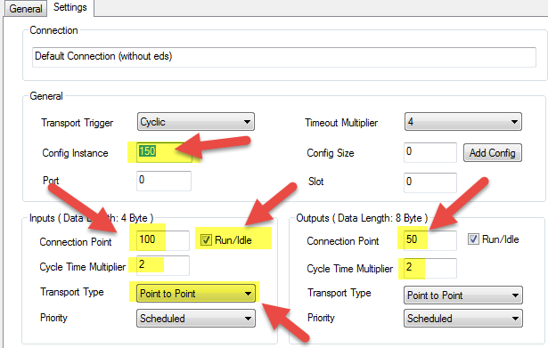

- These default settings are enough to go online successfully. Other values can be tweaked based on network traffic (inputs can be changed to multicast) and RPI can be changed by adjusting the cycle time multiplier to smaller or larger values. (The current values will result in 20 ms RPI’s.)

- Now the project should be “Activated” and the PLC programs can be started. This process is not documented here.

- Once online / running , confirm that the Slave is communicating successfully.
  - In the lower right corner the status should show “green” and the CPU usage will be displayed:

  - Navigate to EtherNet/IP Slave -> Inputs -> State and select it.
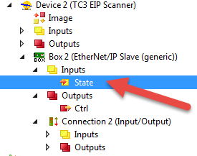
  - Change to “Online” tab.
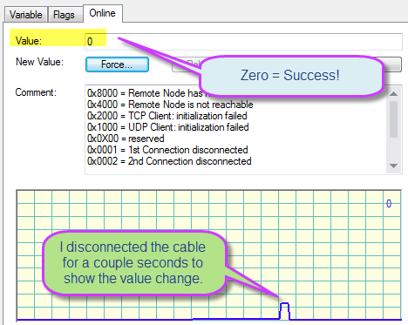
    - A value of “0” indicates successful communication.
    - A non-zero value indicates some sort of communication failure.
      - Check cabling, verify Ping from Beckhoff to DX200, verify DX200 power is on, confirm all settings in DX200 and Beckhoff.
Test the integration:
- Assuming there are no additional networks or expanded I/O cards, then the following input and output locations should be valid. If additional cards are present, appropriate offsets may need to be added/calculated.

- DX200 Inputs
  - The first input will occur at Universal Input #33 (Address #00050 and #20070). With 8 bytes allocated the inputs go through #96 (Address #00127 and #20147).

- DX200 Outputs
  - The first 4 output bytes are ignored! This is caveat of this integration.
  - Thus, the first controllable Universal Output is #65 (Address #10090 and #30110). With 8 bytes allocated, there are 4 total usable output bytes available, which go through output #96 (Address #10127 and #30147)

- DX200 EtherNet/IP Status
  - If address bit #20064 or #20066 equal 1, then an EtherNet/IP communication error is present. Investigate settings on the robot and Beckhoff software.

