**EtherNet/IP Communication Test :: Wago to YRC1000**

The purpose of this document is to show that testing has occurred between Wago and Yaskawa regarding EtherNet/IP connectivity of certain products. This document will guide a user through the exact settings required to duplicate this testing. Following this guide other configurations should be possible using hints and knowledge gained from the initial testing.

**Hardware under test:**

* Wago
  + Coupler: 750-352 (EtherNet/IP_
  + 16 pt Digital Input Module: 750-1406
  + 16 pt Digital Output Module: 750-1504
* YRC1000 Robot Controller
  + Software version: YAS2.80.00A

**Device Settings:**

* Wago
  + IP Address of coupler unit: 192.168.1.1 (Configured by DIP switches)  
    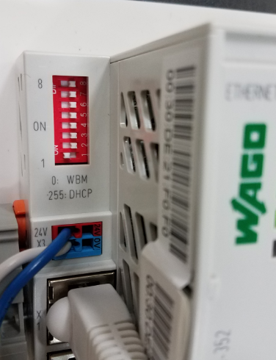
  + First login to the webpage for the IP address above. Then navigate to the “EtherNet/IP” menu setting. Now the webpage shows various EtherNet/IP settings. For this validation only digital inputs and digital outputs were mapped. Other solutions may use analog I/O or status bits, adjust the settings as needed.  
    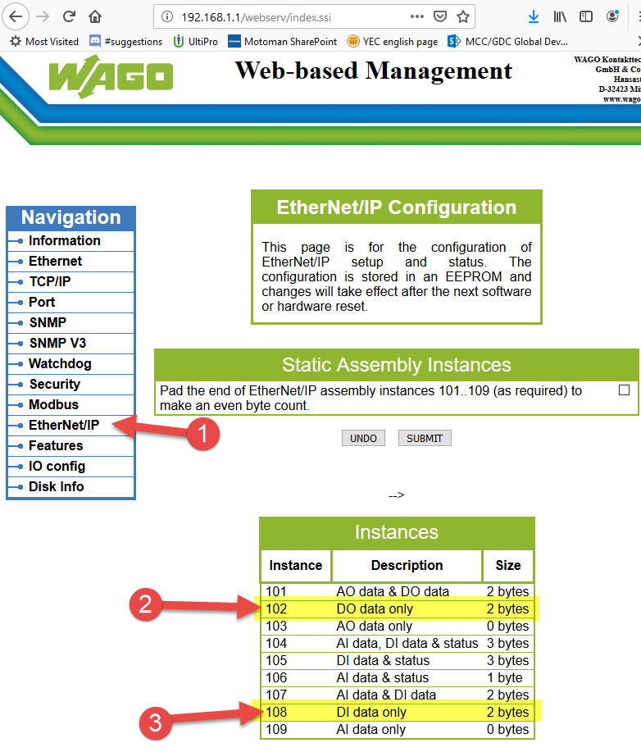
* YRC1000 Robot Controller
  + The following settings are established in maintenance mode with management mode password entered. To access these settings consult manuals or Yaskawa technical support for assistance.
  + First select an IP address so that the robot controller is on the same subnet as the Wago coupler. In this case 192.168.1.31 is used:  
    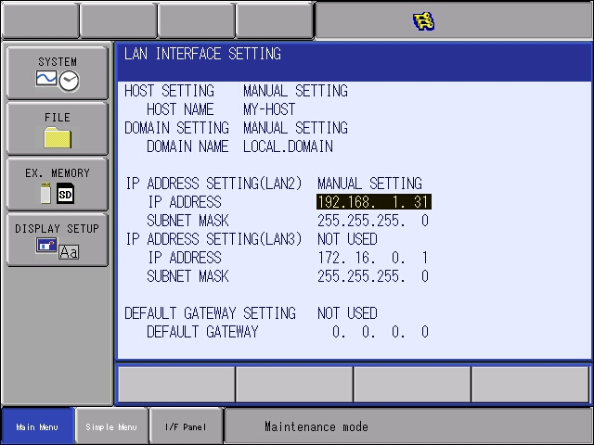
  + Next change to the EtherNet/IP option settings. Define a device “WAGO” with the settings below. These values came from the Wago device’s webpage earlier.
    - For example “DI data instance” on the webpage = 108, and is entered here as “INPUT INSTANCE”.   
      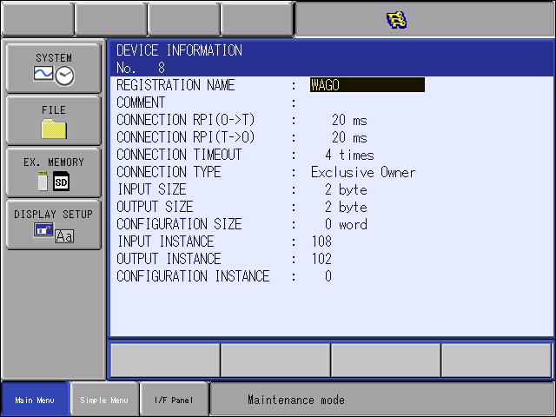
    - Notice: The YRC1000 communication worked with zero values for Communication instance and size.
  + Now move on to the EtherNet/IP settings and enter the “SCANNER” settings by pressing the enter key at DETAIL.   
    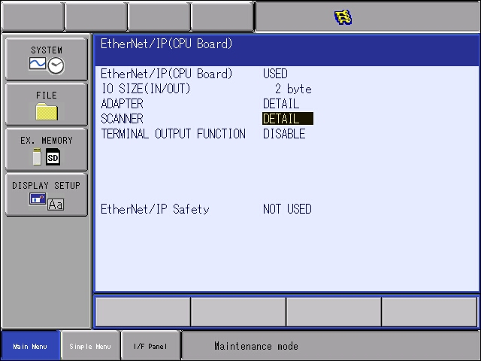
  + Add the “WAGO” device just defined and enter the IP address. (192.168.1.1)  
    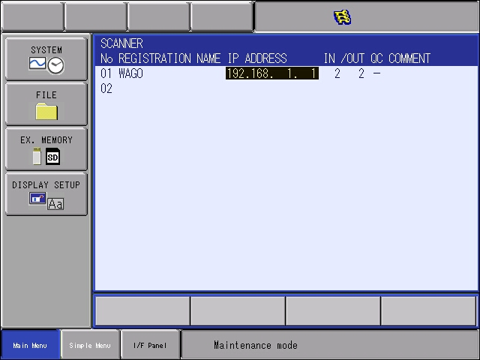
  + Press enter many times to confirm all settings and accept all “Modify” prompts.
  + Issue flash reset of the safety circuit when prompted.
  + Reboot the robot controller normally.

**Confirming Communication and I/O exchange:**

* After the YRC1000 reboots and starts up normally EtherNet/IP communication should now be established. Confirm this by looking status of both devices:
  + Wago: Look at LEDs on the coupler unit.
    - LED: LINK/ACT1 :: blinking green
    - LED: LINK/ACT2 :: off
    - LED: MS :: solid green
    - LED: NS :: solid green
    - LED: I/O :: solid green
  + YRC1000 – from the teach pendant open menu [IN/OUT] 🡪 [EXTERNAL INPUT]. Look at group #20060. All bits should be zero. Any “1” in this byte indicates a failure of some sort.
    - This can also be confirmed by looking at General Purpose Inputs #25 to #32. These inputs can be labeled with a name that helps understand the purpose of each bit. Again, each bit should be off or zero.  
      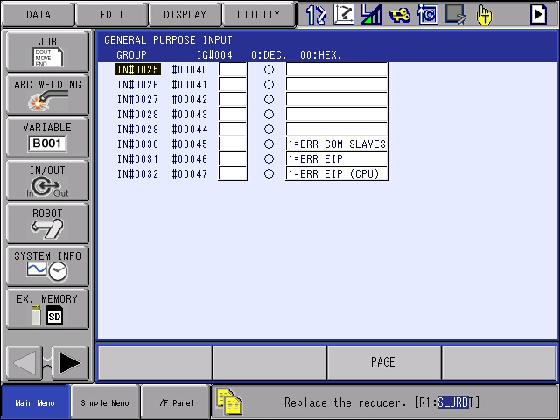
  + If these conditions are matched, then input and output exchange can be verified in the next step.
* Output control from YRC1000 to Wago
  + From the YRC1000 set some outputs. In this case the following outputs were turned on:  
    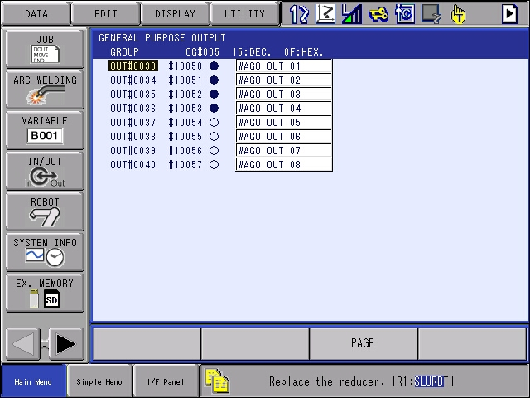

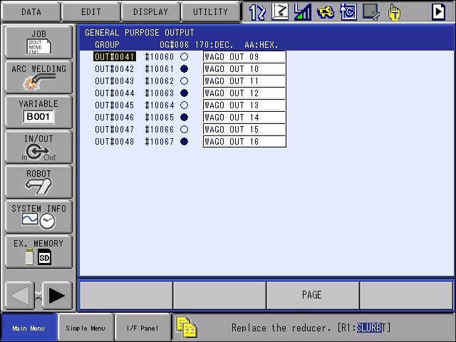

* + Look at the Wago unit, specifically the output slice, and verify that the outputs correspond:  
    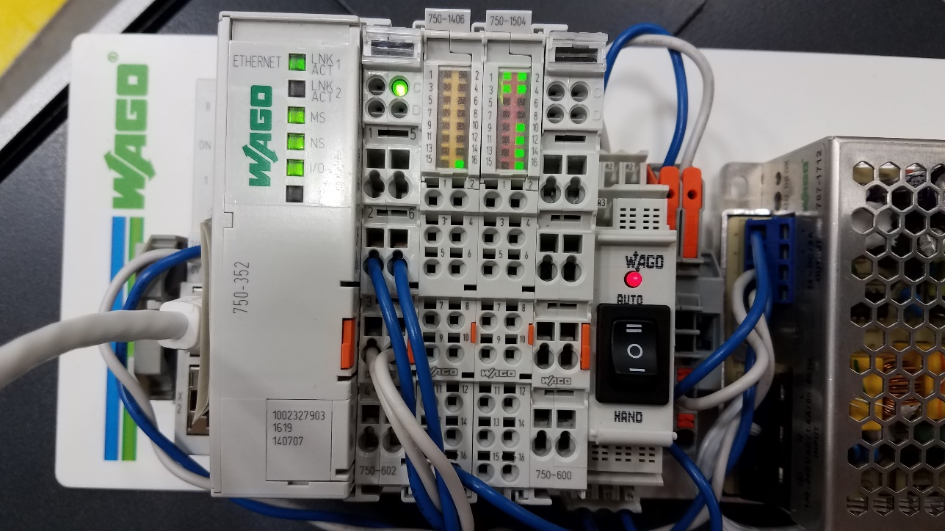 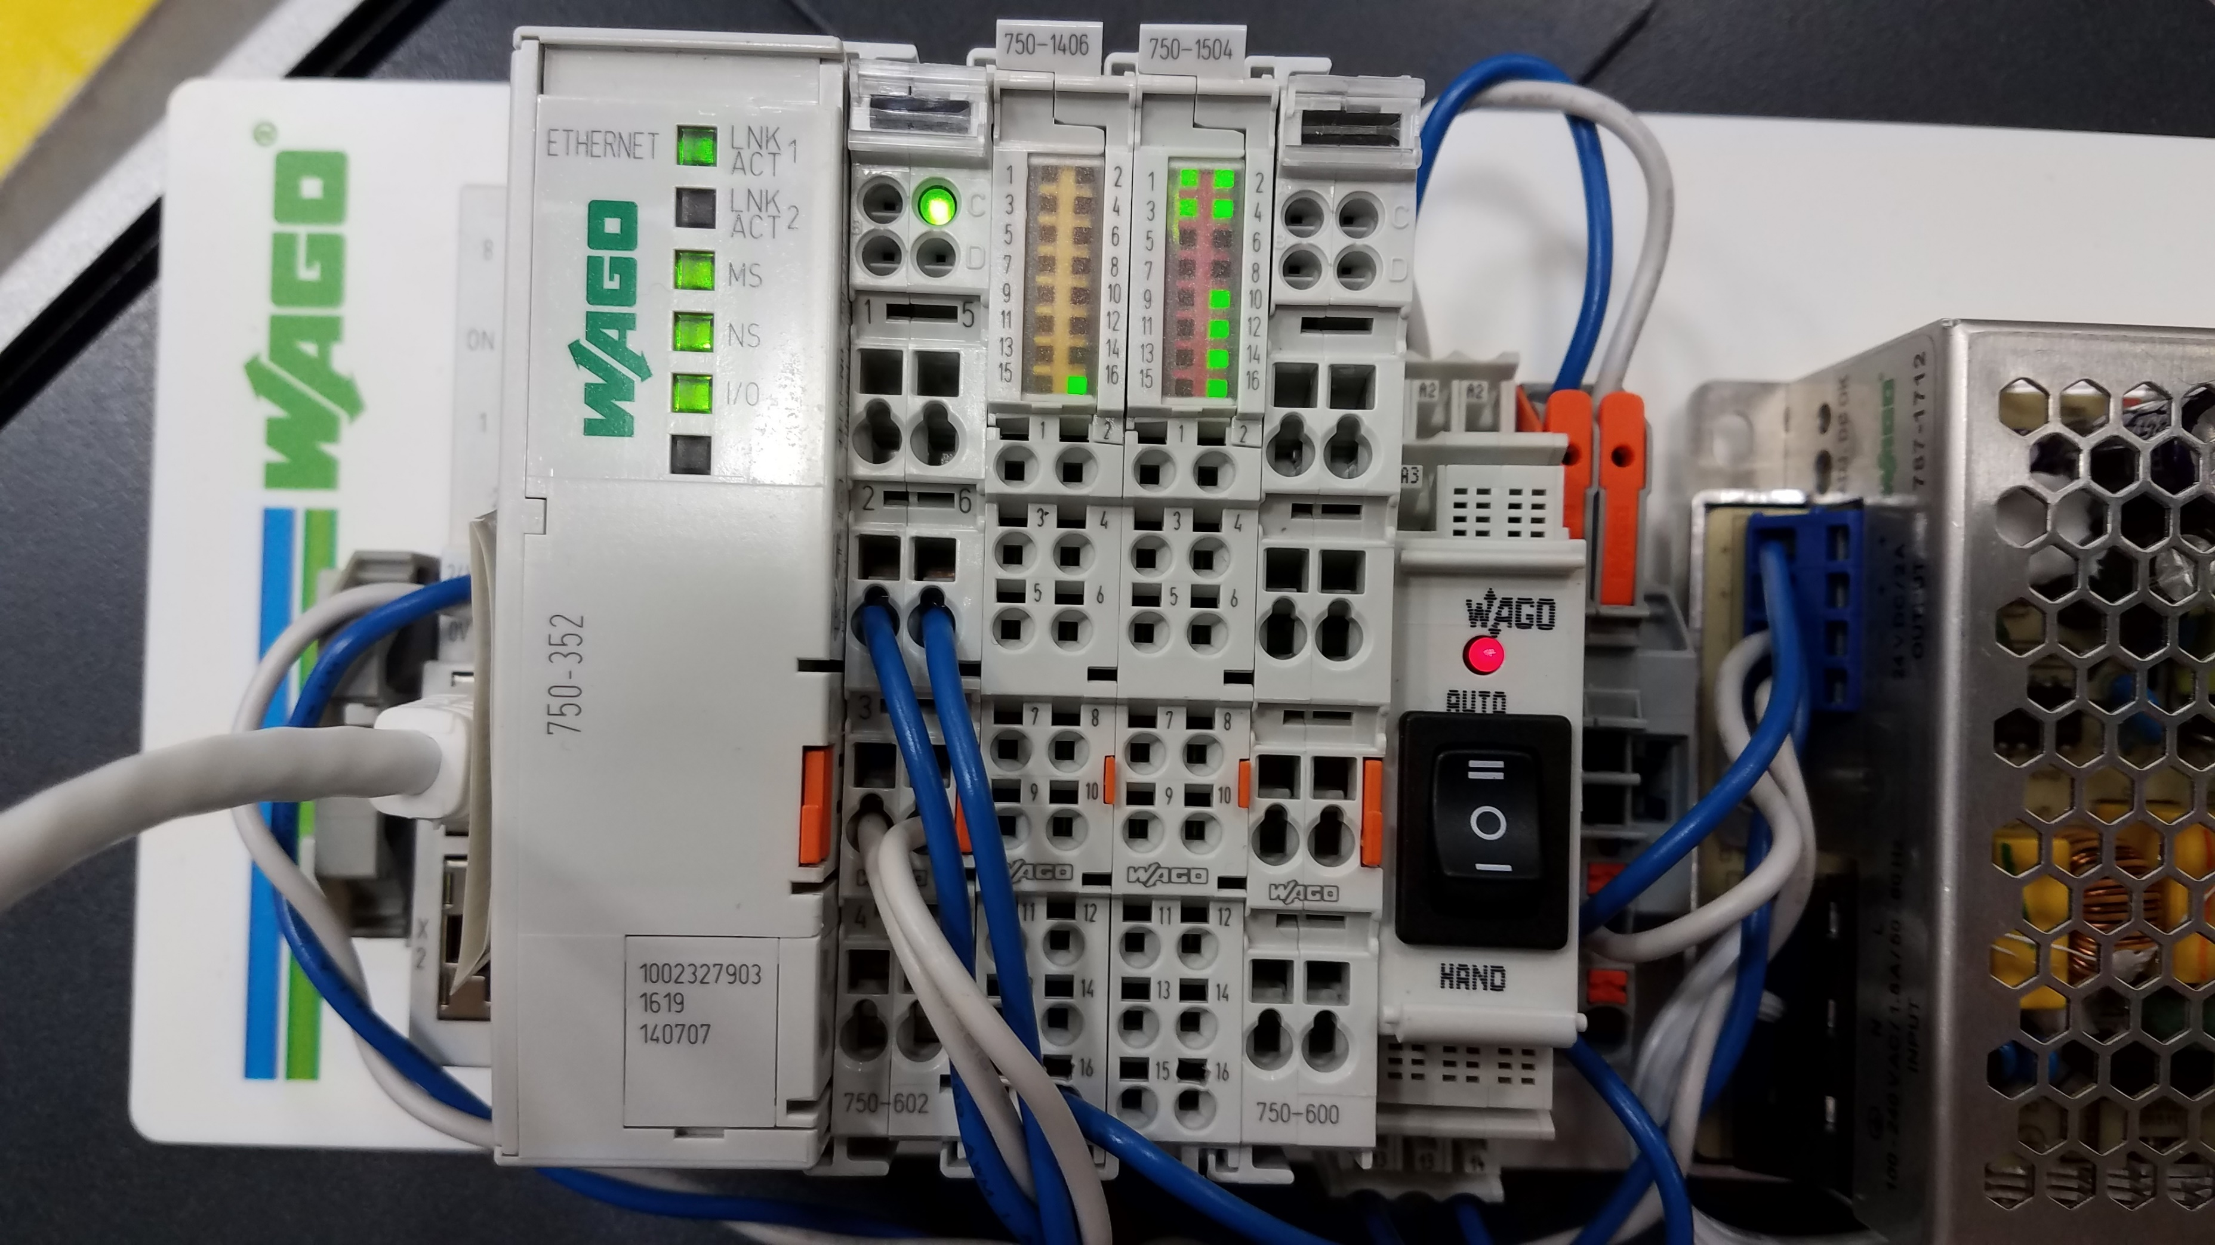
  + The bits sent from the YRC1000 match the bits energized on the Wago unit.
* Input Signals from Wago to YRC1000
  + Send a signal to the unit that will enable an input. (In this case the input was energized by 24V, other input units could take different voltage levels). Verify that the module’s display registers the input change. (In the photo below only input 16 is ‘ON’)  
     
* Input verification on the YRC1000
  + On the YRC1000 look at the 2 bytes which correspond to the Wago input exchange:  
    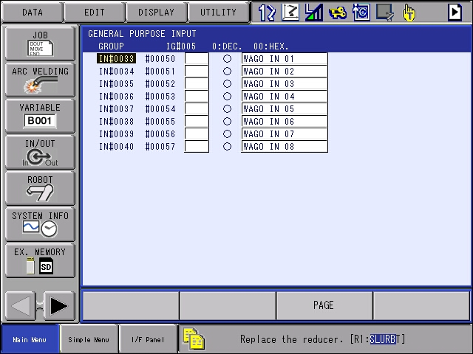  
    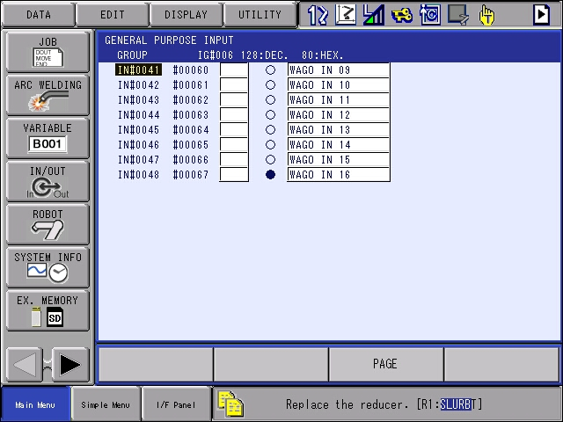
  + The only “ON” bit on the YRC1000 matches the ON signal from the Wago unit.

**Validate Network Reconnection:**

* A final test is to validate that in the event of a network disconnection that the two devices will reconnect.
  + Disconnect the ethernet cable going to the Wago unit.
  + On the Wago unit the LINK/ACT1 LED turns off and the NS LED starts blinking red.
  + The YRC1000 will now indicate failure by looking at the status bits. Any bit turned on for universal input #25 to #32 indicates some sort of failure.  
    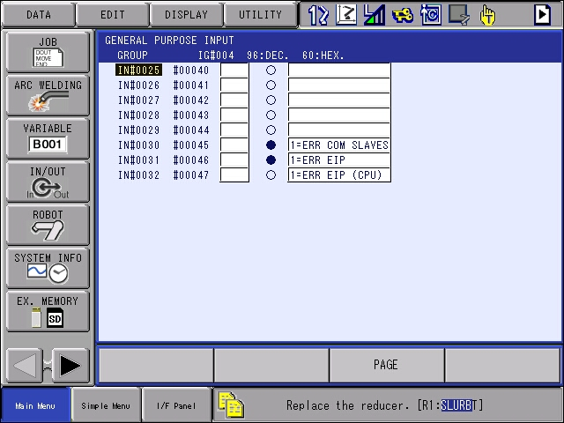
  + A bad network is easy to reproduce. The above steps are here just to witness the difference between functioning and non-functioning communication.
* Next, reconnect the networking cable to the Wago coupler. The network will reconnect in 10-15 seconds.
  + Verify reconnection details as shown on page 5.

**Final Notes:**

* While this testing was done with a YRC1000 robot controller, Yaskawa expects this solution to work with other older generations of robot controllers (ex DX100, DX200 and FS100) and parallel generation of controller (YRC1000micro) following the same approach. The screenshots and I/O locations on the robot controller may be slightly different, but the approach and techniques are the same. Consult manuals to understand the settings and differences between controllers.