YRC1000

## Setup CP1616 as iDevice with ProfiSAFE

Important:

ProfiSAFE can be used only, if CP1616 board is using firmware version 2.8.1.0.0!

If other firmware version is loaded, change it to version 2.8.1.0.0!!

CP1616 is setup as „iDevice“. Make sure that the ProfiNet controller supports „iDevice“ functionality!

In this setup sample TIA portal V15.1 with Update 2 is used.

The CP1616 has to be setup as a “iDevice”. That means for each CP1616 configuration an individual GSD-file has to be created vie TIA-Portal software!

YASKAWA Europe offers a sample TIA project (YRC1000_CP1616_iDevice_2019-10-18_1347_Degroot.zap15_1) with 36 bytes IO-range (incl. the GSD) for following CP1616 configurations:

1. CP1616 standard (w/o ProfiSafe)
2. CP1616 with ProfiSAFE
3. CP1616 standard used with Motologix
4. CP1616 with ProfiSAFE used with Motologix

When using the TIA sample project, just download the needed version into the CP1616; initialize the CP1616 at the YRC1000 controller and install the GSD-file at the TIA PLC-project.

The following steps only needed if you create your own CP1616 iDevice configuration

Start a new projekt in TIA portal and open „Devices and Network“

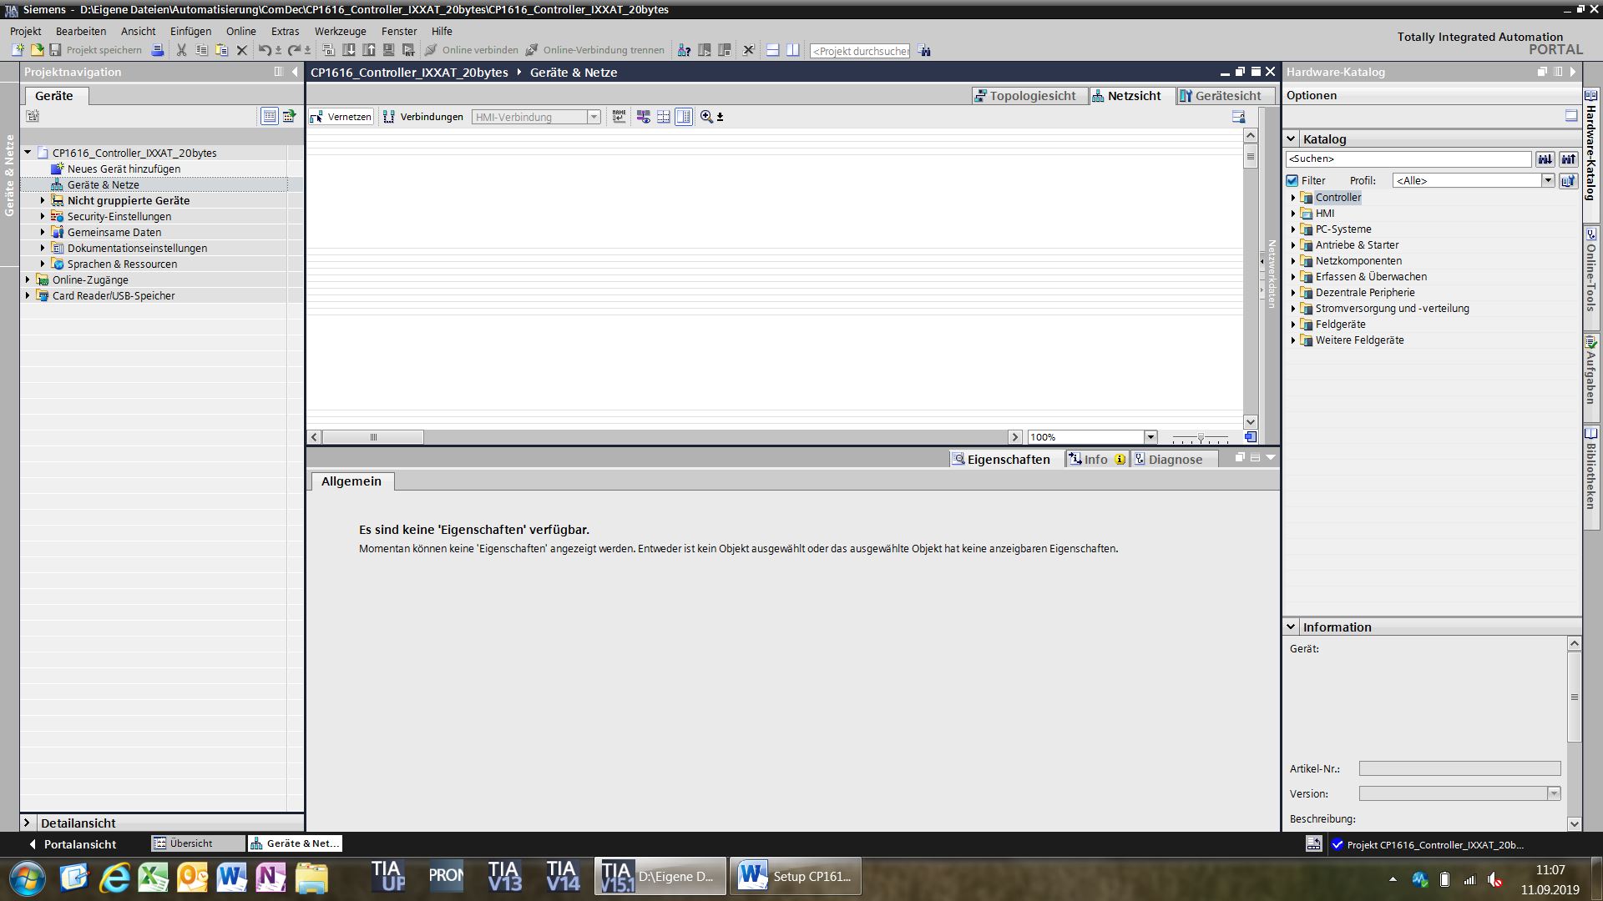

Select a „PC-Station“ from the device catalogue

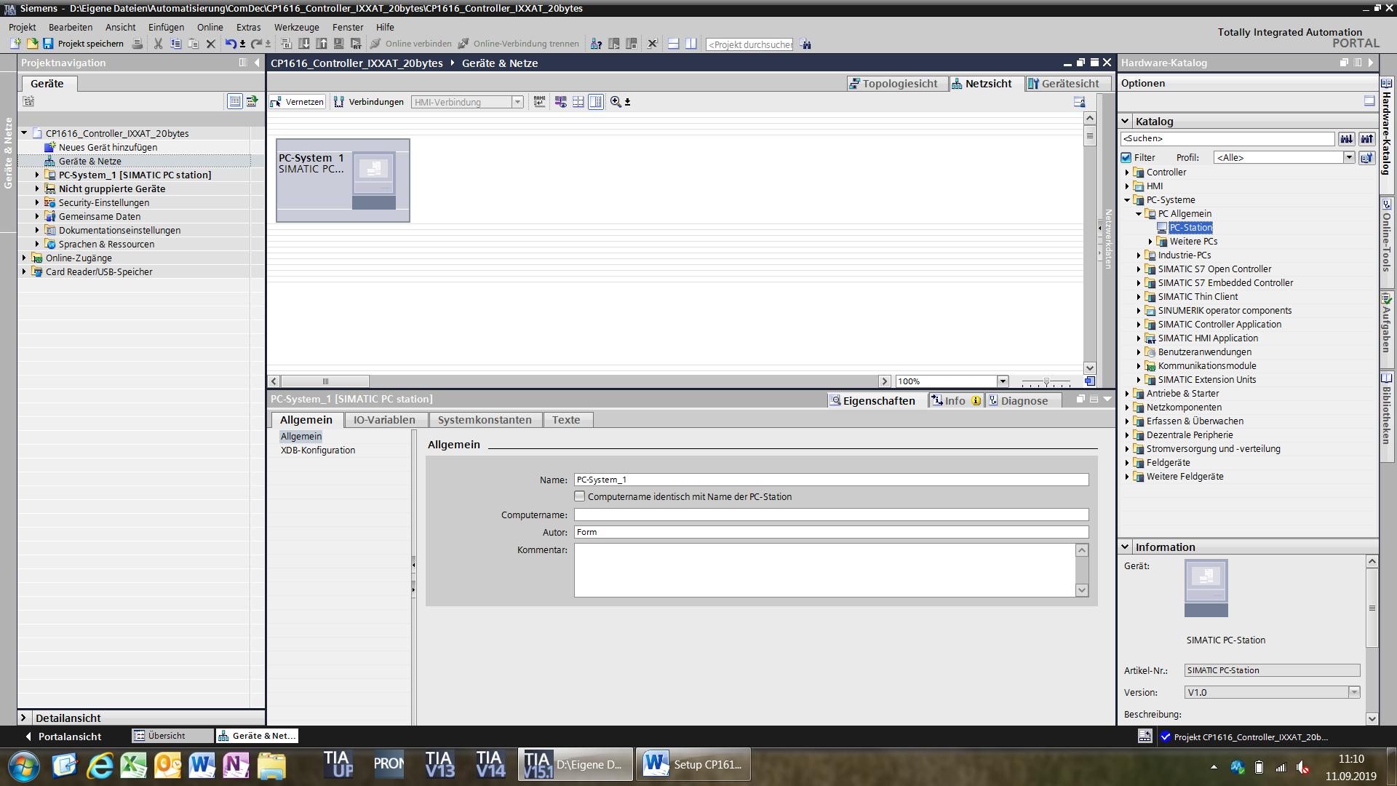

Setup the name for the GSD-file (Product name), which has to be created at the end of this configuration

Ein Bild, das Screenshot, drinnen, Computer enthält.

Change to the „Device view“ and select the used CP1616 version located at „Communication modules“. Check that FW-version is 2.8. at CP1616

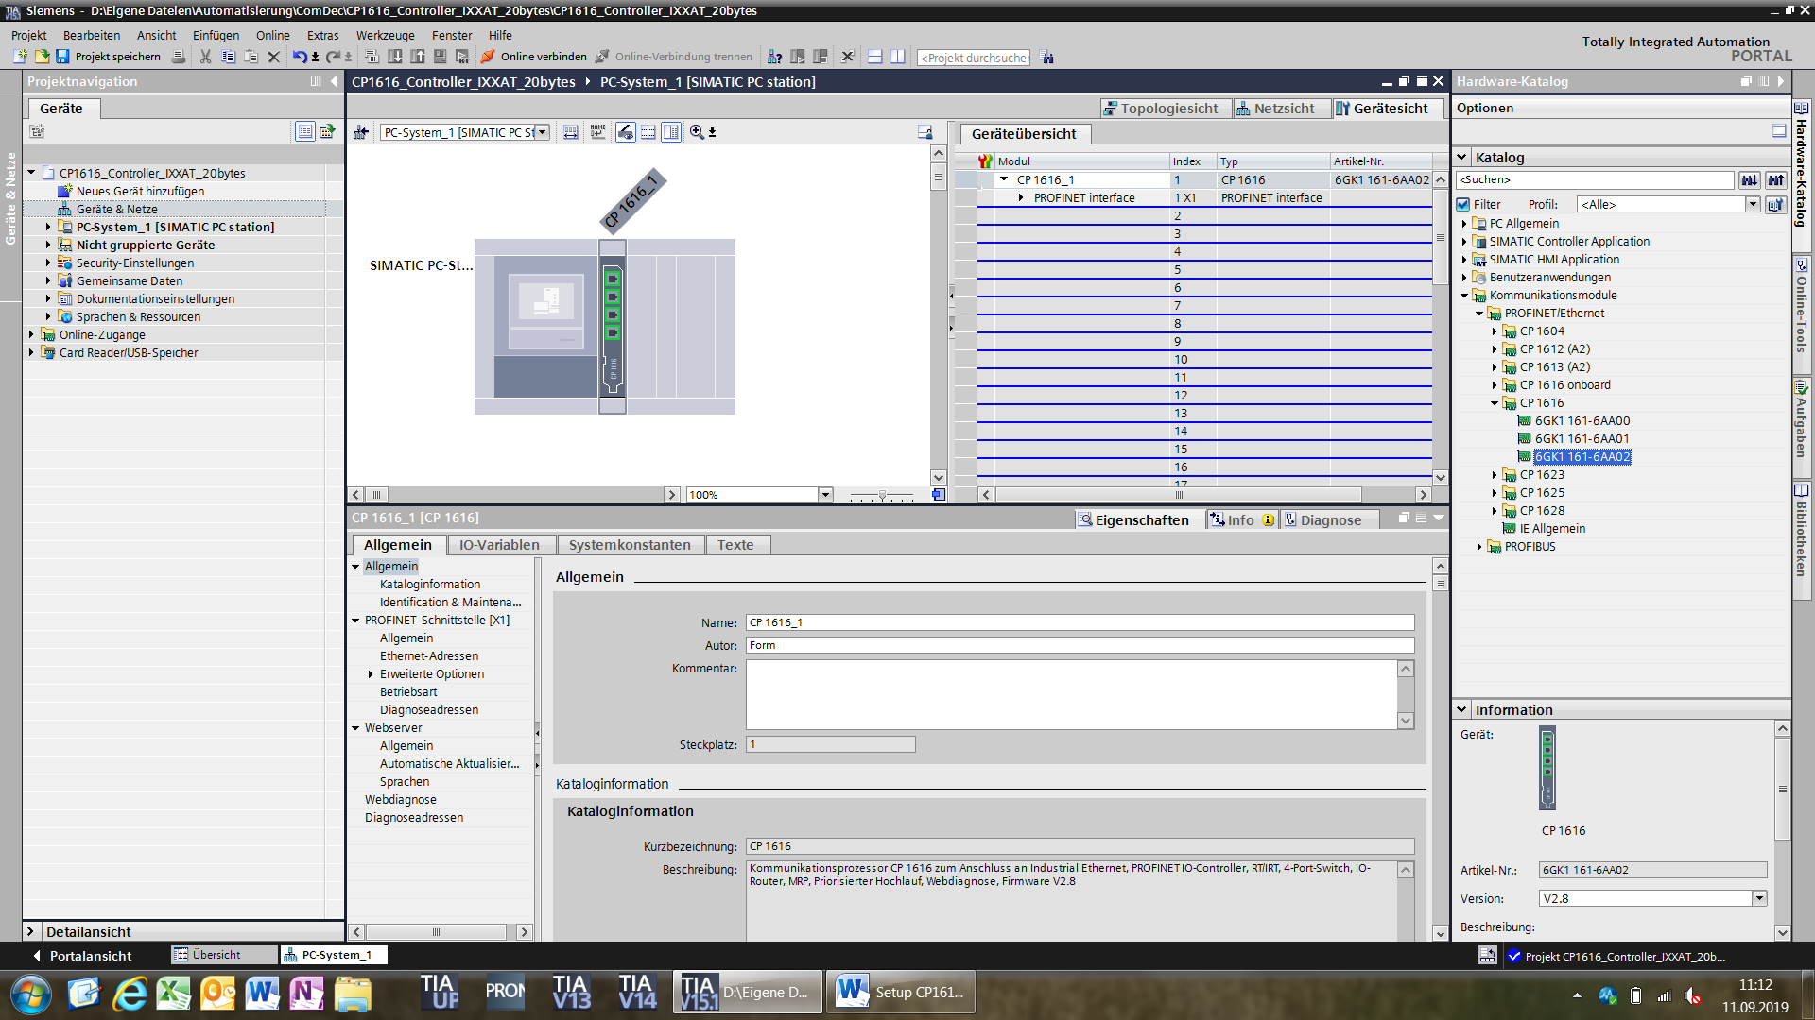

IP-adress and ProfiNet name for the CP1616 iDevice can be set automatically by the IO-controller.

Therefore set the following items to „ON“:

* Radio button „IP adress is set directly by the device“
* Checkbox „Profinet device name is set directly at the device“

Ein Bild, das Screenshot enthält.

Check at the folder „operating mode“ that „IO-Device“ is selected!

This will activate CP1616 as „iDevice“.

The supported ProfiSAFE version must be 2.6.1

Set following checkbox to „ON“:

* „Parameter assignment of PN interface by higher level IO-controller“

Ein Bild, das Screenshot enthält.

Select the „IDevice communication“ folder.

The table for the „Tansfer Area“ should be open now.

At the „Transfer Area“ the safe signals for ProfiSAFE and the standard I/O´s will be setup.

Setup the ProfiSAFE signals first:

1. Move to column „TYPE“ in line 1 and select from the pulldown menue „F-PS“ .
2. At column „LENGTH“ set „8Byte“.
3. In column 1, line 1 you will see a yellow marked square, which indicates that „FailSAFE“ modules are selected.
4. Same setting has to be done at line 2.
5. ProfiSAFE setting is finished
6. Setup standard I/O, by starting in line 3, select at „TYPE“ the „TM“ module.
7. Set at column „LENGTH“ the amount of output bytes.
8. Set in line 4 the input byte in the same way, but change the arrow direction by clicking into this direction „🡨“

Next a GSD-file has to be created, which is needed for the configuration at the controller project

Therefore click on the CP1616 at the network view and click the „COMPILE“ button. After error free

Hardware compilation, go back to the „OPERATING MODE“ folder.

Below the „TRANSFER AEREA“ table you will find a button called „EXPORT“.

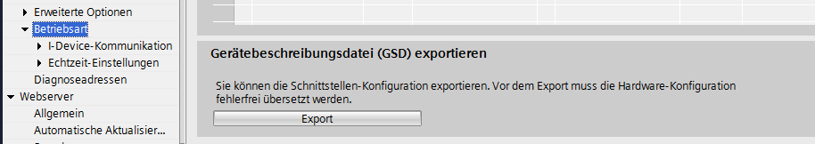

Click on „EXPORT“ and save the GSD-file.

The GSD-file has to be installed later into the controller project (PLC), to configurate the ProfiSAFE iDevice (CP1616) in this project.

Now download the configuration into the CP1616, therefore the YRC1000 has to be started in “Maintenance Mode” first!

After downloading the configuration via TIA Portal into the CP1616, the configuration at YRC1000 at “Maintenance Mode” can be done. At YRC1000 the amount of IO´s for the CP1616 has to be setup, same as configurated in TIA!!

## Setup PLC with CP1616 as iDevice and Profi-SAFE

Open the PLC project and install the new created GSD-file from the iDevice configuration.

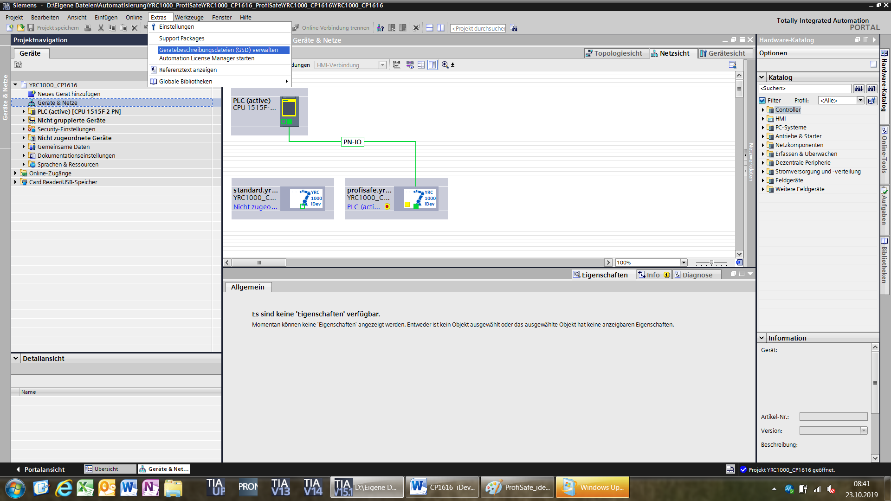

Then select the iDevice (CP1616) at the hardware catalogue.

Check that the firmware (FW) version of the CP1616 is 2.8.!!!

Ein Bild, das Screenshot enthält.

Then connect the iDevice (CP1616) with the subnetwork of the PLC and check Profnet name- and address.

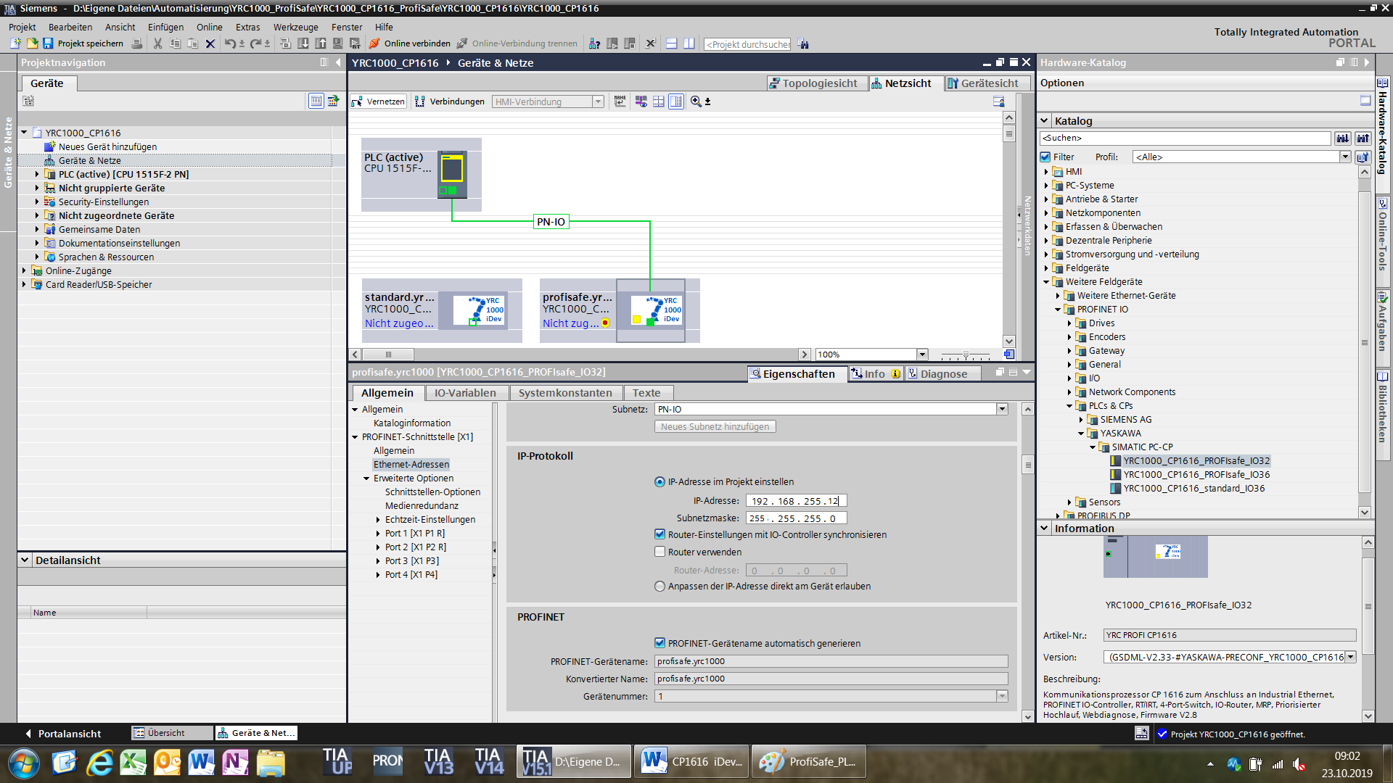

Select the F-CPU and setup SAFE-parameters

Change “F-dest.Add” range up to “299”.

Ein Bild, das Screenshot enthält.

Setup the ProfiSAFE parameters for the iDevice (CP1616)

Therefore double click the CP1616 and open the hardware configuration and change the following settings:

Set “F_dest_Add” = 200 🡪 same setting as in YRC1000

Set “F_Par_CRC” = 1

Ein Bild, das Screenshot enthält.

Then turn back to the “Device and Network” view and select the F-CPU.

Now compile the hardware configuration.

Ein Bild, das Screenshot, Computer, drinnen, Laptop enthält.

If similar error message appears „Operand F00053_RC_fs ACK_REI not defined“, proceed with following steps:

* Move to the indicated “network”

Ein Bild, das Screenshot, Computer, drinnen, Schreibtisch enthält.

In this sample

* replace the „F00053_RC_fs“ against the automatically created function „F00000_RC_fs“!!!

(shown at “F-Peripheric DB´s” at the project window)

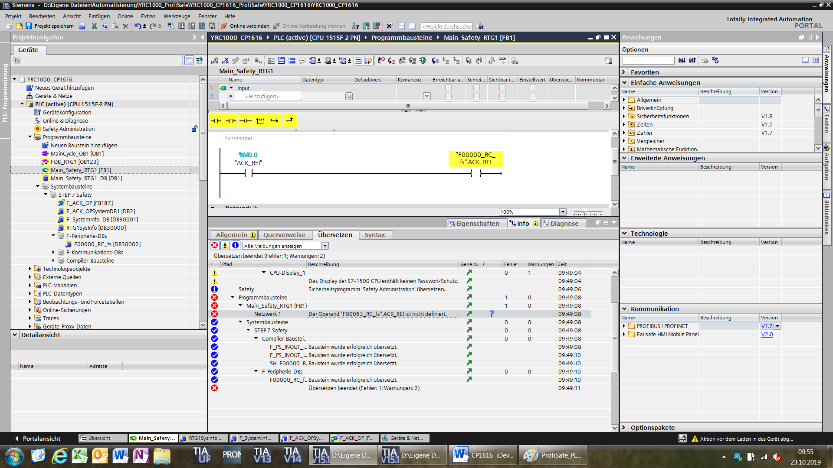

Now compile the hardware configuration and afterwards download it to the PLC.

Go to “online” connection and check if the safety communication is running OK w/o any errors.

If an error is displayed at PLC, check the “Diagnosisbuffer”.

Check if “Passivation” is deactivated.