Connection Guide: Lumberg IO-Link to Yaskawa YRC1000 Robot Controller by EtherNet/IP

This guide is intended to help customers to get communication working by following the specific examples in this guide. While the exact Lumberg hardware, sensors, and devices may not be used by each customer the screenshots and techniques should be applicable to various Lumberg IO Link devices and possibly solutions provided by other vendors.
This solution works because the Lumberg / LioN-X device does not require exchange of the Configuration data which is prevalent in many other IO-Link solutions. Instead, the settings are made by the web interface and stored between power-up / power down.

Exact Testing Configuration:
Robot Controller:
- YRC1000 Software version: YAS3.04.00A-00
- EtherNet/IP function for the LAN port was enabled.
  - Exact settings on the following pages.
Lumberg Hardware:
- Lumberg 8 Port IO-Link Module: LioN-X 8xIO-Link Class A with Multiprotocol
- Application Version: 10.1.1.2
- Fieldbus Version 1.0.0.0
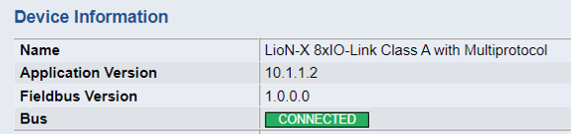
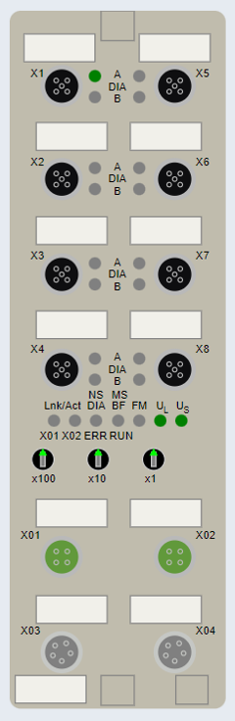

YRC1000 Configuration:
- Start the robot controller in maintenance mode.

- Login as management with all 9’s password:
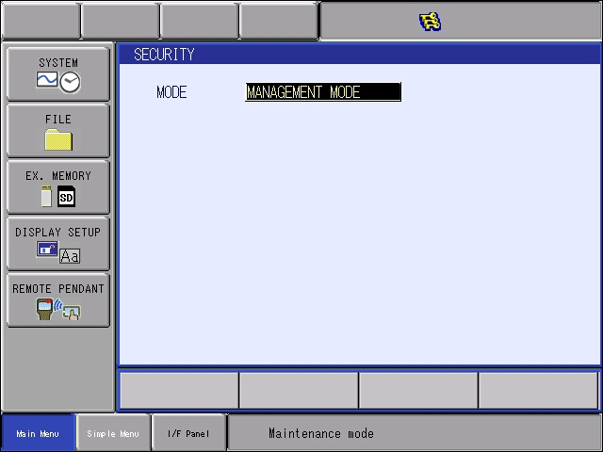

- Select the SYSTEM button, then SETUP button.

- Select OPTION FUNCTION and press the Enter key.

- At the ‘OPTION FUNCTION’ menu move down to “EtherNet/IP (CPU Board)” and press the Enter to move to next screen.
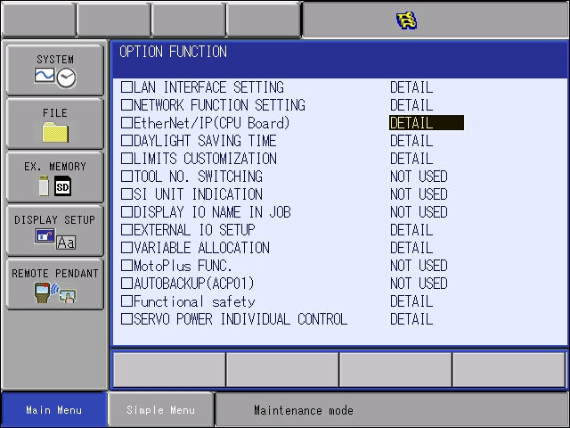

- Next we will add the Lumberg device to the list. Select “DETAIL” next to the DEVICE INFORMATION LIST and press Enter:
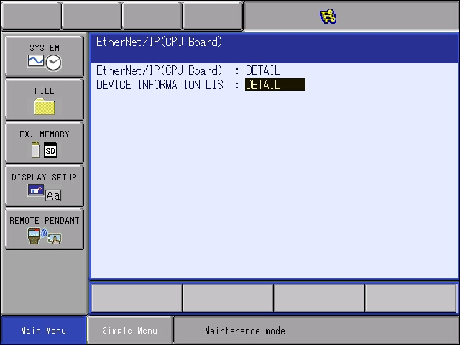

- Enter the information below. The name can be different, but the rest are values which are known to work:
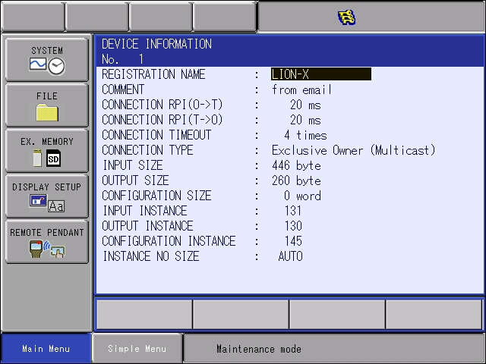

- Press Enter to register the device. You will see it on the device list on the next screen.

- Press Cancel to return to the menu below. Select “DETAIL” next to the ‘EtherNet/IP (CPU Board)” and press Enter:
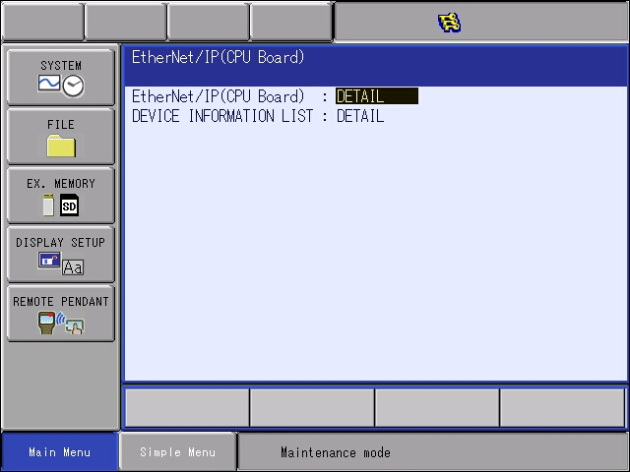

- Set the EtherNet/IP (CPU Board) to “USED”

- Move down to the “SCANNER” selection and select “DETAIL”, then press Enter.
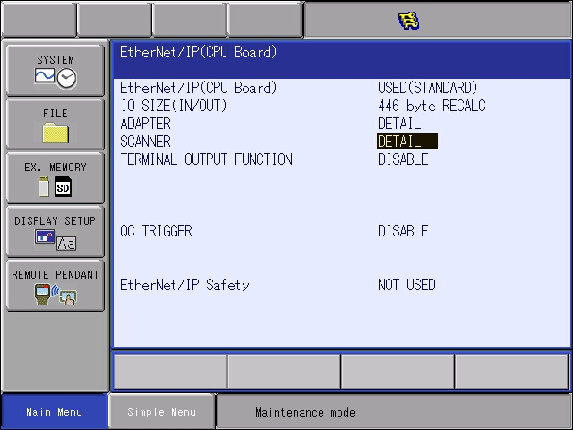

- Add the LION-X device to the list. Set the IP address of the device. In this case the device has been assigned an IP address of 192.168.1.40. (The robot controller is setup as 192.168.1.31)
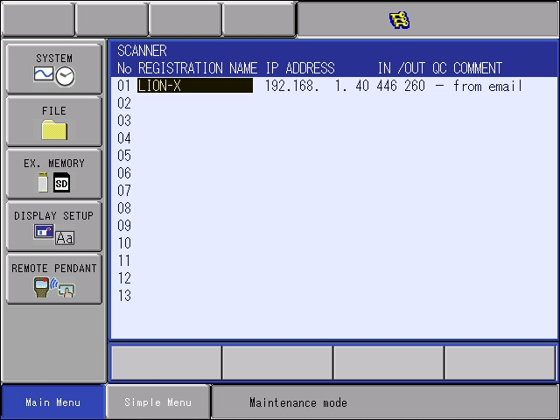
- Press Enter to register the settings and return to the main EtherNet/IP CPU board screen. You should notice that the total IO SIZE (IN/OUT) on this screen matches the max IN and/or OUT from the LION-X. In this case 446 bytes.

- Highlight the RECALC selection one time and press the enter key. It might not change, but it’s a good practice.
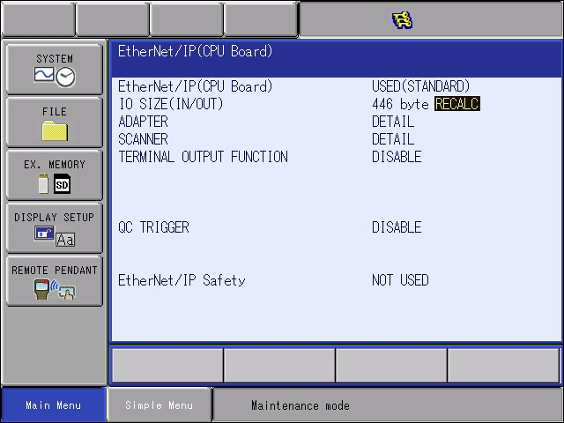
- Press enter at this screen to receive the modify prompt. Press Yes to continue.
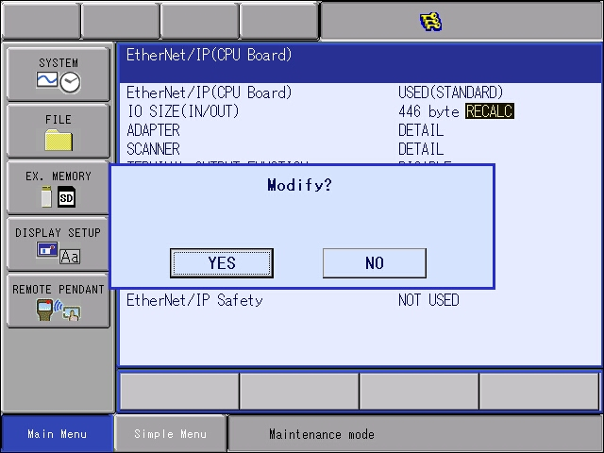
- Keep pressing Enter key and accept yes at all other modify problems (for YRC1000 and YRC1000micro there will be several IO Allocation prompts).

- Confirm the robot’s IP address at LAN2 is setup on the 192.168.1.** subnet. (This step is not included.)
  - By default the typical shipped configuration for LAN2 port is 192.168.1.31

- Flash reset the board if required. (Message will be displayed on the bottom of the pendant.)

- THE SETUP ON ROBOT SIDE IS DONE, REBOOT IN NORMAL MODE.

Lumberg LioN-X IO-Link device:
- Power on device. Connect device to ethernet network such that a PC can connect.

- Set/confirm/adjust the IP address of the device to match the settings earlier.
  - Those steps are not included here. The manual can assist – for the easiest settings rotary switches can be used and the base network is 192.168.1.xxx.

- Login in to the website for the device by typing the IP address into your web browser. The login credentials are:
  - User admin
  - Password private

- The manual shows where the instance IDs and sizes came from. Section 8.1 shows this data which corresponds to the settings we made in the robot controller:
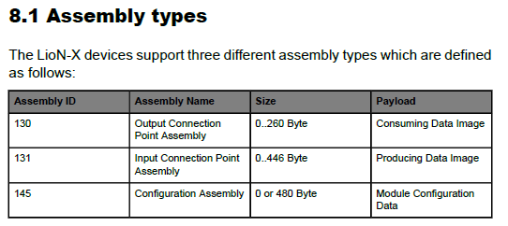

- Note ~ each port is pre-allocated 32 bytes of input and output data. This can be reduced but is not discussed in this document.

Communication Testing:
- Complete the ethernet network. Use a network switch to connect the Lumberg device, Robot controller and a PC to the same network and subnet.

- Connecting to the Lumberg device by webpage we can check if its connected:
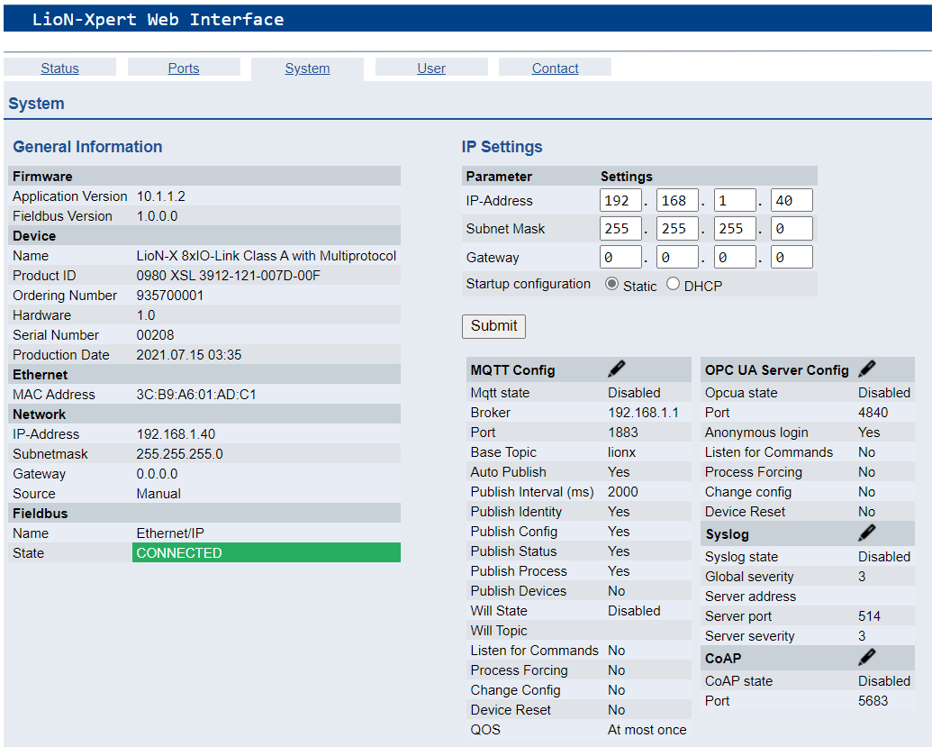
- We can check the status of the EtherNet/IP scanner by looking at the status byte. In this case the status byte was mapped to #20060 to #20067. The presence of any 1 indicates an error of some sort.
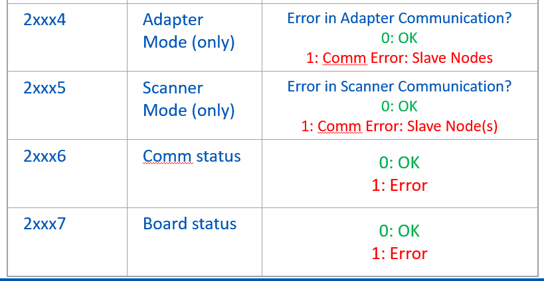

- Next, connect a device to one of the ports on the Lumberg LioN-X device.

- For this testing a Banner multicolor indicator was used. When it is connected to the port we again get the product data about it displayed on the web interface:
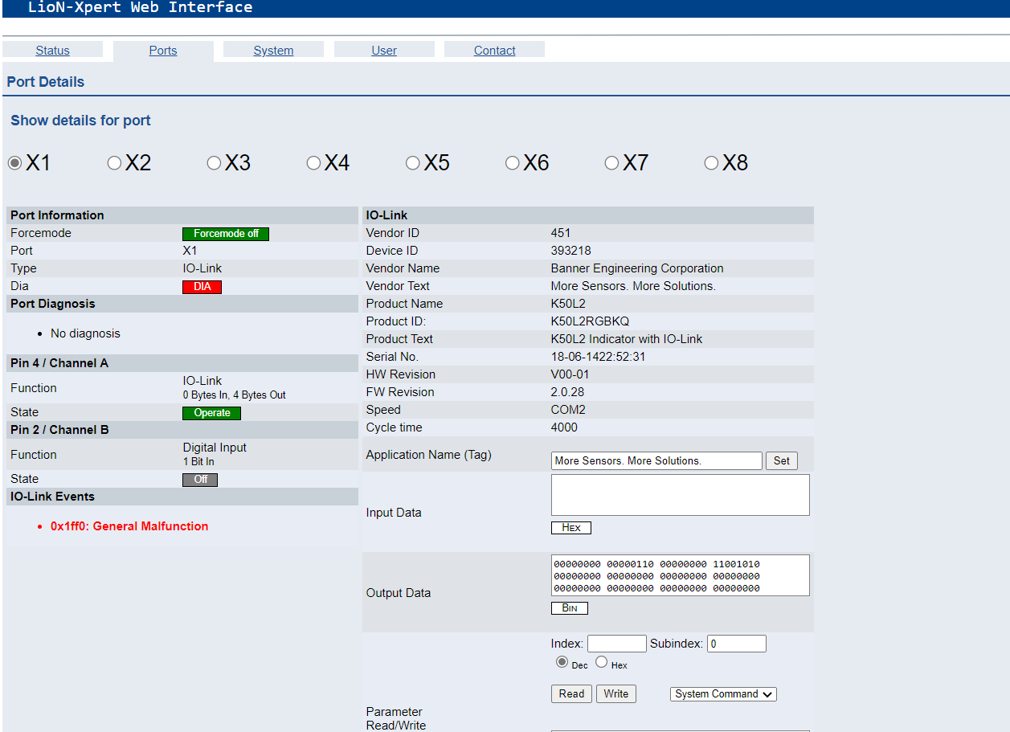

- The indicator can be controlled by sending outputs from the robot controller.
  - To send data data to the device at Port 1:
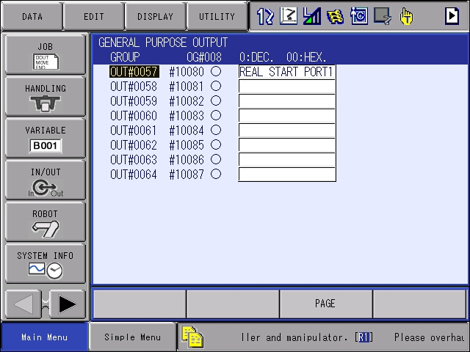

- A second device was test. The indicator was removed from port 1 and a Banner Sensor was attached as shown:
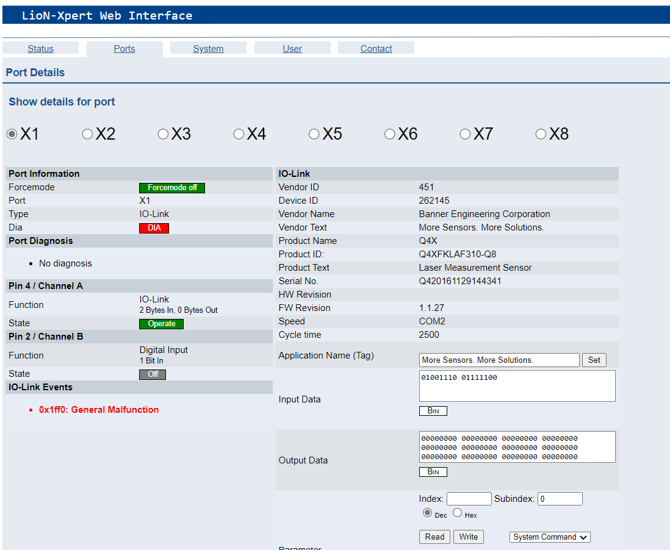

- This same screen shows the received data in the bottom right zoomed in here:

- On the robot controller we see this data here:
  - These screen shots were not taken at the same time, so the data does not correspond. The purpose here is to show the addresses where the data can be found on the robot controller.
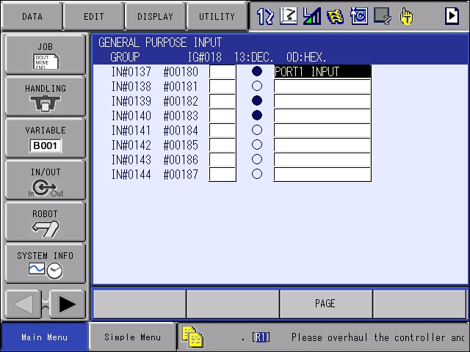
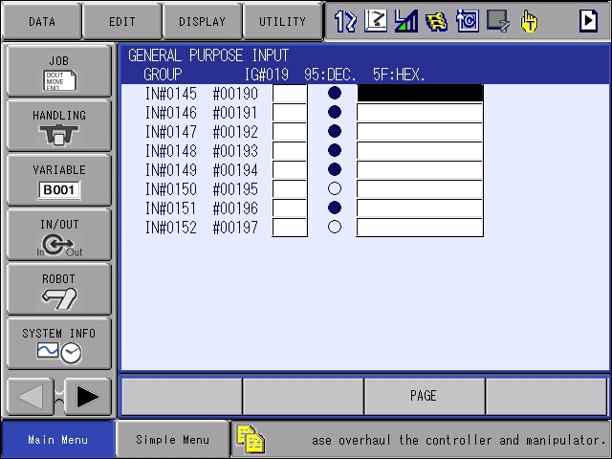

Conclusion:
- Additional testing and I/O allocation may be required once devices are selected to be connected to the LioN-X device.
- The approach here could be applied to other devices as it’s a simple EtherNet/IP connection without Connection data. That’s the caveat required to make the solution work.
Notes:
At the time of this publishing only the three Lumberg IO-Link blocks below will work with our robot controllers,
- 0980 XSL 3912-121-007D-00F (8 x IO-Link Class A, Multiprotocol)
- 0980 LSL 3111-121-0006-002 (8 x IO-Link Class A, EtherNet/IP)
- 0980 LSL 3110-121-0006-002 (4 x IO-Link Class A + 8 x DI, EtherNet/IP)
Lumberg has others that will not work!

