**Change IP address of Simple Connect devices:**

From the pendant menu, touch [Setup] > [Simple Connect]. (You will have to scroll right. It is the last button in the menu.)

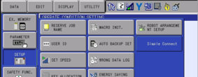

For each device in the [My Network] list, you should select the device and then touch [Device Details].

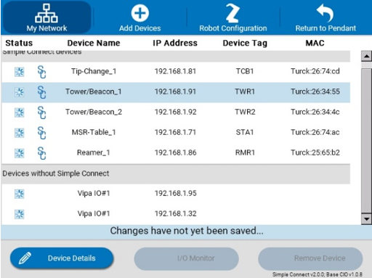

On the Device Details screen, you can press SELECT on the pendant to modify the IP Address field.

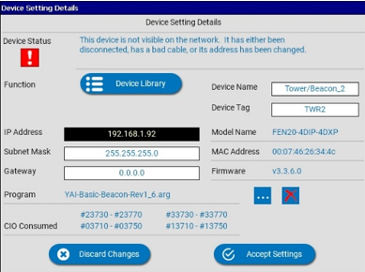

After modifying the IP address, touch [Accept Settings]. Repeat for each device in the list.

When you are done, touch [Return to Pendant] in the top right.



It will then prompt you to save the changes.

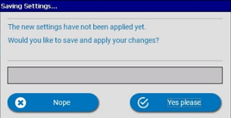

It will take a minute or two to update the device settings for everything in the work cell. When it is complete, it will ask you to reboot the robot controller.