

PalletSolver - Adaptation
Engineering Design Specifications

Document no: MXxXX-EDS
DocUMENT ver.: 1.4.2
DATE: 11/10/2020

Distribution is subject to copyright.

Disclaimers
The information contained in this document is the proprietary and exclusive property of Yaskawa Motoman Robotics except as otherwise indicated. No part of this document, in whole or in part, may be reproduced, stored, transmitted, or used for design purposes without the prior written permission of Yaskawa Motoman Robotics.
The information contained in this document is subject to change without notice.
The information in this document is provided for informational purposes only. Yaskawa Motoman Robotics specifically disclaims all warranties, express or limited, including, but not limited, to the implied warranties of merchantability and fitness for a particular purpose, except as provided for in a separate software license agreement.
Privacy Information
This document may contain information of a sensitive nature. This information should not be given to persons other than those who are involved in the PalletSolver project or who will become involved during the lifecycle
History
Revisions and Reviews
Version | Person(s) | Description | Date
1.0.0 | Eric Marcil | Original version | 07/25/2016
1.1.0 | Eric Marcil | Added 2.4 Prorated Rz ViaPoints adaptation | 08/03/2016
1.2.0 | Eric Marcil | Added section 2.5 to 2.9 | 04/06/2017
1.3.0 | Eric Marcil | Reviewed section 2.5 and added section 2.10 to 2.14 | 07/30/2019
1.3.1 | Eric Marcil | Correction on Left Side Pick | 08/19/2019
1.4.0 | Eric Marcil | Added section 2.15 and 2.16 | 11/12/2019
1.4.1 | Eric Marcil | Added extra modification to section 2.3 | 10/30/2020
1.4.2 | Eric Marcil | Added section 2.17 | 11/10/2020

Document Approval
Motoman:
Yaskawa America, Inc.
Motoman Robotics Division
100 Automation Way
Miamisburg, OH 45342
937-847-6200
Customer:
Company Name
Address
City, State, Zip
Phone

Approvals:
# | Name | Title | Organization/Dept.
1
2
3
4
5
6

# | Signature | Date
1
2
3
4
5
6

Table of Contents
1 Overview 1
1.1 Current System Adaptation 1
1.2 Scope 1
2 Adaptations 2
2.1 Single infeed to alternating build stations 2
2.1.1 Overlapping Infeed User Frame 3
2.1.2 Alternating Between Build Station 4
2.1.3 Linking Infeed States 7
2.2 Single infeed with mixed products to multiple build stations 9
2.2.1 Overlapping Infeeds 9
2.2.2 Switching build station based on SKU 9
2.3 Multiple infeeds with same product to single build station 10
2.3.1 Jobs 11
2.3.2 Concurrent I/O 15
2.3.3 Limitation 16
2.3.4 Infeed 2 Mirror of Infeed 1 17
2.4 Prorated Rz ViaPoint 19
2.4.1 Jobs 22
2.5 Side Pick on Infeed 27
2.5.1 Jobs 32
2.6 Diagonal Station Approach and Departure 41
2.6.1 Jobs 41
2.7 Start Next Build without Pallet 46
2.7.1 Jobs 46
2.8 Forcing Boxes to Reject 50
2.9 Improve Look Ahead Timing 51
2.10 Disabling the SYSTEM_PLC_MESSAGING job 52
2.11 Using EtherNet/IP Explicit Messaging 53
2.11.1 Assign Pattern 53
2.12 Prevent Moving Over Placed Boxes 55
2.13 Increased Number of Dispensers and Dynamic Selection 57
2.14 Using Multiple Grippers 59
2.15 Product Mass Compensation 64
2.15.1 Mapping based on product properties 65
2.15.2 Multi-drop of Product 66
2.16 External Pattern Management 67
2.17 Option to Skip Slipsheet Layers 71
2.17.1 Jobs 71

Index of Figures
Figure 1: Single infeed to alternating build stations 2
Figure 2: Single infeed with mixed products to multiple build stations 9
Figure 3: Multiple infeeds with same product to single build station 10
Figure 4: Multiple infeeds to single build restriction example 1 10
Figure 5: Multiple infeeds to single build restriction example 2 11
Figure 6: Infeed 2 Mirror of Infeed 1 alternative solution 16
Figure 7: Adding via point example 18
Figure 8: Gripper center definition 19
Figure 9: Prorated Rz example 19
Figure 10: Example of issue with wrong direction of rotation 20
Figure 11: Picking boxes on their side, turning them 90 deg. To put them on the pallet 26
Figure 12: Incorrect infeed representation in the PalletSolver-PC 26
Figure 13: Side pick Gripper Side and Box Alignment arguments 27
Figure 14: Side pick Y-Approach and Conveyor Width arguments 28
Figure 15: Side Pick Gripper TCP Minimum Height argument 28
Figure 16: Out of Reach Infeed Aircut 2 Issue 37
Figure 17: PLAN_ADJUST_POSITION_RADIUS arguments 38

Overview
This document defines modifications required to adapt the PalletSolver product to specific cases.

Current System Adaptation
The following adaptation are currently covered:
- Single infeed to alternating build stations;
- Single infeed with mixed products to multiple build stations;
- Multiple infeeds with same product to single build station;
- Prorated Rz ViaPoint
- Picking boxes from their side on the infeed
- Diagonal Station Approach and Departure
- Start Next Build without Pallet
- Forcing Boxes to Reject
- Improve Look Ahead Timing

Scope
These adaptations are work around to using the current version of PalletSolver capability to partially address some special cases that would normally be considered outside the scope of PalletSolver. They may not be perfect solutions and may not work in all given situation.

Adaptations

Single infeed to alternating build stations
The configuration is to have a single infeed system go to multiple build stations. The system starts with one build station and changes to the next build station when the first build station is completed. This allows time to remove a completed build and reload a new pallet without stopping palletizing the product.
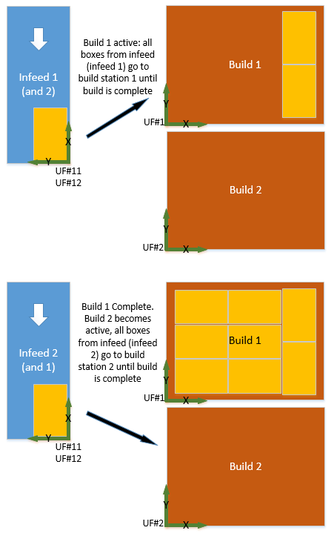
Figure 1: Single infeed to alternating build stations

In order to do this, even though there is only one physical infeed conveyor, the cell is actually defined with multiple infeeds that will all overlap on top of the same physical conveyor. The sequencing mode is then set to PLC controlled and the pick ready signal is only sent to the I/O corresponding to the infeed match the current build station.

Overlapping Infeed User Frame
A call to the job USER_INFEED_SETUP is added to the USER_CONTROL_TASK job before the loop or the !PALLETSOLVER_MASTER_JOB! job after the call to the job INIT_STATION_CLOCK_ORDER. The USER_INFEED_SETUP copies the Infeed1 user frame and data to the other infeed to make sure that they overlap properly.
/JOB
//NAME USER_INFEED_SETUP
//POS
///NPOS 0,0,0,3,0,0
///USER 1
///TOOL 0
///POSTYPE USER
///RECTAN
///RCONF 1,0,0,0,0,0,0,0,0,0,0,0,0,0,0,0,0,0,0,0,0,0,0,0
P00750=0.000,0.000,0.000,0.0000,0.0000,0.0000
///POSTYPE BASE
P00950=348.586,-324.540,-294.380,-179.7850,0.1413,0.5534
P00951=348.586,-324.540,-294.380,-179.7850,0.1413,0.5534
//ALIAS
///GVARS 3,4,0,3,0,5,0,0
B966 FeedCv1_Clock#
B967 FeedCv2_Clock#
I701 Grip_TCP#
I966 FeedCv1UfZ0toBF
I967 FeedCv2UfZ0toBF
R966 FeedCv1_UFangle
R967 FeedCv2_UFangle
P700 Home_User_Set
P750 UF_Origin_Copy
P966 FeedCv1_UForgBF
P967 FeedCv2_UForgBF
///LVARS 1,0,0,0,0,0,0,0
LB000 grip_tcp#
//INST
///DATE 2015/04/30 12:00
///COMM PalletSolver Ver. 1.2.0.0
///ATTR SC,RW,CJ
///GROUP1 RB1
///LVARS 1,0,0,0,0,0,0,0
NOP
'
'******************************
' 1 INFEED to 2 BUILD
' Adaptation to overlap
' infeed station in the intent
' of having one infeed supply
' 2 build station
'******************************
' Copy user frame 11 to the
' overlapping user frame
SET grip_tcp# Grip_TCP#
CNVRT UF_Origin_Copy Home_User_Set UF#(11) TL#(grip_tcp#)
SUB UF_Origin_Copy UF_Origin_Copy
CALL JOB:PLAN_MAKE_USER_FRAME ARGF12 ARGF750
'
' Set the clocking variable
' of build station 1 to the
' overlapping stations
SET FeedCv2_Clock# FeedCv1_Clock#
SET FeedCv2UfZ0toBF FeedCv1UfZ0toBF
SET FeedCv2_UFangle FeedCv1_UFangle
SET FeedCv2_UForgBF FeedCv1_UForgBF
END

Alternating Between Build Station
To alternate between build stations, the sequencing mode is set to PLC mode so that the infeed corresponding to the build station currently being built is explicitly selected. The algorithm select an operating side and check if that side is still valid to build on. A side becomes invalid if the build is done (complete), locked, unassigned or without a pallet. If the operating side is valid, then the build continues on that side. When a side is invalid, the algorithm changes the operating side and then check if that side is valid for building.
Below is an implementation example added to the USER_CONTROL_TASK job:
/JOB
//NAME USER_CONTROL_TASK
//POS
///NPOS 0,0,0,0,0,0
//ALIAS
///IGH 1
0254 uNxtNfedIdEchob1
///OGH 1
0254 uNxt_infeedID_b1
///GVARS 2,0,0,0,0,0,0,0
B000 OperatingSide
B1000 Schedule_Mode
///LVARS 3,12,0,0,0,0,0,0
LB000 InputValue
LB001 BuildStation
LB002 InfeedStation
LI000 User_Loop_Delay
LI001 BuildIO_Offset
LI002 InfeedIO_Offset
LI003 Build_Done_IN#
LI004 Assigned_IN#
LI005 Lock_IN#
LI006 PaletPresent_IN#
LI007 PickReady_OT#
LI008 PickReady_IN#
LI009 PickReq_IN#
LI010 Qty_Needed_adr
LI011 NeededBoxes
//INST
///DATE 2015/12/22 11:30
///COMM PalletSolver Ver. 1.3.0.3
///ATTR SC,RW,CJ
///LVARS 3,12,0,0,0,0,0,0
NOP
SET User_Loop_Delay 10
'
' Sequencing Mode
SET Schedule_Mode 4
'
*UserLoop
'
' Algorithm to complete one build
' before moving to the next one
*Sequence
' Set station for selected side
IFTHEN OperatingSide<1 ORIF OperatingSide>2
SET OperatingSide 1
ENDIF
SET BuildStation OperatingSide
SET BuildIO_Offset EXPRESS ( BuildStation - 1 ) * 8
SET InfeedIO_Offset EXPRESS 108 + ( BuildStation - 1 ) * 25
SET InfeedStation B[InfeedIO_Offset]
DIN InputValue IGH#(uNxtNfedIdEchob1)
IFTHEN InputValue<>0
DOUT OGH#(uNxt_infeedID_b1) 0
JUMP *SetReady
ENDIF
'
' Check if we can continue on
' same side/station
SET InfeedIO_Offset EXPRESS ( InfeedStation - 1 ) * 16
SET Build_Done_IN# EXPRESS 1057 + BuildIO_Offset
SET Assigned_IN# EXPRESS 1058 + BuildIO_Offset
SET Lock_IN# EXPRESS 1059 + BuildIO_Offset
SET PaletPresent_IN# EXPRESS 262 + BuildIO_Offset
'
JUMP *Switch IF IN#(Build_Done_IN#)=ON
JUMP *Switch IF IN#(Lock_IN#)=ON
JUMP *Switch IF IN#(Assigned_IN#)=OFF
JUMP *Switch IF IN#(PaletPresent_IN#)=OFF
' Valid OperatingSide
DOUT OGH#(uNxt_infeedID_b1) InfeedStation
JUMP *SetReady
'
*Switch
' Make sure infeed ready is off
SET PickReady_OT# EXPRESS 1121 + InfeedIO_Offset
DOUT OT#(PickReady_OT#) OFF
DOUT OGH#(uNxt_infeedID_b1) 0
'
INC OperatingSide
JUMP *Seq_Done
'
*SetReady
' Check if infeed ready
SET PickReq_IN# EXPRESS 1121 + InfeedIO_Offset
SET PickReady_IN# EXPRESS 321 + InfeedIO_Offset
SET PickReady_OT# EXPRESS 1121 + InfeedIO_Offset
IFTHEN IN#(PickReq_IN#)=OFF
' No request turn off pick ready
DOUT OT#(PickReady_OT#) OFF
DOUT OT#(7) OFF
DOUT OT#(8) OFF
ELSEIF IN#(PickReady_IN#)=OFF
' Check if conveyor boxes
' matches request
SET Qty_Needed_adr EXPRESS 123 + ( InfeedStation - 1 ) * 25
SET NeededBoxes B[Qty_Needed_adr]
SWITCH NeededBoxes CASE 0
DOUT OT#(PickReady_OT#) ON
CASE 1
DOUT OT#(7) ON
IFTHEN IN#(7)=ON ANDIF IN#(8)=OFF
DOUT OT#(PickReady_OT#) ON
ELSEIF IN#(7)=ON ANDIF IN#(8)=ON
SETUALM 8010 "Too many boxes on conveyor" 0
PAUSE
ENDIF
CASE 2
DOUT OT#(7) ON
DOUT OT#(8) ON
IFTHEN IN#(7)=ON ANDIF IN#(8)=ON
DOUT OT#(PickReady_OT#) ON
ENDIF
DEFAULT
SETUALM 8011 "Requested boxes exceed capacity" 0
PAUSE
ENDSWITCH
ENDIF
*Seq_Done
'
TIMER T=User_Loop_Delay
JUMP *UserLoop
END

Linking Infeed States
Since on there is only one physical conveyor corresponding to multiple infeeds, some of the signals of the infeed need to be replicated for all infeeds. For example, if the infeed 1 is locked, there is probably a problem with the conveyor, so infeed 2 which is also overlapping the same conveyor should also be automatically locked.
The following are modifications to the concurrent I/O to synchronize the signals for Lock Request, Unlock Request and Purge of the infeed 1 and infeed 2.

// Infeed 1 and 2 Signal Overlap
// Lock Request
STR #20432 // Infeed 1 LockReq External input
OR #20452 // Infeed 2 LockReq External input
AND #10273 // PLC control
STR #27432 // Infeed 1 LockReq Network input
OR #27452 // Infeed 2 LockReq Network input
OR #11412 // Infeed 1 LockReq Output
OR #11432 // Infeed 2 LockReq Output
AND-NOT #10273 // Robot control (not PLC control)
OR-STR
STR-NOT #10412 // Infeed 1 Not Locked
OR-NOT #10432 // Infeed 2 Not Locked
AND #71350 // Latch
OR-STR
OUT #71350 // Infeed 1 & 2 LockReq

STR #71350 // infeed 1 & 2 LockReq
OUT #00412 // infeed 1 LockReq

STR #71350 // infeed 1 & 2 LockReq
OUT #00432 // infeed 2 LockReq

// Unlock Request
STR #20433 // Infeed 1 UnlockReq External input
OR #20453 // Infeed 2 UnlockReq External input
AND #10273 // PLC control
STR #27433 // Infeed 1 UnlockReq Network input
OR #27453 // Infeed 2 UnlockReq Network input
OR #11413 // Infeed 1 UnlockReq Output
OR #11433 // Infeed 2 UnlockReq Output
AND-NOT #10273 // Robot control (not PLC control)
OR-STR
STR #10412 // Infeed 1 Locked
OR #10432 // Infeed 2 Locked
AND #71351 // Latch
OR-STR
OUT #71351 // infeed 1 & 2 UnlockReq

STR #71351 // infeed 1 & 2 UnlockReq
OUT #00413 // infeed 1 UnlockReq

STR #71351 // infeed 1 & 2 UnlockReq
OUT #00433 // infeed 2 UnlockReq

// Purge
STR #20431 // Infeed 1 Purge External input
OR #20451 // Infeed 2 Purge External input
AND #10273 // PLC control
STR #27431 // Infeed 1 Purge Network input
OR #27451 // Infeed 2 Purge Network input
OR #11411 // Infeed 1 Purge Output
OR #11431 // Infeed 2 Purge Output
AND-NOT #10273 // Robot control (not PLC control)
OR-STR
STR-NOT #10414 // Infeed 1 Purge Req Ack
AND-NOT #10434 // Infeed 2 Purge Req Ack
AND #71352 // Latch
OR-STR
OUT #71352 // infeed 1 & 2 purge

STR #71352 // infeed 1 & 2 purge
OUT #00411 // infeed 1 purge

STR #71352 // infeed 1 & 2 purge
OUT #00431 // infeed 2 purge

Single infeed with mixed products to multiple build stations
This adaptation is for the case where mixed products are coming in the same conveyor and need to be palletized to separate to multiple build stations (on product per build).
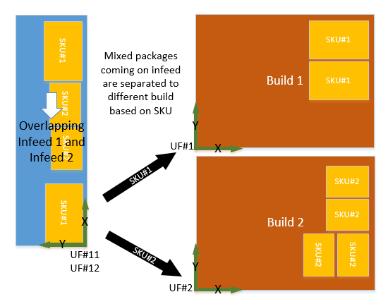
Figure 2: Single infeed with mixed products to multiple build stations
In order to do this, even though there is only one physical infeed conveyor, the cell is actually defined with multiple infeeds that will all overlap on top of the same physical conveyor. The pick ready signal is only sent to the I/O corresponding to the infeed matching the SKU currently at the end of the conveyor.

Overlapping Infeeds
For overlapping infeeds that same approach as for the “Single infeed to alternating build stations”. So please refer to sections: 2.1.1 Overlapping Infeed User Frame and 2.1.3 Linking Infeed States.

Switching build station based on SKU
The switching between build stations is simply done by setting the Pick Ready signal (in the USER_CONTROL_TASK or by the PLC program) of the infeed associated with the build station where the package should go to, based on the SKU of the package currently at the end of the conveyor.

Multiple infeeds with same product to single build station
The adaptation is enables PalletSolver to pick the same product from multiple infeed conveyer and combine them on the same build station. Technically, PalletSolver doesn’t support picking from multiple infeed, the outputted pattern file can only hold pick information for a single infeed. To the multiple infeed configuration is done on the online side (DX controller). In PalletSolver DX, the multiple physical infeeds are defined as normal during setup, then during operation that infeed 1 data will be copied over to the other infeeds and the robot will pick from whichever infeed sends the “Pick Ready” signal first.
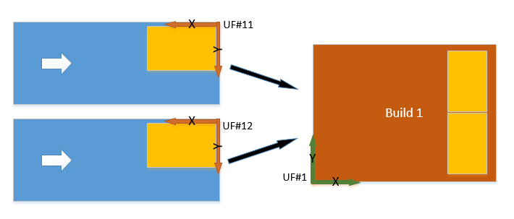
Figure 3: Multiple infeeds with same product to single build station
Since the pick information (relative coordinate) is the same for the multiple infeed, it is important that all infeeds have the same configuration and that their respective user frame be taught in the same relative position.
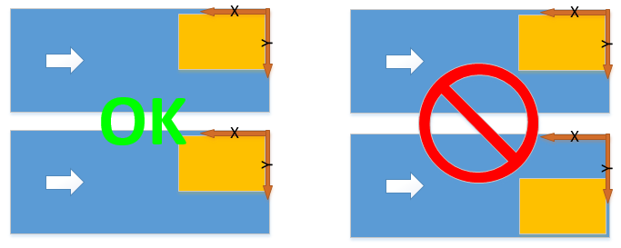
Figure 4: Multiple infeeds to single build restriction example 1
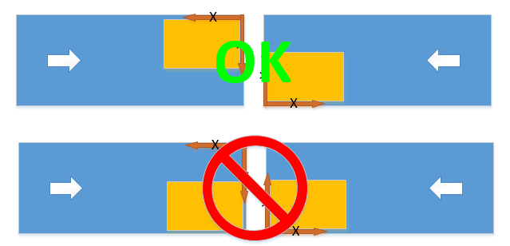
Figure 5: Multiple infeeds to single build restriction example 2

Jobs
This adaptation requires PalletSolver ver 1.3.0.21 or later.
In the “PALLETSOLVER_PLANNER” job, after the call to PLAN_UPDATE_STATION add a call to the USER_2INFEED_TO_1BUILD job.
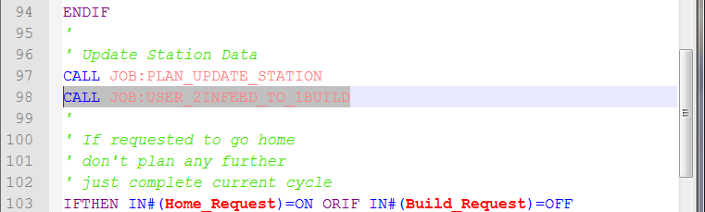
The PLAN_UPDATE_STATION is modified to update only the infeed 1:
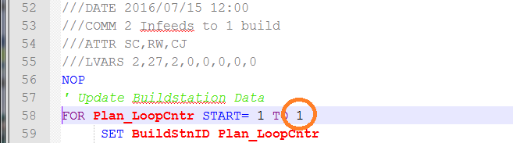

And both infeed 1 and 2 PickReady is checked to be off before setting the quantity and pick request for the next cycle:
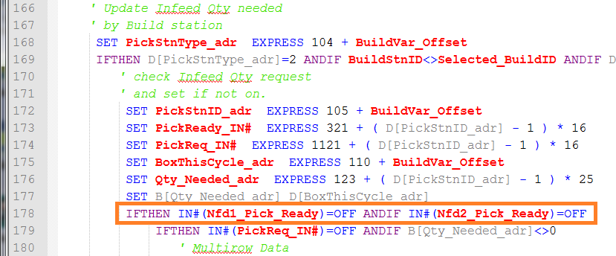
In the PLAN_PICK_BOX.JBI, remove the second condition on the SETUALM 8025 segment since when the Selected_InfID = 2, it will not match the planned infeed (D[PickStnID_adr]) which 1.
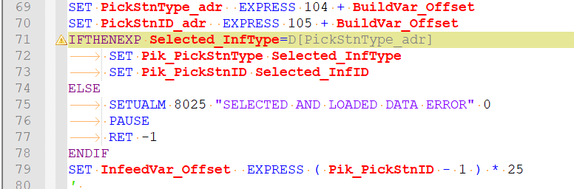

The USER_2INFEED_TO_1BUILD job copies the infeed 1 data over to the infeed 2 data:
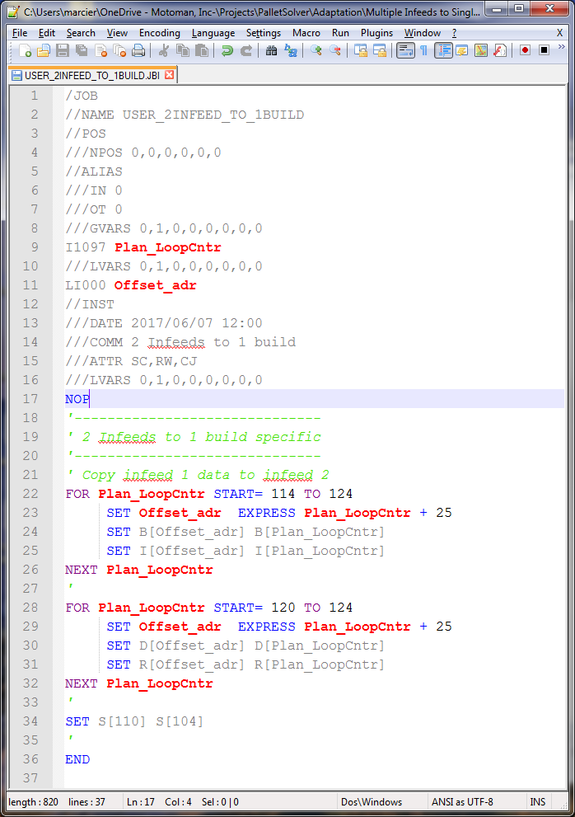
The MOTION_PICK_BOX_*** also needs to be modified so that when the 2nd infeed is being picked from the values for the 1st infeed are updated properly. To do so, instead of referencing the “Pik_PickStnID” variable, the infeed is referenced using the infeed defined by the build station pattern. Below is an example for the MOTION_PICK_BOX_VAC.
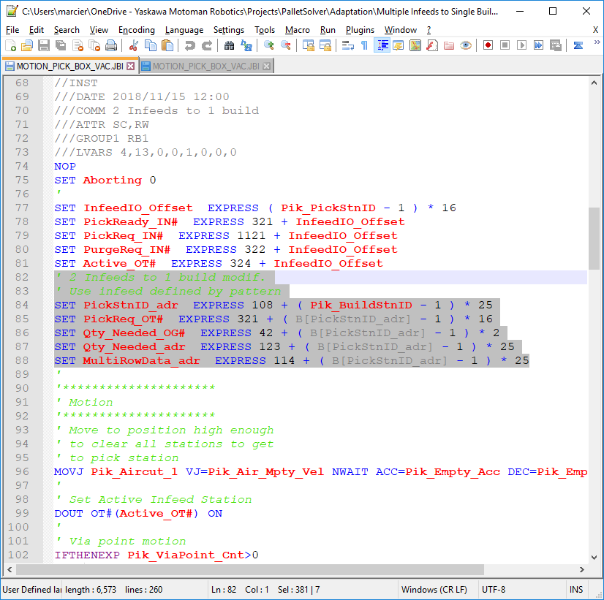
Same thing applies for the MOTION_PLACE_ADJUST_COUNTERS where the reference to the “Plc_PickStnID” variable is replaced by the infeed defined by the build station pattern.
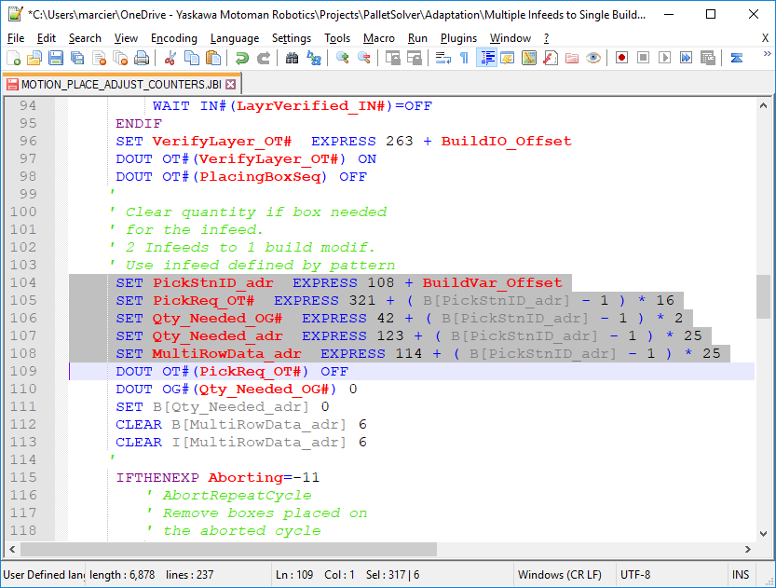

Concurrent I/O
The concurrent I/O needs to be modified to link some of the infeed 2 I/O signals to the infeed 1 signals. The signal to link are the Pick Request (IN#337) and the Number of Boxes Needed (OG#44). Below are the changes to apply:
// Link infeed 2 Pick Request to infeed 1 Pick Request
STR #30430
OUT #30450
// Link infeed 2 Needed Box to infeed 1 Needed Box
GSTR #30440
GOUT #30460

Limitation
There will be restriction on the Offline side:
- Both infeeds need to be configure the same way: same box, same alignment, same box orientation…
- Interference zone should be defined as the compound restriction of both physical infeeds since we are only validating for one infeed but physically the robot could go at either one.
- Pattern would be generated for infeed 1 to build 1.
Online side:
- The data for infeed 1 will be duplicate to infeed 2. So box quantity for the next cycle is set on both infeed and the user algorithm needs to decide which infeed will be next and send the Pick Ready signal to the corresponding infeed.
Below is an example of a USER_CONTROL_TASK, where input 1 and input 2 are product sensor mounted on infeed 1 and infeed 2 respectively:
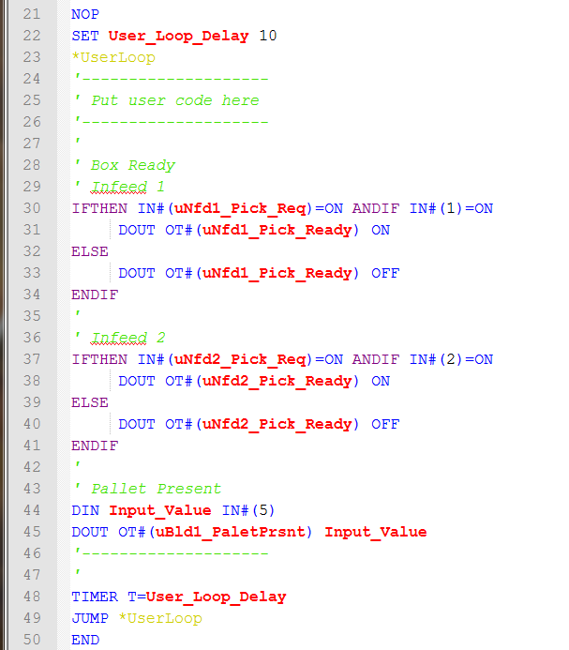

Infeed 2 Mirror of Infeed 1
In the case where Infeed 2 is a mirror of infeed 1. Define the user frame of infeed 2 at the end of the conveyor but with the X-axis going with the flow of product. Then in the USER_2INFEED_TO_1BUILD job we dynamically recalculate the infeed 2 frame offset to move it back by the length of the boxes current on the conveyor.
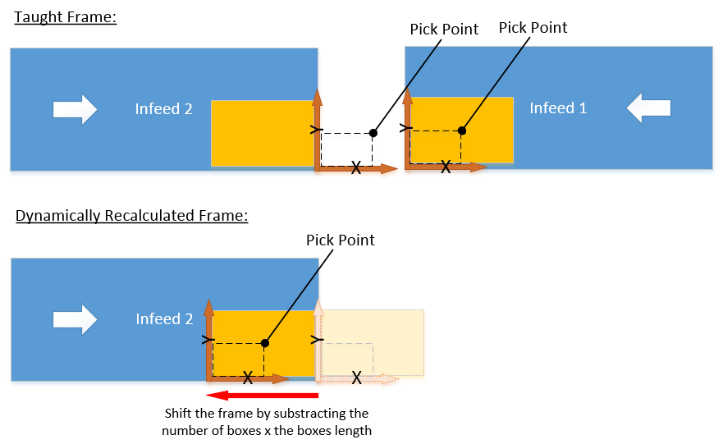
Figure 6: Infeed 2 Mirror of Infeed 1 alternative solution
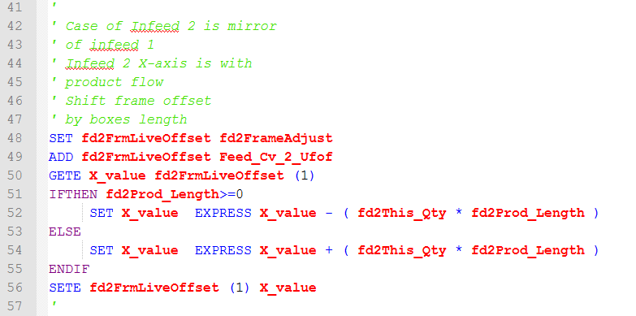
Note: There is an extra check to see if the product length (fd2Prod_Length) is negative or positive. It should be positive but during test, the value was negative. It seems to be cause by the MotoPlus application pattern importer. This should be investigated and fixed for future release.

Prorated Rz ViaPoint
The standard robot motion between stations consist of radial motion. In some irregular shaped cell layout, this may cause collision with fencing or some other components in the cell. Via-points can be define to modify the path of the robot between stations.
Figure 7: Adding via point example
The standard solution uses a user set fixed Rz for the via-points. This adaption prorates the Rz value to optimize the T-axis motion. Unfortunately, this calculation can only take place in the Motion task and causes a small pause at the AirCut1 position which is evaluated to add about 0.30 sec per cycle. Still, depending on the cell configuration this small pause may add less overall time to the cycle than having a fixed Rz position.
When a via-point is define between stations, the robot path will be modified so that the center of the gripper passes by the via-point X, Y coordinates. The Z coordinate will be the same or above the define via-point.
Up to 6 via-points can be defined. Via-points are considered defined when the X or Y value of a via-point is none zero. Via points are define the robot base frame (X, Y, Z) and set in the USER_ADJUSTMENT job.
For calculation purpose, all points are converted to the position of the center of the gripper in the Base frame. The center of gripper is based on the gripper X/Y interferences defined in the PalletSolver-PC application and transferred to the online when a new pattern file is assigned.
Figure 8: Gripper center definition
The gripper orientation is prorated according to the angular position of the via-point between the start position (current position) and end position (target position).
Figure 9: Prorated Rz example
The difficulty arises in the control of the direction of rotation of the gripper. When setting a target position in base frame, the controller will select the shortest path to that position from the current position. More specifically it selects the inverse kinematic solution within the robot soft-limits the motor motion minimization to reach. So when adding intermediate via points, it important to insure that the via point’s gripper rotation is the same as the target rotation.
In the previous example, the short rotation is assumed, but if the short rotation (+90°) solution to the target position is slightly outside of the soft-limits, the long rotation (-270°) needs to be used, as in the case below.
Figure 10: Example of issue with wrong direction of rotation
When adding a via-point at Rz=-53.8°, the short rotation (+53.8°) solution is within the soft-limits. This results in a +53.8° rotation to the via-point followed by a -323.8° rotation to the target destination. This introduces unnecessary rotation and will increase cycle time.
In reality, the via-point Rz should be at Rz=+107.6. But by simply looking at the position in Base frame, it is not possible to know in which direction the rotation should be. So the only way to confirm the direction of rotation, is to convert the position in pulses and determine the direction of rotation between the current position and the target position by looking at the T-axis pulse values.
Unfortunately, the DX controller doesn’t allow to easily convert position from base frame to pulse. The only solution is to wait at the time of the motion:
- Get the command pulse position of the current position;
- Initiate the motion toward the target position but interrupt it;
- Retrieve the command pulse position of the target position;
- Analyze the T-axis values of current and target positions to determine the direction of rotation.
- Create via-point according to the desired rotation.
So this calculation needs to take place in the MOTION subtask and causes an interruption of the motion at the AirCut1 position.
Test where conducted where a via-point was places about midway of the arc between the aircut1 and aircut2 so that the path change would be minimal. Cycle time measurement over 9 layers of 5 boxes (single pick) gave an average increase of about 0.29 second per cycle. So about 0.145 second at each AirCut1 position (pick and place).

Jobs
This adaptation requires PalletSolver ver 1.3.1.5 or later.
All the new calculations are done in the job: MOTION_CALC_VIA_POINTS.JBI
/JOB
//NAME MOTION_CALC_VIA_POINTS
//POS
///NPOS 0,0,0,0,0,0
//ALIAS
///IN 1
0993 uOperating
///GVARS 4,1,1,2,0,0,0,0
B812 Pik_Clock#
B813 LastPlc_Clock#
B862 LastPik_Clock#
B863 Plc_Clock#
I701 Grip_TCP#
D781 T_PulseRatio
R750 Gripper_Center_X
R751 Gripper_Center_Y
///LVARS 1,7,9,4,0,3,0,0
LB000 IsPlace
LI000 CurrentClock
LI001 TargetClock
LI002 TargetPos_adr
LI003 ViaPoint_Cnt_adr
LI004 Via_adr
LI005 ViaIndex
LI006 ViaData_adr
LD000 X_value
LD001 Y_value
LD002 CurrentTpulse
LD003 TargetTpulse
LD004 ViaTpulse
LD005 CurrentRz
LD006 TargetRz
LD007 RzDifference
LD008 ViaRz
LR000 CurrentAngle
LR001 TargetAngle
LR002 ViaAngle
LR003 ATAN_Ratio
LP000 CurrentPos
LP001 TargetPos
LP002 ToolShift
//ARGINFO
///ARGTYPE B,,,,,,,
///COMMENT
IsPlace

//INST
///DATE 2016/08/03 12:00
///COMM PalletSolver Prorated Rz
///ATTR SC,RW
///GROUP1 RB1
///LVARS 1,7,9,4,0,3,0,0
NOP
GETARG IsPlace IARG#(1)
'
' Set variables addresses
IFTHEN IsPlace=0
SET CurrentClock LastPlc_Clock#
SET TargetClock Pik_Clock#
SET ViaPoint_Cnt_adr 816
SET TargetPos_adr 801
ELSEIF IsPlace=1
SET CurrentClock LastPik_Clock#
SET TargetClock Plc_Clock#
SET ViaPoint_Cnt_adr 844
SET TargetPos_adr 851
ELSE
SETUALM 8023 "INVALID ARGUMENT"
PAUSE
RET -1
ENDIF
'
' Calculate Tcp to Center offset
GETS ToolShift $PX001
CNVRT ToolShift ToolShift BF TL#(Grip_TCP#)
SUB ToolShift ToolShift
SET X_value EXPRESS Gripper_Center_X * 1000
SET Y_value EXPRESS Gripper_Center_Y * 1000
SETE ToolShift (1) X_value
SETE ToolShift (2) Y_value
INVMAT ToolShift ToolShift
'
' Convert points to base frame
' and gripper tool
GETS CurrentPos $PX006
GETE CurrentTpulse CurrentPos (6)
CNVRT CurrentPos CurrentPos BF TL#(Grip_TCP#)
MULMAT CurrentPos CurrentPos ToolShift
GETE CurrentRz CurrentPos (6)
' Get target position in pulse
MOVL P[TargetPos_adr] V=10.0 UNTIL IN#(uOperating)=ON
GETS TargetPos $PX006
GETE TargetTpulse TargetPos (6)
CNVRT TargetPos TargetPos BF TL#(Grip_TCP#)
MULMAT TargetPos TargetPos ToolShift
GETE TargetRz TargetPos (6)
'
' Get angles around the robot
GETE X_value CurrentPos (1)
GETE Y_value CurrentPos (2)
IFTHEN X_value<>0
SET ATAN_Ratio EXPRESS Y_value / ( X_value )
ATAN CurrentAngle ATAN_Ratio
' Adjust ATAN calculated value
' based on quadrant.
IFTHEN X_value<0 ANDIF Y_value>0
ADD CurrentAngle 180
ELSEIF X_value<0 ANDIF Y_value<0
SUB CurrentAngle 180
ENDIF
ELSEIF Y_value<0
SET CurrentAngle -90
ELSEIF Y_value>0
SET CurrentAngle 90
ELSEIF Y_value=0
SET CurrentAngle 0
ENDIF
'
GETE X_value TargetPos (1)
GETE Y_value TargetPos (2)
IFTHEN X_value<>0
SET ATAN_Ratio EXPRESS Y_value / ( X_value )
ATAN TargetAngle ATAN_Ratio
' Adjust ATAN calculated value
' based on quadrant.
IFTHEN X_value<0 ANDIF Y_value>0
ADD TargetAngle 180
ELSEIF X_value<0 ANDIF Y_value<0
SUB TargetAngle 180
ENDIF
ELSEIF Y_value<0
SET TargetAngle -90
ELSEIF Y_value>0
SET TargetAngle 90
ELSEIF Y_value=0
SET TargetAngle 0
ENDIF
'
' Calculate Rz difference based
' on T rotation direction
SET RzDifference EXPRESS TargetRz - CurrentRz
IFTHEN CurrentTpulse<TargetTpulse ANDIF RzDifference<0
ADD RzDifference 3600000
ELSEIF CurrentTpulse>TargetTpulse ANDIF RzDifference>0
SUB RzDifference 3600000
ENDIF
'
' Calculate each Via Point
SET ViaIndex 0
SET Via_adr ViaPoint_Cnt_adr
*ViaLoop
SET P[Via_adr] TargetPos
' Set Rz
SET ViaData_adr I[Via_adr]
SET ViaAngle R[ViaData_adr]
IFTHEN ViaAngle>CurrentAngle ANDIF ViaAngle>TargetAngle
SET ViaRz CurrentRz
ELSEIF ViaAngle<CurrentAngle ANDIF ViaAngle<TargetAngle
SET ViaRz CurrentRz
ELSE
SET ViaRz EXPRESS CurrentRz + RzDifference * ( ViaAngle - CurrentAngle ) / ( TargetAngle - CurrentAngle )
ENDIF
SETE P[Via_adr] (6) ViaRz
' Set X, Y
GETE X_value P[ViaData_adr] (1)
GETE Y_value P[ViaData_adr] (2)
SETE P[Via_adr] (1) X_value
SETE P[Via_adr] (2) Y_value
MULMAT P[Via_adr] P[Via_adr] ToolShift
'
' increment indexes
INC ViaIndex
INC Via_adr
JUMP *ViaLoop IF ViaIndex<B[ViaPoint_Cnt_adr]
RET 0
END

The job is then called from the various MOTION_PICK and MOTION_PLACE jobs instead of simply adjusting the Z height. For example, for the MOTION_PICK_BOX_VAC the changes look as follows:
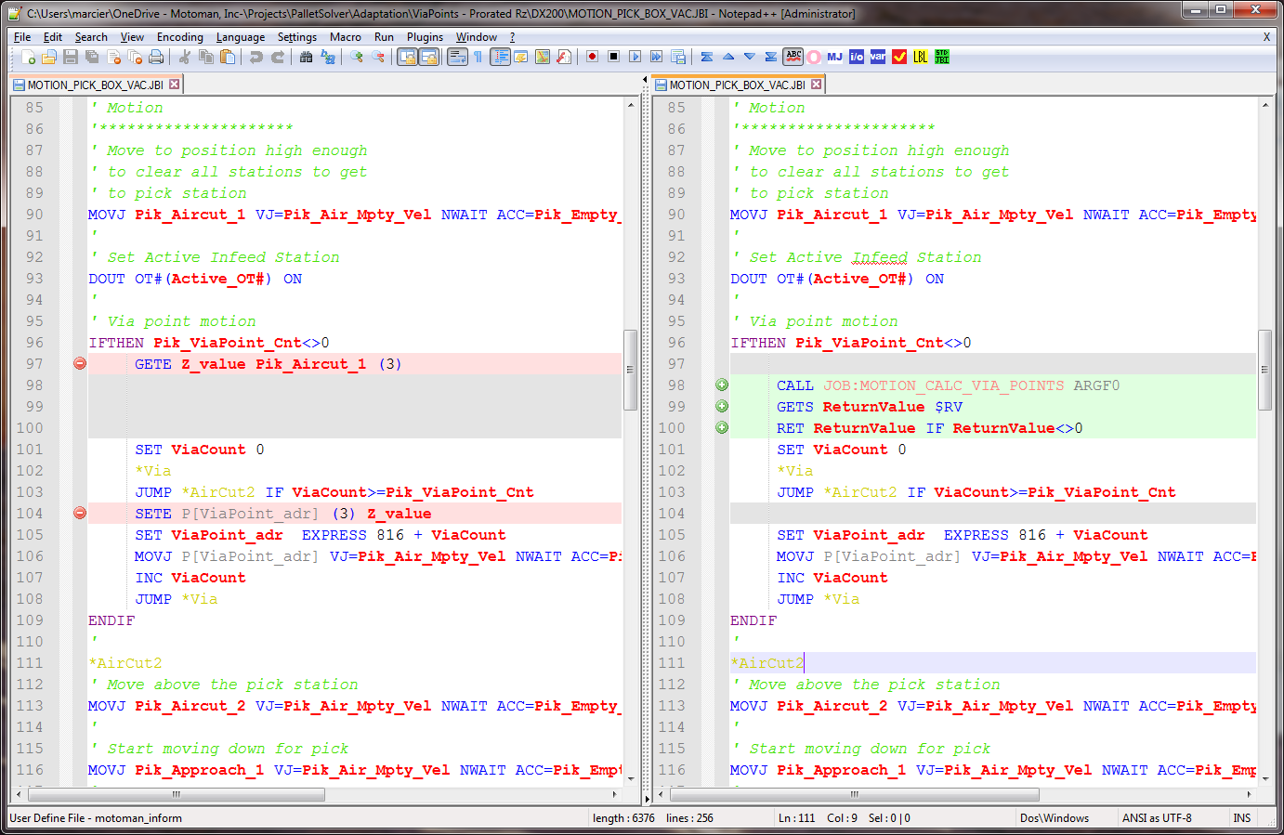

Side Pick on Infeed
6/20/19: Reviewed: Added side pick from front
The following adaptation is to modify PalletSolver to enable the picking of a box on the infeed from its side, turning them 90 degrees and laying them down on the pallet
Figure 11: Picking boxes on their side, turning them 90 deg. To put them on the pallet
Limitations:
- All boxes need to be picked in the same orientation for a given pattern.
- 6-axis robot required
- Vacuum gripper only
- PalletSolver-PC is not modified so when programming the pattern, it is important is to define the box as laydown on the build. The infeed view presents a top view, but in reality, it should be a side view. This important is to correctly position the gripper on the boxes and disregard the background conveyor.

Figure 12: Incorrect infeed representation in the PalletSolver-PC
Note: If this is causing confusion, we might be able to remove the background image of the conveyor top view by manually modifying the image files after the PalletSolver installation is completed.
- Supported configuration are left, right and front side of a conveyor with left or right alignment.
Figure 13: Side pick Gripper Side and Box Alignment arguments

To handle this, the boxes must be defined in PalletSolver-PC as it will be placed on the pallet (not in the orientation on the infeed).
User defined values will be added to the PalletSolver to indicate if the box needs to be pick from the left side, right side or front of the infeed.
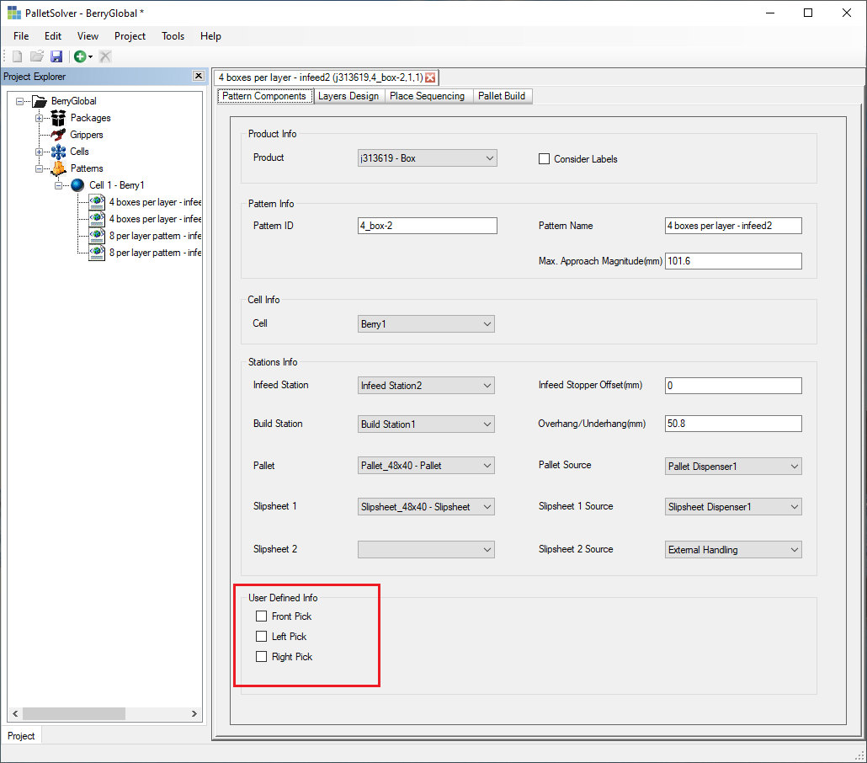

Based on the User Defined value, the GripperSide, Approach_mm and MinTcpHeight_mm are passed to the job PLAN_PICK_BOX_VAC_SIDE.
Figure 14: Side pick XY-Approach and Conveyor Width arguments
The Gripper Minimum Height is used to specify minimum Z height when picking the box on the infeed. This use as a precaution to prevent the gripper from hitting the infeed conveyor.
Figure 15: Side Pick Gripper TCP Minimum Height argument
Unless all products are always coming with the length of the box along the conveyor length, the option for Smart Conveyor Single Row option need to be enabled in the USER_ADJUSTMENT in order to take into account any rotation in the box.
SET UsrSmartOneRow 1

Jobs
If there are possibilities that some boxes are turned 90 degrees so that the length of the box is along the height of the conveyor, enable the Smart Conveyor Single Row option in the USER_ADJUSTMENT job:
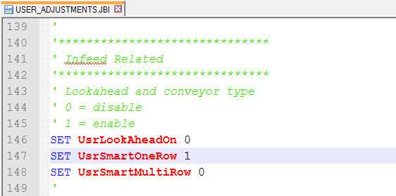
In the PLAN_PICK_BOX job, replace the call the PLAN_PICK_BOX_VAC by a call to the PLAN_PICK_BOX_VAC_SIDE and specify the appropriate arguments for your system.
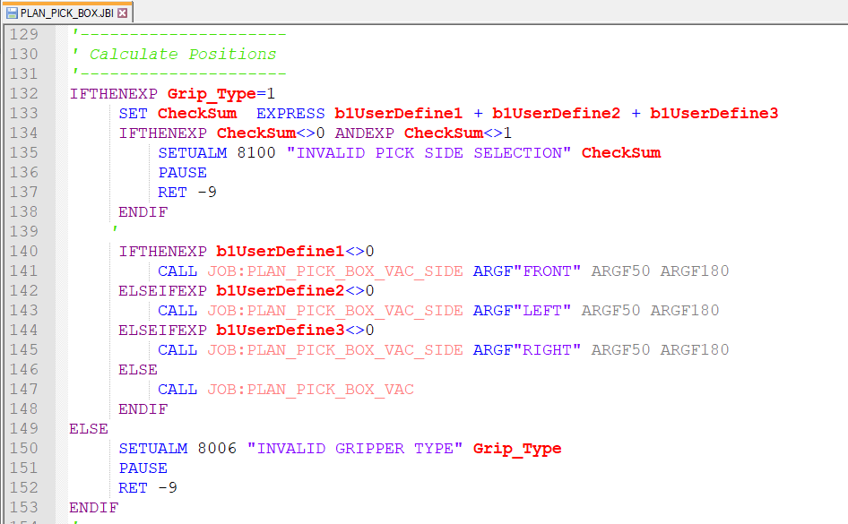
All the calculation of the various approach, pick and depart position are done in the PLAN_PICK_BOX_VAC_SIDE job:
/JOB
//NAME PLAN_PICK_BOX_VAC_SIDE
//POS
///NPOS 0,0,0,9,0,0
///TOOL 0
///POSTYPE BASE
///RECTAN
///RCONF 0,0,0,0,0,0,0,0,0,0,0,0,0,0,0,0,0,0,0,0,0,0,0,0
P00800=0.000,0.000,0.000,0.0000,0.0000,0.0000
///USER 62
///POSTYPE USER
P00801=0.000,0.000,0.000,0.0000,0.0000,0.0000
P00802=0.000,0.000,0.000,0.0000,0.0000,0.0000
P00803=0.000,0.000,0.000,0.0000,0.0000,0.0000
P00804=0.000,0.000,0.000,0.0000,0.0000,0.0000
P00805=0.000,0.000,0.000,0.0000,0.0000,0.0000
P00806=0.000,0.000,0.000,0.0000,0.0000,0.0000
P00807=0.000,0.000,0.000,0.0000,0.0000,0.0000
P00808=0.000,0.000,0.000,0.0000,0.0000,0.0000
//ALIAS
///GVARS 3,1,2,0,0,10,0,0
B758 UsrSmartOneRow
B801 Pik_PickStnID
B802 Pik_BuildStnID
I701 Grip_TCP#
D759 All_Clear_By_um
D800 Pik_Clear_Z_BF
P700 Home_User_Set
P800 Pik_Aircut_1
P801 Pik_Aircut_2
P802 Pik_Approach_1
P803 Pik_Approach_2
P804 Pik_Approach_3
P805 Pik_Pick
P806 Pik_After_1
P807 Pik_After_2
P808 Pik_Clear
///LVARS 1,10,14,0,1,2,0,0
LB000 ProdOrient
LI000 BuildVar_Offset
LI001 InfeedVar_Offset
LI002 Prod_Length_adr
LI003 Prod_Width_adr
LI004 Prod_Adj_Ht_adr
LI005 PickPos_adr
LI006 Infeed_Clear_adr
LI007 Prod_Orient_adr
LI008 InfeedWidth_adr
LI009 BoxAlign_adr
LD000 Prod_UnderHang
LD001 PickHeight
LD002 XY_Approach
LD003 XY_Position
LD004 Z_Above_Low
LD005 Z_After_Mid
LD006 Z_After_High
LD007 Z_Clear
LD008 Z_HighestInUF
LD009 Z_Height_in_BF
LD010 Rx_Side_Angle
LD011 Rx_Mid_Angle
LD012 Value
LD013 MinTcpHeight
LS000 GripperSide
LP000 Transform
LP001 Result
//ARGINFO
///ARGTYPE S,D,D,,,,,
///COMMENT
GripperSide
Approach_mm
MinTcpHeight_mm

//INST
///DATE 2019/08/19 12:00
///COMM Side Pick Adaptation
///ATTR SC,RW,CJ
///GROUP1 RB1
///LVARS 1,10,14,0,1,2,0,0
NOP
GETARG GripperSide IARG#(1)
GETARG XY_Approach IARG#(2)
MUL XY_Approach 1000
IFTHENEXP XY_Approach<0
MUL XY_Approach -1
ENDIF
GETARG MinTcpHeight IARG#(3)
MUL MinTcpHeight 1000
'
SET BuildVar_Offset EXPRESS ( Pik_BuildStnID - 1 ) * 25
SET InfeedVar_Offset EXPRESS ( Pik_PickStnID - 1 ) * 25
SET Prod_Adj_Ht_adr EXPRESS 123 + InfeedVar_Offset
SET PickPos_adr EXPRESS 102 + BuildVar_Offset
SET Prod_Orient_adr EXPRESS 114 + InfeedVar_Offset
SET BoxAlign_adr EXPRESS 124 + InfeedVar_Offset
SET InfeedWidth_adr EXPRESS 124 + InfeedVar_Offset
' Determine product orientation
' and width on infeed conveyor
' Note: SET UsrSmartOneRow to 1
' in USER_ADJUSTMENT job
SET ProdOrient B[Prod_Orient_adr]
AND ProdOrient 64
IFTHENEXP UsrSmartOneRow=0 OREXP ProdOrient=0
' Use Product Length and Width
SET Prod_Length_adr EXPRESS 121 + InfeedVar_Offset
SET Prod_Width_adr EXPRESS 120 + InfeedVar_Offset
ELSE
' Swap Product Length and Width
SET Prod_Length_adr EXPRESS 120 + InfeedVar_Offset
SET Prod_Width_adr EXPRESS 121 + InfeedVar_Offset
ENDIF
'
'---------------------
' Calculate Positions
'---------------------
' Set Pick position in proper
' coordinate system and tool
CNVRT Pik_Pick Home_User_Set UF#(62) TL#(Grip_TCP#)
GETE Value P[PickPos_adr] (1)
SETE Pik_Pick (1) Value
GETE Value P[PickPos_adr] (2)
SETE Pik_Pick (2) Value
SETE Pik_Pick (3) D[Prod_Adj_Ht_adr]
SETE Pik_Pick (4) 1800000
SETE Pik_Pick (5) 0
GETE Value P[PickPos_adr] (6)
SETE Pik_Pick (6) Value
'
' Initialize transformation
SET Transform Pik_Pick
SUB Transform Transform
IFTHENEXP GripperSide="LEFT"
SET Value EXPRESS D[Prod_Length_adr]
SETE Transform (1) Value
SETE Transform (4) 900000
SETE Transform (6) 1800000
IFTHENEXP B[BoxAlign_adr]=0
'infeed left alignment
SET Value EXPRESS D[InfeedWidth_adr] - D[Prod_Adj_Ht_adr]
SETE Transform (2) Value
SET Value EXPRESS D[Prod_Width_adr] - D[InfeedWidth_adr]
SETE Transform (3) Value
ELSEIFEXP B[BoxAlign_adr]=1
'infeed right alignment
'do nothing
ELSE
SETUALM 8025 "UNSUPPORTED BOX ALIGNMENT" Pik_PickStnID
PAUSE
RET -1
ENDIF
ELSEIFEXP GripperSide="RIGHT"
SETE Transform (4) 900000
IFTHENEXP B[BoxAlign_adr]=0
'infeed left alignment
SETE Transform (2) D[InfeedWidth_adr]
SET Value EXPRESS D[Prod_Width_adr] - D[InfeedWidth_adr]
SETE Transform (3) Value
ELSEIFEXP B[BoxAlign_adr]=1
'infeed right alignment
SETE Transform (2) D[Prod_Adj_Ht_adr]
ELSE
SETUALM 8025 "UNSUPPORTED BOX ALIGNMENT" Pik_PickStnID
PAUSE
RET -1
ENDIF
ELSEIFEXP GripperSide="FRONT"
SETE Transform (1) D[Prod_Adj_Ht_adr]
SETE Transform (4) 900000
SETE Transform (6) -900000
IFTHENEXP B[BoxAlign_adr]=0
'infeed left alignment
SETE Transform (2) D[InfeedWidth_adr]
SET Value EXPRESS D[Prod_Width_adr] - D[InfeedWidth_adr]
SETE Transform (3) Value
ELSEIFEXP B[BoxAlign_adr]=1
'infeed right alignment
SETE Transform (2) D[Prod_Length_adr]
ELSE
SETUALM 8025 "UNSUPPORTED BOX ALIGNMENT" Pik_PickStnID
PAUSE
RET -1
ENDIF
ELSE
SETUALM 8026 "UNSUPPORTED GRIPPER SIDE" Pik_PickStnID
PAUSE
RET -1
ENDIF
'
MULMAT Result Transform Pik_Pick
SET Pik_Pick Result
'
' Check that gripper doesn't
' hit infeed
' PickHeight in UF
GETE PickHeight Pik_Pick (3)
IFTHENEXP PickHeight<MinTcpHeight
SETUALM 8027 "PICK HEIGHT TOO LOW" Pik_PickStnID
PAUSE
RET -1
ENDIF
'
'-----------------------
' Calculate Z Heights
'-----------------------
IFTHENEXP PickHeight>D[Prod_Adj_Ht_adr]
SET Prod_UnderHang PickHeight
ELSE
SET Prod_UnderHang D[Prod_Adj_Ht_adr]
ENDIF
'
' Z Above Low in UF
SET Z_Above_Low EXPRESS D[Prod_Width_adr] + All_Clear_By_um
' Z Height After picking box
SET Z_After_High EXPRESS D[Prod_Width_adr] + Prod_UnderHang + All_Clear_By_um
' Z Clear Height in UF
SET Infeed_Clear_adr EXPRESS 710 + ( Pik_PickStnID - 1 )
SET Z_Clear EXPRESS D[Infeed_Clear_adr] + All_Clear_By_um + Prod_UnderHang
IFTHENEXP Z_Clear<Z_After_High
SET Z_Clear Z_After_High
ENDIF
SET Z_After_Mid EXPRESS PickHeight + Prod_UnderHang + All_Clear_By_um
'
'-----------------------
' Calculate Rx Angles
'-----------------------
GETE Rx_Side_Angle Pik_Pick (4)
IFTHENEXP Rx_Side_Angle>0
SET Rx_Mid_Angle EXPRESS ( Rx_Side_Angle + 1800000 ) / 2
ELSE
SET Rx_Mid_Angle EXPRESS ( Rx_Side_Angle - 1800000 ) / 2
ENDIF
'
'--------------------------
' Calculate other positions
'--------------------------
' Calculate Safe Position above
' last build or current position
CALL JOB:PLAN_CALC_AIRCUT1 ARGF800 ARGFGrip_TCP#
GETE Z_Height_in_BF Pik_Aircut_1 (3)
IFTHENEXP Pik_Clear_Z_BF<Z_Height_in_BF
SET Pik_Clear_Z_BF Z_Height_in_BF
ENDIF
SETE Pik_Aircut_1 (3) Pik_Clear_Z_BF
'
' Calculate Safe Approach
' above pick station
SET Pik_Aircut_2 Pik_Pick
IFTHENEXP GripperSide="LEFT"
GETE XY_Position Pik_Pick (2)
ADD XY_Position XY_Approach
SETE Pik_Aircut_2 (2) XY_Position
ELSEIFEXP GripperSide="RIGHT"
GETE XY_Position Pik_Pick (2)
SUB XY_Position XY_Approach
SETE Pik_Aircut_2 (2) XY_Position
ELSEIFEXP GripperSide="FRONT"
GETE XY_Position Pik_Pick (1)
SUB XY_Position XY_Approach
SETE Pik_Aircut_2 (1) XY_Position
ENDIF
CALL JOB:PLAN_FIND_HIGHEST_Z_UF_VS_BF ARGF"Pick" ARGFZ_Above_Low ARGFPik_Clear_Z_BF
GETS Z_HighestInUF $RV
SETE Pik_Aircut_2 (3) Z_HighestInUF
SETE Pik_Aircut_2 (4) -1800000
'
' Calculate Approach
SET Pik_Approach_1 Pik_Aircut_2
SETE Pik_Approach_1 (3) Z_Above_Low
SETE Pik_Approach_1 (4) Rx_Mid_Angle
'
SET Pik_Approach_2 Pik_Approach_1
SETE Pik_Approach_2 (3) Z_Above_Low
SETE Pik_Approach_2 (4) Rx_Side_Angle
'
SET Pik_Approach_3 Pik_Approach_2
SETE Pik_Approach_3 (3) PickHeight
'
' Calculate Departure
SET Pik_After_1 Pik_Pick
SETE Pik_After_1 (3) Z_Above_Low
'
SET Pik_After_2 Pik_After_1
SETE Pik_After_2 (3) Z_After_Mid
SETE Pik_After_2 (4) 1800000
'
' Calculate Clear
SET Pik_Clear Pik_After_2
SETE Pik_Clear (3) Z_Clear
SETE Pik_Clear (4) 1800000
'
' Adjust position that might be
' out of reach
CALL JOB:PLAN_ADJUST_POSITION_RADIUS ARGF800 ARGF1050 ARGF2550
CALL JOB:PLAN_ADJUST_POSITION_RADIUS ARGF801 ARGF1050 ARGF2550
CALL JOB:PLAN_ADJUST_POSITION_RADIUS ARGF808 ARGF1050 ARGF2550
'
RET 0
END

Finally, an approach point was added in the motion sequence, so the call to MOTION_PICK_BOX_VAC need to be modified to MOTION_PICK_BOX_VAC_SIDE.
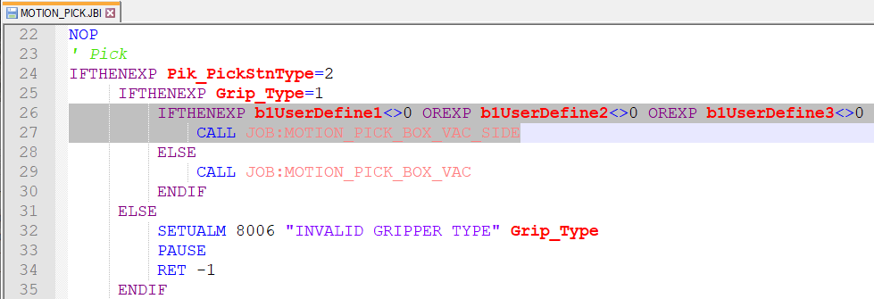
The MOTION_PICK_BOX_VAC_SIDE is a simple modification of the regular MOTION_PICK_BOX_VAC where the motion to reorient the tool where added.
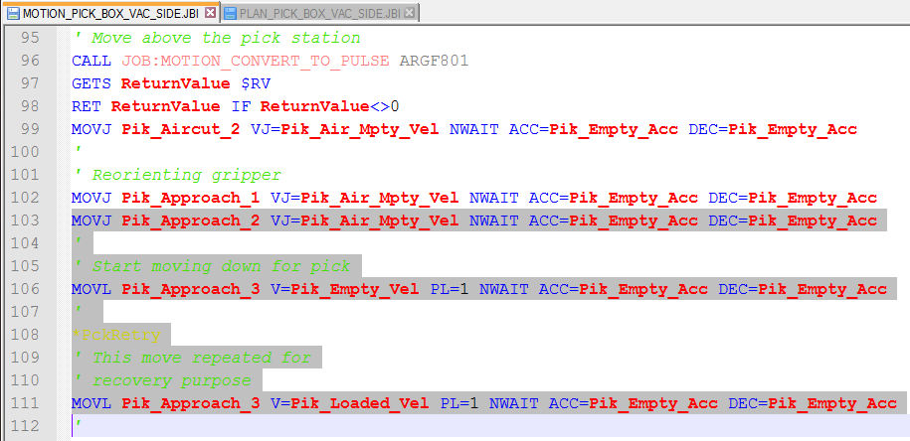

Diagonal Station Approach and Departure
In some cell layout, some station can be somewhat far away from the robot. Technically the robot can reach them and pick/place the package but because of clearance height elsewhere in the cell, the aircut positions above the station becomes too high resulting in ALARM 4684: Interpolation Invalid.
So, the idea is to modify the aircut positions to be closer to the robot and move diagonally to the point closer to the pick/place positions. The figure below illustrates this problem for the infeed that is far from the robot. If the Pik_Aircut2 is directly above the pick position, it cannot be reached, but by adjusting it to be closer to the robot, the pick can be performed without alarm.
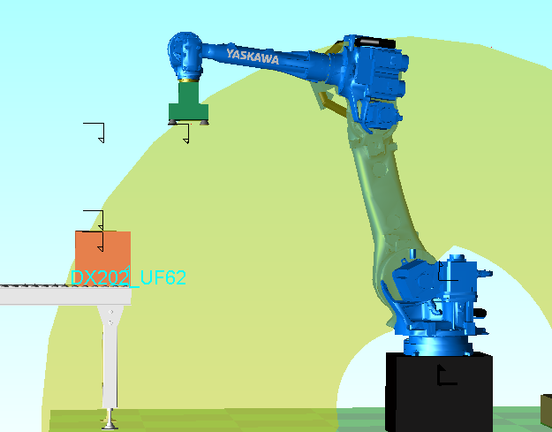
Modified Pik_Aircut2
Normal, out of reach Pik_Aircut2
Pik_Approach1
Figure 16: Out of Reach Infeed Aircut 2 Issue

Jobs
The idea is to modify the position by calculate how much higher the Pik_Aircut2 position is above the pik_Approach1 and move it back that much so that the approach is done at about 45 degrees. Similar calculation is also applied on the departure position (Pik_After2 and Pik_Clear).
The job PLAN_ADJUST_POSITION_RADIUS was added to make generic calculation to move any point back toward the robot if required. It takes for arguments, the address of the P variable that needs to be checked, a reference height in mm in the base frame coordinate system and a reference radius in mm in the XY plane.
Height_ref_mm
Radius_ref_mm
Figure 17: PLAN_ADJUST_POSITION_RADIUS arguments
The position is converted to the base frame coordinate system. Its height is then check against the reference height. If it above, the amount by which it exceeds the reference height is removed from the reference radius to obtain the maximum allowable radius. The position radius is then compared to the maximum radius and if it exceeds the maximum, the X and Y coordinates are prorated to bring them back to the maximum radius. Note that after an adjustment, the position will remain in the Base Frame coordinate system.

/JOB
//NAME PLAN_ADJUST_POSITION_RADIUS
//POS
///NPOS 0,0,0,0,0,0
//ALIAS
///LVARS 0,1,7,1,0,0,0,0
LI000 Position_adr
LD000 Height_ref
LD001 Radius_ref
LD002 X_position
LD003 Y_position
LD004 Z_position
LD005 Radius
LD006 Radius_max
LR000 Radius_sqrt
//ARGINFO
///ARGTYPE I,D,D,,,,,
///COMMENT
Position_adr
Height_ref_mm
Radius_ref_mm

//INST
///DATE 2017/04/05 12:00
///COMM PalletSolver Reach Adjustment
///ATTR SC,RW,CJ
///GROUP1 RB1
///LVARS 0,1,7,1,0,0,0,0
NOP
' This job adjust point x,y
' values when above a given
' height to keep point inside
' robot reach envelop
'
GETARG Position_adr IARG#(1)
GETARG Height_ref IARG#(2)
MUL Height_ref 1000
GETARG Radius_ref IARG#(3)
MUL Radius_ref 1000
'
' Convert point in base frame
CNVRT PX[Position_adr] PX[Position_adr] BF
'
' Check if above height
GETE Z_position P[Position_adr] (3)
RET IF Z_position<Height_ref
'
' Check if outside of radius
GETE X_position P[Position_adr] (1)
GETE Y_position P[Position_adr] (2)
SET Radius_sqrt EXPRESS X_position * X_position + Y_position * Y_position
SQRT Radius_sqrt Radius_sqrt
SET Radius Radius_sqrt
SET Radius_max EXPRESS Radius_ref + Height_ref - Z_position
RET IF Radius<Radius_max
'
' Adjust X-Y values
SET X_position EXPRESS X_position * Radius_max / ( Radius )
SET Y_position EXPRESS Y_position * Radius_max / ( Radius )
SETE P[Position_adr] (1) X_position
SETE P[Position_adr] (2) Y_position
END

The PLAN_PICK_* and PLAN_PLACE_* jobs for the appropriate package and gripper type, call the PLAN_ADJUST_POSITION_RADIUS after the calculation of the position that are causing problems (usually the AirCut1, AirCut2, Clear positions).
WARNING!
Be careful that this position is not being used afterward to calculate any other positions. Do the adjustment call after the last reference to a position in the job.
Below is an example for picking/placing boxes with a vacuum gripper where it was determined that adjustment where required for points above Z=345 mm (base frame) with a reference radius of 1775 mm at that height.
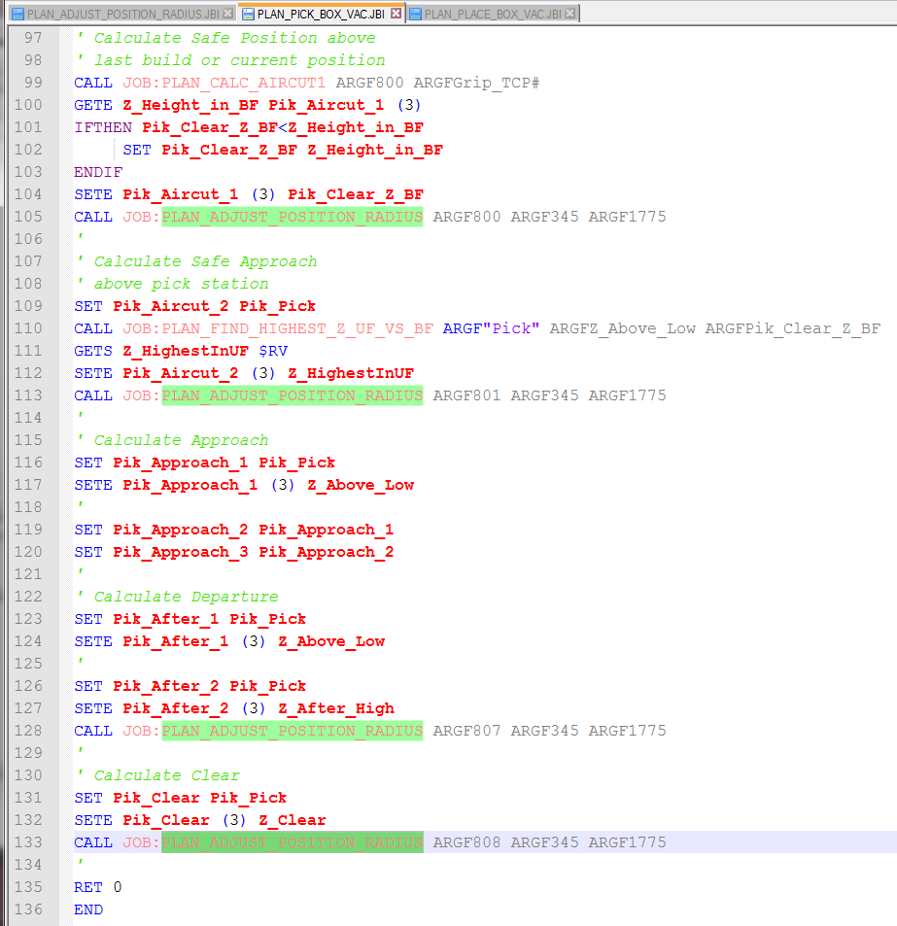
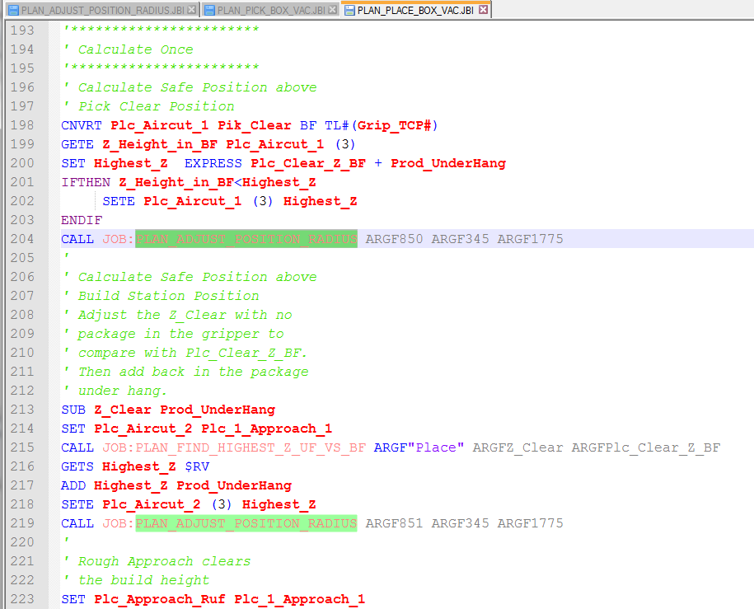

Start Next Build without Pallet
Normally, after a build is complete, the pallet is removed and the build clear signal is sent to reset the build station and allow the next build to start. The new pallet is either put in place by the robot or by an external source (operator or pallet conveyor). In either case, if the system is about to start a pick cycle for a slipsheet or product without the pallet present sensor being on, the system will generate a Job Warning #2 and lock the build station.
On system with only one build station, the system will become idle until the Pallet is in place and won’t start planning for slipsheet or product. There were request for system with pallet conveyor to be able to start the planning and the pick sequence while the pallets are being conveyed. So for example, this allow to start the pick of a slipsheet or boxes before the new empty pallet is in position. The changes presented in this section should allow this.
Warning!!!
Sending the build clear signal, before the completed pallet is out of the robot reach, will reset the build height to zero which may lower the minimum clearance height calculation thereafter. If the layout or cell flow causes the robot to pass over a build station with a completed build that is not completely cleared out of the area, the robot could hit the pallet.

Jobs
The job modification consists in moving the PalletPresent check normally before the call to the pick job to after the pick. Also, normally when the pallet is missing, the job warning is sent, the station is locked and PalletSolver continues to work in other stations (if any). In this modification, since the pick will already have taken place, the call to MOTION_SET_JOB_WARNING is replaced to a call to MOTION_PICK_PLACE_ERROR. This will allow possible recovery in the event that there is a problem with the pallet and we need to abort the sequence.
In 'PALLETSOLVER_MOTION job delete the section highlighted below:
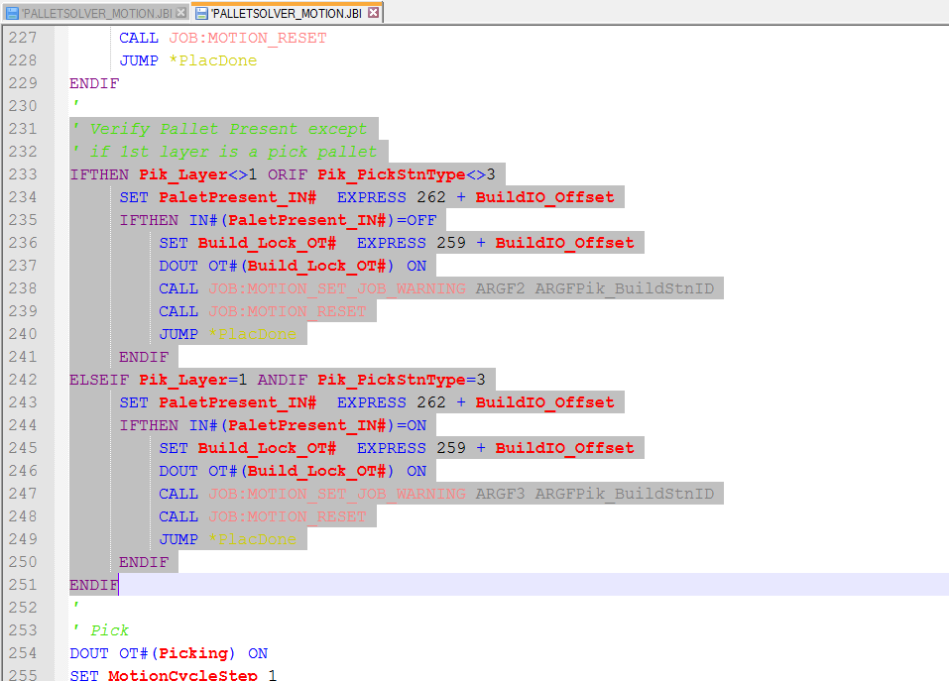
Then after the pick add the following:
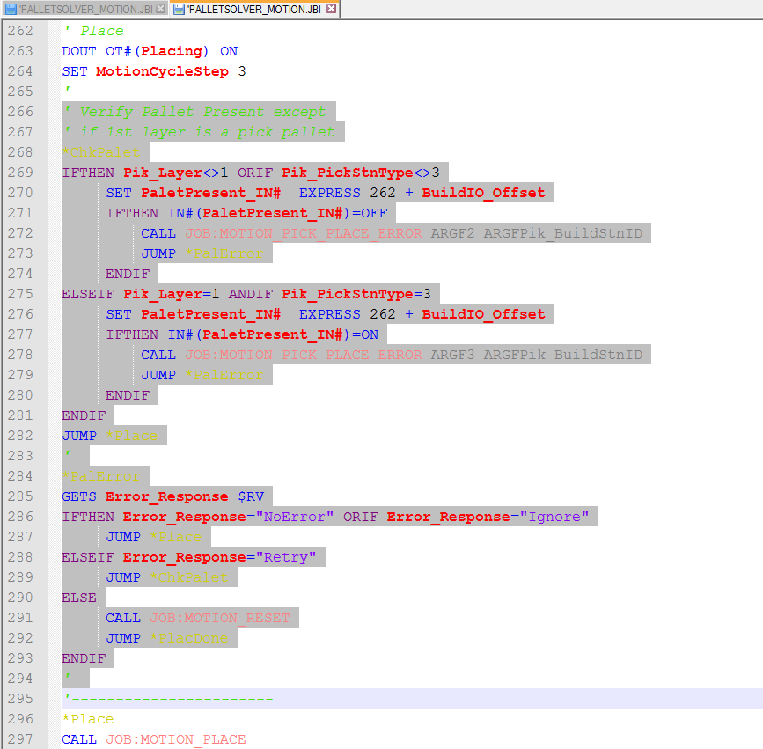
The MOTION_PICK_PLACE_ERROR job was also modified to allow automatic recovery from job warning 2 or 3 when the pallet issue is resolved.
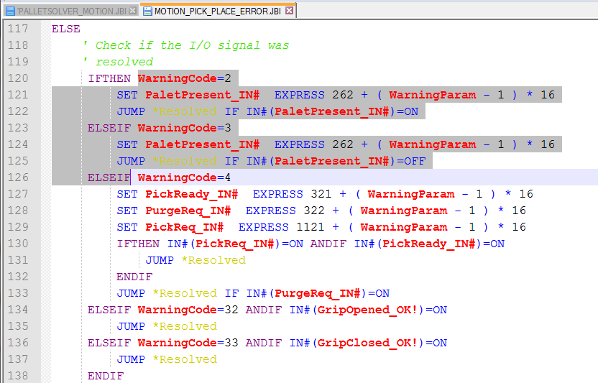

Forcing Boxes to Reject
Some systems have sensors on the infeed to identify if a product (box) is good or not. In the case of a bad box, it still ends up at the end of the infeed and need to be removed by the robot to prevent production interruption.
The easiest approach is to do the pick, and then signal an abort before the product is place. Since the cycle was aborted and that there is product on the gripper, PalletSolver will automatically go to the Home position and then enter the reject sequence (USER_MOVE_REJECT job).
In the MOTION_PICK job at the end:
…
GETS ReturnValue $RV
RET ReturnValue IF ReturnValue<0
'
' Check User force reject
IFTHEN IN#(<RejectPartInput>)=ON ANDIF Pik_PickStnType=2
' AbortRepeatCycle
RET -11
ENDIF
'
' Normal complete
RET 0
END

Where: <RejectPartInput>: is replaced by your input number.

Improve Look Ahead Timing
When using smart conveyors, the time required to setup the boxes properly for the next pick can be significant. In the PalletSolver standard version, the infeed quantity data and the pick request is only being set after the current pick sequence is completed. This is most obvious when picking a slipsheet or pallet and the infeed data is not being updated.
The following change can be done to improve the timing on setting the infeed information even though the next cycle is a slipsheet or pallet.
In the PLAN_UPDATE_STATION on the line:
IFTHEN D[PickStnType_adr]=2 ANDIF BuildStnID<>Selected_BuildID ANDIF D[DataLayer_adr]<=B[Total_Layer_adr]
The condition in red can be to remove to improve timing.
Note: Testing doesn’t seem to have any “side effect”. I think that was put in there as a precaution when trying to get the correct timing but it is not really required (as far as I can tell). It was to prevent updating, until the current cycle has started the place sequence. But since that section is fairly critical, I would like to see an actual implementation and more testing before making that change into the standard version.

Disabling the SYSTEM_PLC_MESSAGING job
If the messaging between controller and PLC is not required. The system job can be disabled but the concurrent I/O should be change so that it doesn’t generate alarm 9065.
Delete the following rungs:
STR #50070
AND #50054
AND #01991
AND #10273
OUT #79703
Once that is loaded in, you can go (in Management security mode) to JOB → CTRL SYSTEM JOB go to the page with the SYSTEM_PLC_MESSAGING. Then move to the START MODE field and set it to MANUAL.
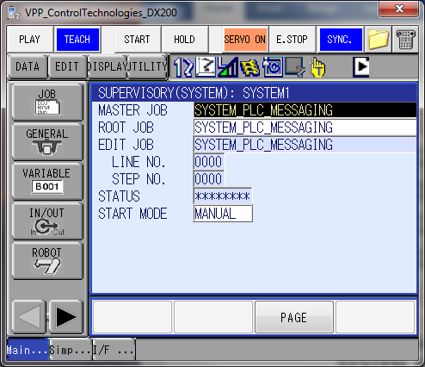

Using EtherNet/IP Explicit Messaging
Explicit Messaging is available with the DX200 EtherNet/IP option. This is an alternative to using the PLC Messaging defined in the PalletSolver Manual. By using explicit messaging, the value of variable can be directly retrieved or set from the PLC. The SYSTEM_PLC_MESSAGING can then be disabled (refer to section 2.10).
The explicit messages definition available are defined in chapter 5 of the EtherNet/IP Communication Function manual.
The variable of interest and their description can be found in the “PalletSolver Variable Common Reference” document.
Below is an Rockwell Studio 5000 example of an explicit message to retrieve variable B781: Assign Build Station.
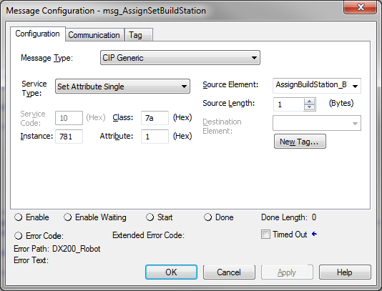

Assign Pattern
To assign pattern, a concurrent I/O change is also required to trigger the MotoPlus application that executes the conversion of the Pattern file to a controller Job.
External Input (PLC byte 35 bit 7) is used to request the pattern assignment and External Output (PLC byte 35 bit 7) to indicate that the assignment is complete.
// MODIFICATION TO ASSIGN PATTERN WITH EXPLICITE MESSAGING
STR #11997 // Universal Output #1592 (from SYSTEM_PLC_MESSAGING)
OR #20627 // External Input Assign Request
OUT #37257 // Network Output to MotoPlus Assign Request

STR #27257 // Network Input from MotoPlus Assign Done
OUT #30627 // External Output Assign Done
Below is an Rockwell Studio 5000 example using explicit message to assign a pattern:

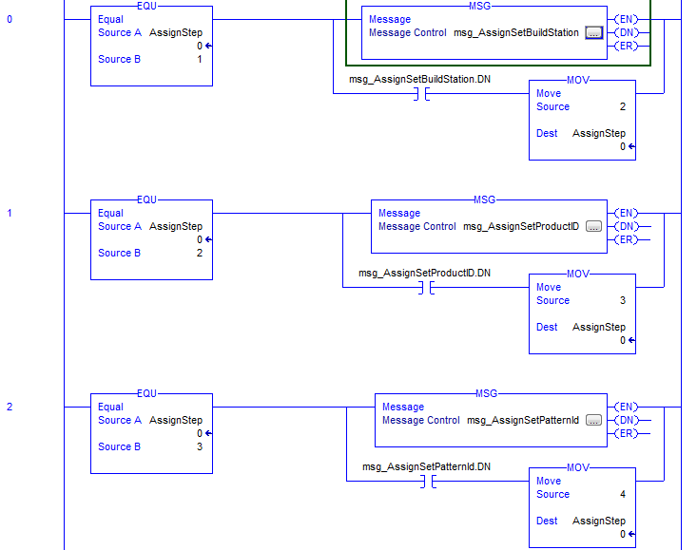
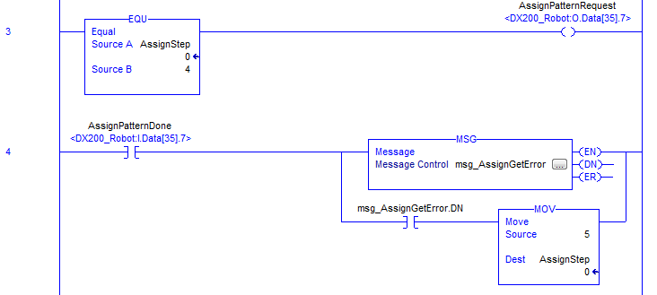

Prevent Moving Over Placed Boxes
Normally, PalletSolver doesn’t assumes that boxes are places in a particular order on a layer and will always plan to move above boxes already placed on the layer.
In some cases, it might be desired to prevent raising above placed boxes to resolve reach issues or improve cycle time. Note that it then falls upon the pattern to programmer to make sure that boxes are sequence from the farthest to the closest, so that there is no collision with the previously placed boxes.
The cell layout must also be done so that the robot doesn’t cross over the build stations went moving between other stations.
The strategy is to use the place height instead of the clear height when calculating the Z_Clear value. The modification is made in the MOTION_PLACE_ADJUST_COUNTERS, PLAN_UPDATE_CLEARANCE_HEIGHT and the appropriate PLAN_PLACE_BOX_xxx.
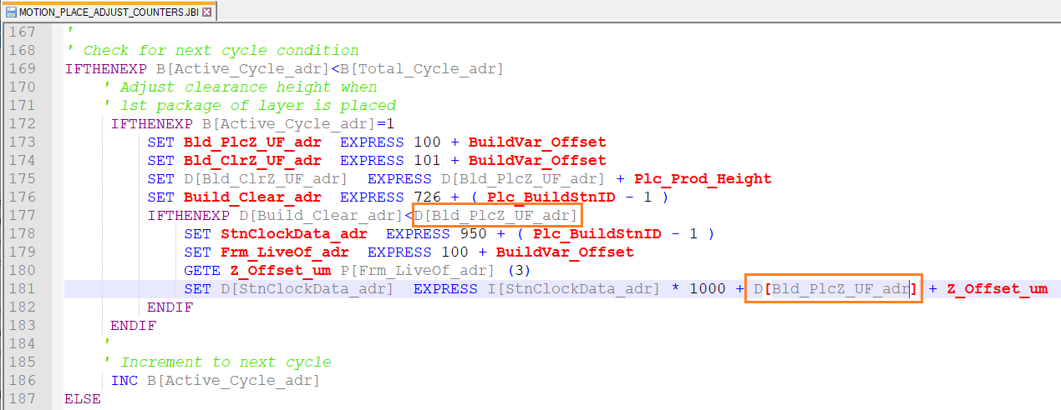
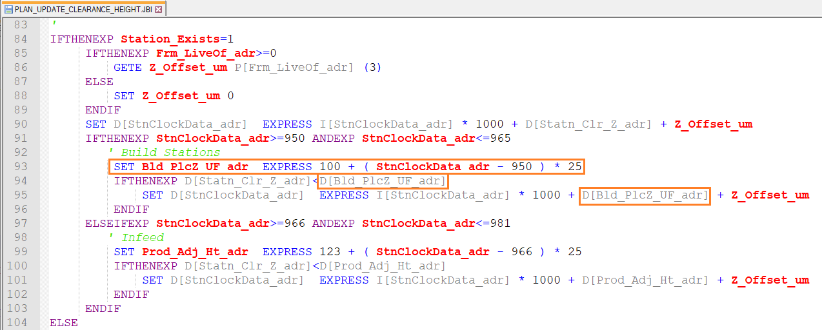
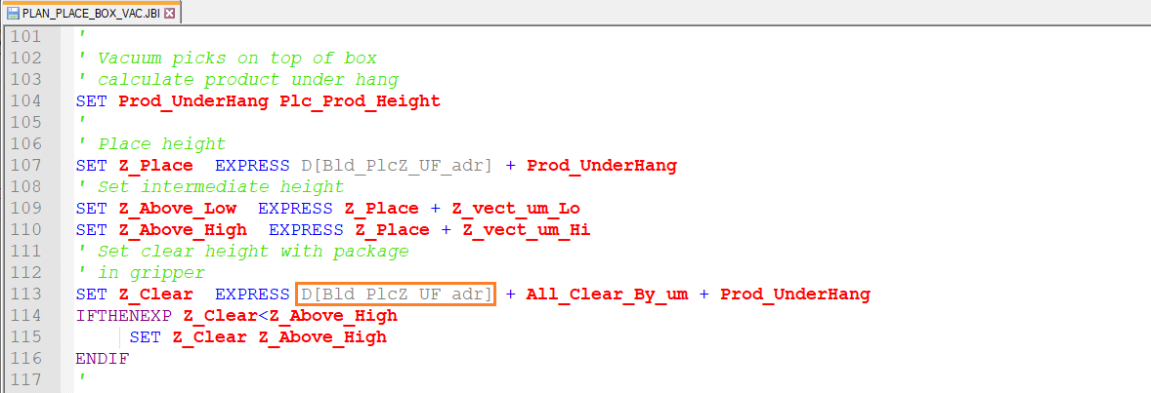
You also need to make proper adjustment to the approach vector to lower the approach profile. Please refer to Approach Vector section in chapter 6.2.3.1 USER_ADJUSTMENTS of the manual for details.
NOTICE

Increased Number of Dispensers and Dynamic Selection
The standard PalletSolver solution is designed for 4 dispensers (2 pallet types and 2 slip-sheet types). In some cases, the cell layout calls for more dispensers or the content (specific pallet or slipsheet) of the dispensers may be changed at the type of build. To accommodate this, the selection of the dispenser for the pallet or slipsheet will have to be managed by the PLC.
This solution assumes that the pallet types and slipsheet are of similar size (mainly height) but different material/quality. So, the solution would be to definition one dispenser for pallets and one dispenser for slipsheets in PalletSolver-PC. During operation, a value transferred by I/O from the PLC to the robot controller will specified which dispenser to use for the pallet and a second value for the slipsheet. Based on those values, the dispenser user frame will be dynamically selected at the time of the build.
A user frame (#21 to #25) will need to be defined for each physical dispenser. The standard PalletSolver Setup application will not be used to define user frame offsets for the dispensers and the dynamic user-frame adjustment option will not be available. Instead P variables will be used to define the User Frame to use and any required offset. These values may be added to the USER_ADJUSTMENT job.
P602: Pallet Dispenser #1 offset defined in UF#21 (PLC Pallet Selection = 0)
P603: Pallet Dispenser #2 offset defined in UF#22 (PLC Pallet Selection = 1)
P604: Pallet Dispenser #3 offset defined in UF#23 (PLC Pallet Selection = 2)
P605: Pallet Dispenser #4 offset defined in UF#24 (PLC Pallet Selection = 3)
P606: Pallet Dispenser #5 offset defined in UF#25 (PLC Pallet Selection = 4)
P652: Slipsheet Dispenser #1 offset defined in UF#21 (PLC Slipsheet Selection = 0)
P653: Slipsheet Dispenser #2 offset defined in UF#22 (PLC Slipsheet Selection = 1)
P654: Slipsheet Dispenser #3 offset defined in UF#23 (PLC Slipsheet Selection = 2)
P655: Slipsheet Dispenser #4 offset defined in UF#24 (PLC Slipsheet Selection = 3)
P656: Slipsheet Dispenser #5 offset defined in UF#25 (PLC Slipsheet Selection = 4)
The dispenser selection is made in the PLAN_PICK_DISPENSER job. In this example, only one build station is considered (or the selection is the same for all build station) and input group #79 and #80 are used to receive the dispenser selection from the PLC for the Pallet and Slipsheet respectively.
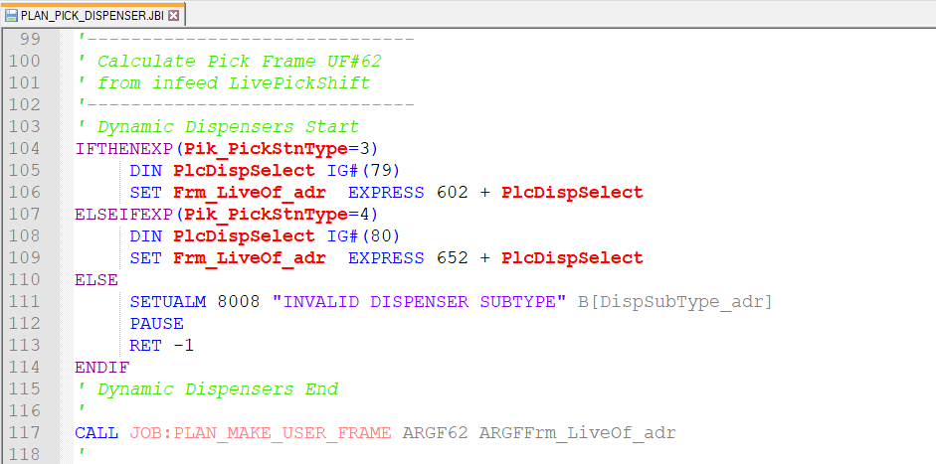
The PLC will also have to reset the search start height whenever the dispenser selection is changed.
449 | 00570 | Pdisp1ReqSrch_Ht
465 | 00590 | Sdisp1ReqSrch_Ht
It will also need to manage any signals for stack height and empty based on the selected dispenser.
452 | 00573 | Pdisp1LoStackSen
453 | 00574 | Pdisp1Empty_Sens
468 | 00593 | Sdisp1LoStackSen
469 | 00594 | Sdisp1Empty_Sens

Using Multiple Grippers
Some system may have a gripper that can pick different product using different gripping mechanisms or switching gripper with a tool changer. Technically, PalletSolver is not designed to handle multiple grippers but the following adaptation can work around some of the limitation.
To make it possible would require some customizations:
PalletSolver-PC:
PalletSolver-PC will need to use two projects. One for each gripper. Cell ID for both projects need to be the same.

MotoPlus Application:
The MotoPlus application needs to be modified:
- To remove the GripperID check:

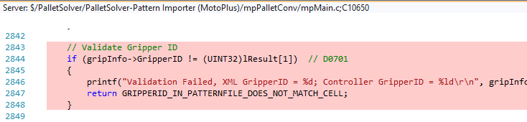
Change to:
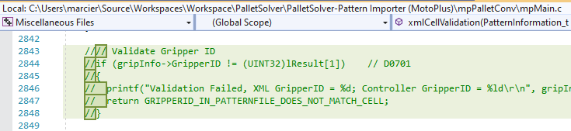
- The GripperID and GripperType information needs to be added the PATTERN#.JBI. The following variables are used for this.
I | 0913 | GripperID
I | 0914 | GripperType

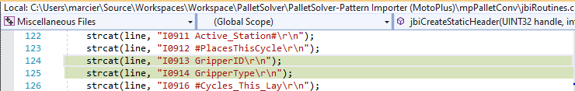
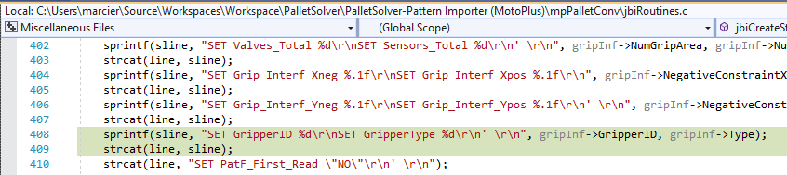
Jobs:
The PLAN_SET_NEW_PATTERN_FILE_DATA job then copies the GripperType information to the build station variable section:
B | 0107 | b1GripType

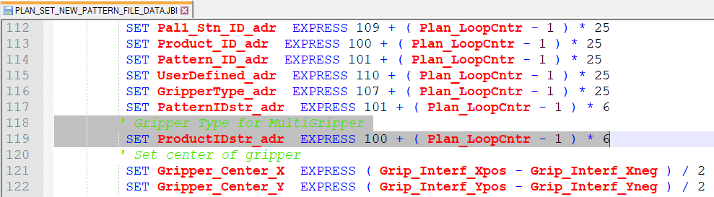
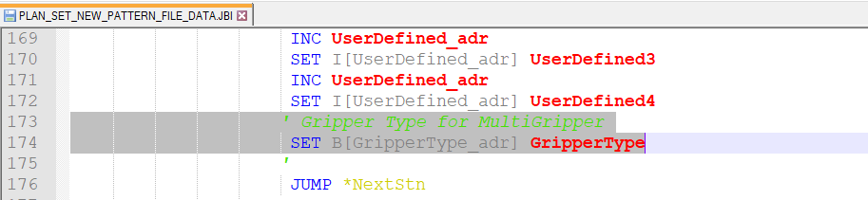

The PLAN_PICK and PLAN_PLACE jobs then copies the build station gripper type to the normal variables used for the motion planning calculation:
B | 0701 | Grip_Type
Then based on that Grip_Type override, the Grip_TCP# overwritten with the appropriate Tool # define for the gripper:
I | 0701 | Grip_TCP#

So, the PLAN_PICK and PLAN_PLACE need to be reviewed to set the TCP you want to use:
' MultiGripper Support Start
SET GripperType_adr EXPRESS 107 + ( Selected_BuildID - 1 ) * 25
SET Pik_GripperType B[GripperType_adr]
SET Grip_Type B[GripperType_adr]
IFTHENEXP Grip_Type=1
SET Grip_TCP# 0
ELSEIF Grip_Type=2
SET Grip_TCP# 1
ELSE
SETUALM 8006 "INVALID GRIPPER TYPE" Grip_Type
PAUSE
RET -2
ENDIF
' MultiGripper Support End

The gripper type is also set to the new variables:
B | 0811 | Pik_GripperType
B | 0861 | Plc_GripperType
Which are then used by the revised MOTION_PICK and MOTION_PLACE.
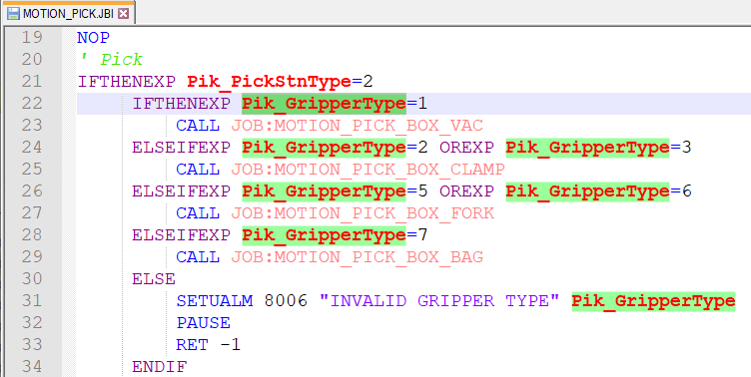
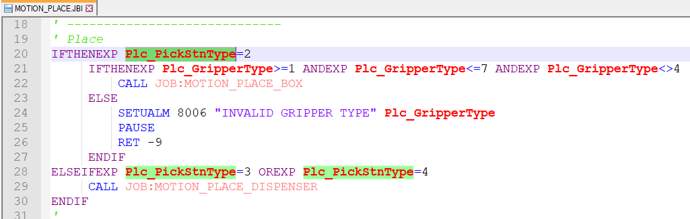
No changes to the plan/motion related to moving home, ready position (idle) or reject station were made but it might be something that needs to be considered. Proper testing of the various scenarios needs to be done.
Gripper I/O:
Some changes will also be required to manage the gripper I/O. There are various possibilities like:
- Changing the USER_GRIPPER jobs to switch based on Pik_GripperType and Plc_GripperType variables.
- Make concurrent I/O changes by adding some I/O switch based on the Pik_GripperType and Plc_GripperType variables.
- In PalletSolver-PC, define dummy Grip Areas and Sensors Areas that are used by one gripper but not the other. For example, Gripper#1 uses grip area 1 and 2 and Gripper#2 uses grip area 3 and 4. But for Gripper#2, to define grip area 3 and 4, you also need to define grip area 1 and 2, so you just define dummy ones and then don’t assign them to the virtual gripper definition so they will not actually be used by Gripper#2.

Gripper Definition:
Finally, with the cell setup application, you will only be able to set one of the gripper.
You will need to set the other gripper manually. Below are some of the variables that are normally set by the Cell Setup application.

B | 0760 | Grip_NumArea
B | 0761 | Grip_OpenSensor
B | 0762 | Grip_CloseSensor
B | 0763
B | 0764 | HighDropHeight%
B | 0765 | Frk_#Ret_Zone

D | 0760 | Clp_Max_Insert
D | 0761 | Clp_Min_Clear
D | 0762 | Clp_Max_Opening
D | 0763
D | 0764
D | 0765 | Frk_Frk_Thicknes
D | 0766 | Frk_Max_Frk_L
D | 0767 | Frk_Mid_Frk_L
D | 0768 | Frk_Sml_Frk_L
D | 0769
D | 0770 | Frk_Y_Approach
D | 0771 | Frk_Z_LowAproach
D | 0772 | Frk_Z_LowDepart
D | 0773 | Frk_Z_OpenClear

Product Mass Compensation
There have been requests to use PalletSolver with collaborative robot like the HC10. The potential issue is with the PFL function that relies on the tool mass and center of gravity to calculate expected forces and based on that detect external forces.
Currently, PalletSolver uses the same tool file regardless of the picked box. We usually tell customers to use a typical load to set the tool information for the gripper.
That will not work for the HC robot with PFL since without accurate tool definition, the expected load will be incorrect and false collisions will be detected. Customization will be needed to dynamically switch tool whenever product is pick or placed and multiple tools files defined accurately for the various product combinations.
Experience with the current HC10 software indicates that the tool mass, center of gravity and inertia needs to be accurate to avoid false collision detection. PalletSolver has information about the product ID and product properties (weight, length, width, and height), so the concept is that based on this information a user customized job is called to return the appropriate tool to use when picking a product.
There is a limitation of 64 tool definitions, given that PalletSolver usually used 4 of them (product, pallet, slipsheet and teaching), that leave about 60 tools for various product configuration.
This solution would assume that the default product tool definition is used for the properties of the gripper without product (empty gripper). When product is picked up, the USER_SET_TOOL_BY_PRODUCT is called to get the tool file to use. Once the product is placed the tool is set back to the default tool.
The following job is an example of the added call to the USER_SET_TOOL_BY_PRODUCT during the planning phase.
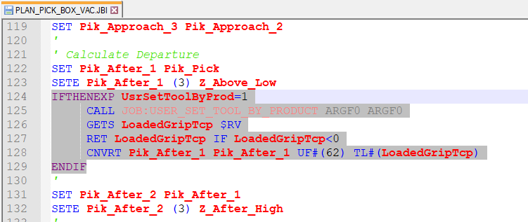

The called USER_SET_TOOL_BY_PRODUCT job would basically hold a mapping between the product and the tool. In the simplest form, it would be a mapping between product ID and tool no:
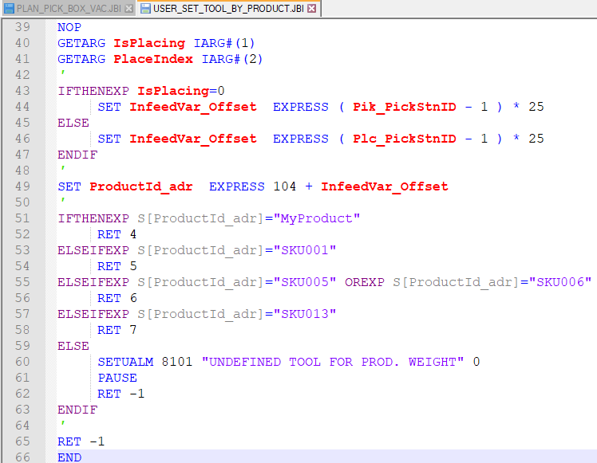
So, if a new product is added, a new tool definition needs to be made to account for the gripper plus the new product weight, CG and Inertia. The mapping between new product and tool number also needs to be added to the USER_SET_TOOL_BY_PRODUCT job.

Mapping based on product properties
It is also possible to recover data about the product weight and dimension. It would be possible to return the tool selection base on this information, but at this time, it is unclear on how accurate the tool the definition would need to be. Define a tool at every 200g, 500g or 1 kg variation? Would the box size variation require to have different tool at the same weight but with different CG and Inertia?

Multi-drop of Product
PalletSolver also support picking multiple boxes together and then placing each one separately. This would also add complexity. The tool would need to be adjusted between each drop. The tool selection would have to be based not only on the product ID but also the number of products. Then as the product is gradually released, tool would need to be adjusted accordingly to account for the number of boxes remaining in the gripper and the location of those boxes. The complexity and number of tool definition could grow rapidly.

External Pattern Management
An integrator asked about the capability to generate simple patterns directly on their HMI but would still want to use the PalletSolver structure and code. If the integrator is willing to manage the pattern on their side, there could be a fairly easy way to integrate it in PalletSolver.
Pattern files generated by PalletSolver-PC are then converted to a PATTERN# (where the # represent the build station ID) job. The PATTERN job simply fills a pre-established range of variable with the next cycle data. So, the PATTERN file could be replaced by a simple job signaling the PLC to populate the variable table with the data for the next cycle.
In the following example, input and output 41 are used for handshaking:
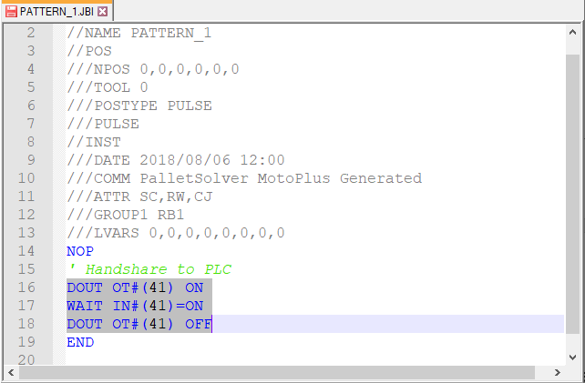
The requested layer and cycle data are stored in variables:
I | 0926 | This_Layer_#
I | 0927 | This_Cycle_#
When output#41 is turned on, the PLC or external source ready the layer and cycle requested and populates the variable table accordingly. Then turns on input #41 to signal that the data is ready.
Below is a small test PC application to test the concept:
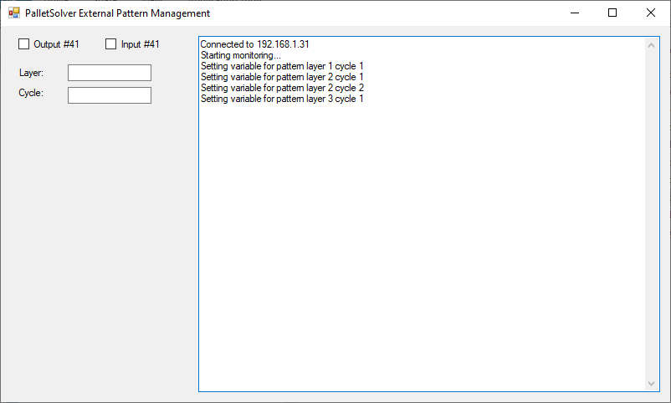
That table is fairly big but not all values need to be populated every cycle. The table covers up to 8 stations and 8 separate places for 1 pick. Plus, some values are only used when the pattern is initially assigned. Some refinement would be needed to clearly identify those variable and maybe an extra signal to notify the PLC when those values are needed. But at a first look, the following variable would be needed for every pick/single place cycle:
B | 0910 | #Packages_Pick
B | 0911 | Pick_App_Vector
B | 0912 | #Package_Place_1
B | 0913 | Place_Vector_Ap1
I | 0910 | ActiveStatonType
I | 0911 | Active_Station#
I | 0912 | #PlacesThisCycle
I | 0916 | #Cycles_This_Lay
I | 0917 | Max#Box_This_Lay
D | 0910 | Valves_Pick
D | 0911 | Sensors_Pick
D | 0912 | Valves_Place_1
D | 0913 | Sensors_Place_1
P | 0910 | Pick_Position
P | 0912 | Position_Place_1

The full variable table looks as follows:
B | 0900 | Station1_Type |  | I | 0900 | Station1_ID |  | D | 0900 | Sta_1_PackageID#
B | 0901 | Station2_Type |  | I | 0901 | Station2_ID |  | D | 0901 | Sta_2_PackageID#
B | 0902 | Station3_Type |  | I | 0902 | Station3_ID |  | D | 0902 | Sta_3_PackageID#
B | 0903 | Station4_Type |  | I | 0903 | Station4_ID |  | D | 0903 | Sta_4_PackageID#
B | 0904 | Station5_Type |  | I | 0904 | Station5_ID |  | D | 0904 | Sta_5_PackageID#
B | 0905 | Station6_Type |  | I | 0905 | Station6_ID |  | D | 0905 | Sta_6_PackageID#
B | 0906 | Station7_Type |  | I | 0906 | Station7_ID |  | D | 0906 | Sta_7_PackageID#
B | 0907 | Station8_Type |  | I | 0907 | Station8_ID |  | D | 0907 | Sta_8_PackageID#
B | 0908 |  |  | I | 0908 | Pattern_loop |  | D | 0908 | Valves_Total
B | 0909 | Max_#_Layers |  | I | 0909 | PatternFileID |  | D | 0909 | Sensors_Total
B | 0910 | #Packages_Pick |  | I | 0910 | ActiveStatonType |  | D | 0910 | Valves_Pick
B | 0911 | Pick_App_Vector |  | I | 0911 | Active_Station# |  | D | 0911 | Sensors_Pick
B | 0912 | #Package_Place_1 |  | I | 0912 | #PlacesThisCycle |  | D | 0912 | Valves_Place_1
B | 0913 | Place_Vector_Ap1 |  | I | 0913 | GripperID |  | D | 0913 | Sensors_Place_1
B | 0914 | #Package_Place_2 |  | I | 0914 | GripperType |  | D | 0914 | Valves_Place_2
B | 0915 | Place_Vector_Ap2 |  | I | 0915 |  |  | D | 0915 | Sensors_Place_2
B | 0916 | #Package_Place_3 |  | I | 0916 | #Cycles_This_Lay |  | D | 0916 | Valves_Place_3
B | 0917 | Place_Vector_Ap3 |  | I | 0917 | Max#Box_This_Lay |  | D | 0917 | Sensors_Place_3
B | 0918 | #Package_Place_4 |  | I | 0918 | Max#Box_Pattern |  | D | 0918 | Valves_Place_4
B | 0919 | Place_Vector_Ap4 |  | I | 0919 | Max_#_BoxLayers |  | D | 0919 | Sensors_Place_4
B | 0920 | #Package_Place_5 |  | I | 0920 | UserDefined1 |  | D | 0920 | Valves_Place_5
B | 0921 | Place_Vector_Ap5 |  | I | 0921 | UserDefined2 |  | D | 0921 | Sensors_Place_5
B | 0922 | #Package_Place_6 |  | I | 0922 | UserDefined3 |  | D | 0922 | Valves_Place_6
B | 0923 | Place_Vector_Ap6 |  | I | 0923 | UserDefined4 |  | D | 0923 | Sensors_Place_6
B | 0924 | #Package_Place_7 |  | I | 0924 | Product_ID |  | D | 0924 | Valves_Place_7
B | 0925 | Place_Vector_Ap7 |  | I | 0925 | Pattern_ID |  | D | 0925 | Sensors_Place_7
B | 0926 | #Package_Place_8 |  | I | 0926 | This_Layer_# |  | D | 0926 | Valves_Place_8
B | 0927 | Place_Vector_Ap8 |  | I | 0927 | This_Cycle_# |  | D | 0927 | Sensors_Place_8
B | 0928 |  |  | I | 0928 |  |  | D | 0928
B | 0929 | #Row_Pick |  | I | 0929 | Infeed_Alignment |  | D | 0929 | Infeed_Width
B | 0930 | Pick_Row1_Qty |  | I | 0930 | Pick_Row1_Orient |  | D | 0930
B | 0931 | Pick_Row2_Qty |  | I | 0931 | Pick_Row2_Orient |  | D | 0931
B | 0932 | Pick_Row3_Qty |  | I | 0932 | Pick_Row3_Orient |  | D | 0932
B | 0933 | Pick_Row4_Qty |  | I | 0933 | Pick_Row4_Orient |  | D | 0933
B | 0934 | Pick_Row5_Qty |  | I | 0934 | Pick_Row5_Orient |  | D | 0934
B | 0935 | Pick_Row6_Qty |  | I | 0935 | Pick_Row6_Orient |  | D | 0935

R | 0900 | InfeedStopOffset |  | S | 0300 | Sta1PackageIDstr |  | P | 0900 | Package_1
R | 0901 | Place_Vector_XY |  | S | 0301 | Sta2PackageIDstr |  | P | 0901 | Package_2
R | 0902 | Grip_Interf_Xneg |  | S | 0302 | Sta3PackageIDstr |  | P | 0902 | Package_3
R | 0903 | Grip_Interf_Xpos |  | S | 0303 | Sta4PackageIDstr |  | P | 0903 | Package_4
R | 0904 | Grip_Interf_Yneg |  | S | 0304 | Sta5PackageIDstr |  | P | 0904 | Package_5
R | 0905 | Grip_Interf_Ypos |  | S | 0305 | Sta6PackageIDstr |  | P | 0905 | Package_6
R | 0906 |  |  | S | 0306 | Sta7PackageIDstr |  | P | 0906 | Package_7
R | 0907 |  |  | S | 0307 | Sta8PackageIDstr |  | P | 0907 | Package_8
R | 0908 |  |  | S | 0308 |  |  | P | 0908
R | 0909 |  |  | S | 0309 |  |  | P | 0909 | Pulse_Frame
R | 0910 |  |  | S | 0310 | p1ConversionDate |  | P | 0910 | Pick_Position
R | 0911 |  |  | S | 0311 | p2ConversionDate |  | P | 0911
R | 0912 |  |  | S | 0312 | p3ConversionDate |  | P | 0912 | Position_Place_1
R | 0913 |  |  | S | 0313 | p4ConversionDate |  | P | 0913
R | 0914 |  |  | S | 0314 | p5ConversionDate |  | P | 0914 | Position_Place_2
R | 0915 |  |  | S | 0315 | p6ConversionDate |  | P | 0915
R | 0916 |  |  | S | 0316 | p7ConversionDate |  | P | 0916 | Position_Place_3
R | 0917 |  |  | S | 0317 | p8ConversionDate |  | P | 0917
R | 0918 |  |  | S | 0318 |  |  | P | 0918 | Position_Place_4
R | 0919 |  |  | S | 0319 |  |  | P | 0919
R | 0920 |  |  | S | 0320 |  |  | P | 0920 | Position_Place_5
R | 0921 |  |  | S | 0321 | PatF_First_Read |  | P | 0921
R | 0922 |  |  | S | 0322 | Product_Name |  | P | 0922 | Position_Place_6
R | 0923 |  |  | S | 0323 | Pattern_Name |  | P | 0923
R | 0924 |  |  | S | 0324 | Product_ID_str |  | P | 0924 | Position_Place_7
R | 0925 |  |  | S | 0325 | Pattern_ID_str |  | P | 0925
R | 0926 |  |  | S | 0326 | Conversion_Date |  | P | 0926 | Position_Place_8
R | 0927 |  |  | S | 0327 | Version |  | P | 0927

Option to Skip Slipsheet Layers
Some people may have identical patterns with and without slipsheets, instead of having to maintain two copies of the same pattern (with and without slipsheet) the following adaptation may be use.

Jobs
In the PLAN_BUILD_STATION_NEED.JBI, code can be added to simply check if the current layer is a slipsheet and increment to the next layer is a given input signal is ON. Add the highlighted code.
IFTHENEXP IN#(<yourSignal>)=ON ANDEXP D[PickStnType_adr]=4
' Skip Slipsheet
SET Data_Layer_adr EXPRESS 106 + ( Plan_LoopCntr - 1 ) * 25
SET Active_Layer_adr EXPRESS 102 + ( Plan_LoopCntr - 1 ) * 25
IFTHENEXP D[Data_Layer_adr]=B[Active_Layer_adr]
'Increase Layer
SET Active_Layer_adr EXPRESS 102 + ( Plan_LoopCntr - 1 ) * 25
INC B[Active_Layer_adr]
ENDIF
ELSEIFEXP IN#(Stn_Exists_adr)=ON ANDEXP IN#(Stn_HasIssue_adr)=OFF
' check feeding station is ready
' set build station ID
SET SelectedBuildID Plan_LoopCntr
SET Selected_BuildID Plan_LoopCntr
SET Selected_InfType D[PickStnType_adr]
SET Selected_InfID D[PickStnID_adr]
ENDIF

