PalletSolver Setup Optimization

For the best performance of the PalletSolver product, it is best to setup or study the cell layout to properly define frames location and optimal path. Go back to the PalletSolver-PC and enter station restrictions. Then generate some simple patterns to test that everything is properly configured. Then you can start building up your library of patterns.

Gripper/Tool Setup

TCP location
Depending on the gripper type, the TCP Z location needs to be at a specific location. Usually the location when the box is picked, vacuum gripper is at the bottom of the “compressed” suction cups, clamp gripper is at the bottom of the clamp and fork and bag grippers is on top of the fork. The X and Y position can be anywhere, however it is usually easier to have it in the middle of the gripper. In most cases, values can be determined from the CAD drawing of the gripper. Otherwise, in some cases, it might be difficult to teach the TCP in the middle because there is no physical structure to use as a reference, then you can teach it on some edge (center of a suction cup, tip of a fork…). Normally the too Z-axis must be pointing down and the X-axis is along the long edge of the gripper.
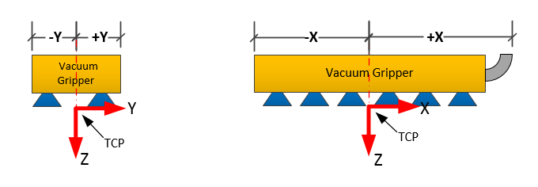

PalletSolver-PC TCP and Controller Tool must match
Whatever you decide, make sure that the PalletSolver-PC gripper definition matches the controller tool definition. To test it, on the controller set the jog coordinate system to Tool and use the X+ and Z+ keys to jog the gripper and confirm directions. If you have multiple grip zones, activate individual grip zone to confirm their relative position is correct (You can use the Pendant PalletSolver HMI: Settings Gripper Test). Most common error is that you’re flipped by 180 degrees.

Define tool mass, center of gravity and inertia
In the controller, set the tools mass, center of gravity and inertia. Otherwise, the controller will assume the worst-case scenario and will run slower. The tool definition can’t dynamically change to compensate for the presence of product or not. So, try to define the tool property with the gripper hold a typical package.
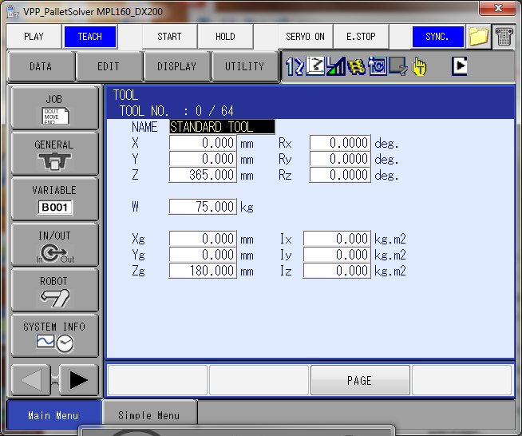

Set T-axis soft-limits
Protect your gripper cabling by setting softlimits for the T-axis (Pendant menu: ROBOT SOFTLIMIT SETTING). Rotate the gripper using the T-axis in the negative direction until the desired position where the cables are not being pulled too much, record that T-axis softlimit(-). Repeat the process for the positive direction and record the T-axis softlimit(+).
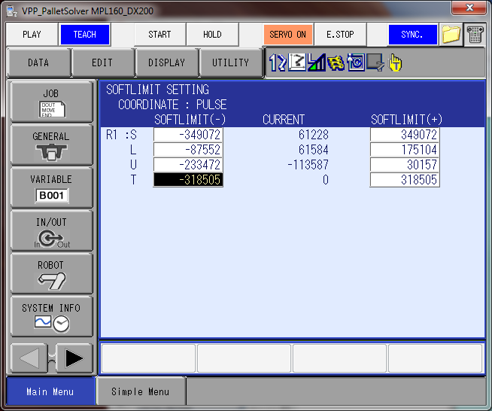

Have a teaching TCP pointer
Palletizing grippers are generally large and bulky, it may make it difficult to accurately teach user frame. If possible, during the design of the gripper include mean of mounting a teaching pointer. You can have a filet hole to the structure and screwing in a rod with a pointed end when you need to teach the user frames. Define a separate TCP/tool for teaching user frame, put it at the end of a teaching rod or a shape corner of the gripper.

Use multiple TCP
If you use the same gripper to pick boxes, pallets and slipsheets, define different TCP for each category of package. Odds are that the various pick mechanism won’t share the same TCP. And even if they do, having separate TCP allows to make adjustments independently.

Pallet and Slipsheet TCP
By default, PalletSolver will pick align the tool TCP with the center of the pallet or slipsheet. By moving the TCP location, you can adjust where the gripper will go on the pallet or slipsheet. In the same fashion, the tool X-axis always line-up with the dispenser station user frame X-axis. So, to adjust the gripper orientation in the dispenser, you can either change the tool X-axis orientation or the station user frame orientation.

User Frame Definition
User Frame are preassigned for PalletSolver:
    - Build Station 1-8: UF #1 to #8
    - Infeed Station 1-8: UF #11 to #18
    - Pallet Dispenser 1-2: UF #21 to #22
    - Slipsheet Dispenser 1-2: UF #31 to #32
    - Reject Station: UF#41
    - Pick/Place Frame: UF#62 and #63: Dynamically defined based on currently selected station frame plus associated offsets.

User Frame Location
Plan out where your user frame will be ahead of time.
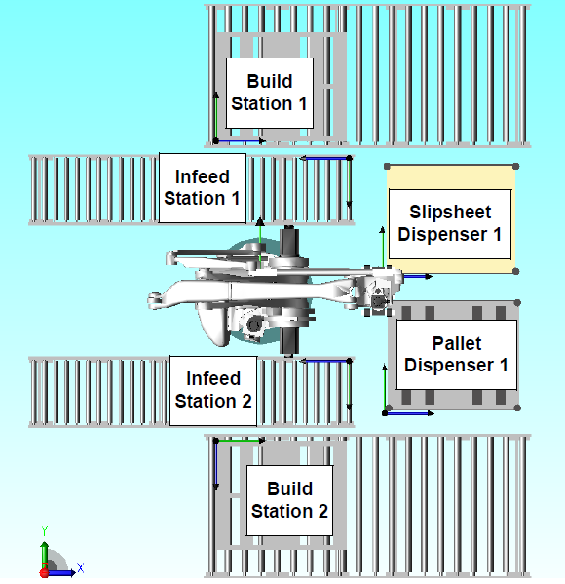
Z-axis must point upward. Once the X-axis is determined, use the right-hand rule to figure out which way the Y-axis must point so that the Z-axis points upward.
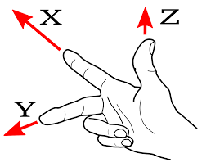

Tricks to improve teaching accuracy
To improve teaching accuracy:
- Use a teaching tool with its own TCP
- If possible, don’t rotate the gripper between points when defining the user frame.
- Try to put as much distance as possible between points
- Some people make jigs that can be placed on the conveyor and pallet holder to make teaching easier.

Offsetting User Frame
Sometimes the robot cannot reach the required user frame location on all stations or it is easier to teach on top of a pallet or box. It is possible to teach the user frame to a different location and then offset it to the proper location.
For example, in the figure below, the robot reach is shown in yellow. Location (1) is the desired user frame location. However, the robot cannot reach this point. In these cases, the user can set the station user frame to a known location such as the front left edge of the outfeed conveyor or position (2). A measurable offset such as the width of the outfeed conveyor (3) can be added to position (2).
Position (2) becomes the user frame. Position (3) is the offset from Position (2).
Note that there is not orientation offset, so make sure to teach the offset user frame in the proper orientation. Even when teaching in the correct location, offset can sometime be used to make small tuning adjustment instead of re-teaching a user-frame that is slightly off.
The offset value is entered in the PalletSolver-Setup application on the teach pendant.

Avoiding Collisions
The first thing is to make sure that the TCP and User Frame are properly defined as per the previous sections.

Define Interference Areas
In the PalletSolver-PC define the interference areas around the gripper and the infeed and build stations. Interference values (-X, +X, -Y, +Y) are absolute distance from the TCP or User Frame and should be positive. The gripper interference defined should be the overall dimensions of the gripper including any protrusions that may cause interference.
Remember that there might be small discrepancies between layout drawings, physical world and taught user-frame. So it is good practice to make interference area more restrictive than the physical world, plan to have a few inches of gap between the gripper and potential obstructions.
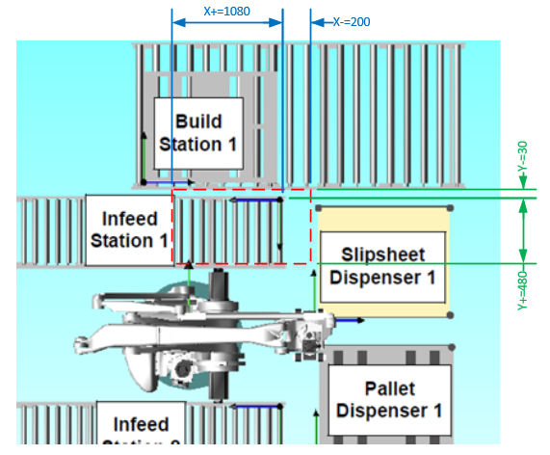
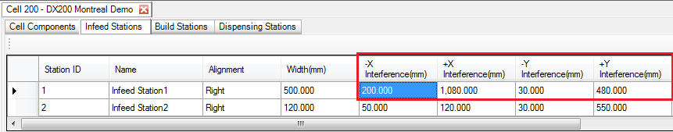
It will prevent positioning of the gripper in collision during the Place Sequencing of a layer.
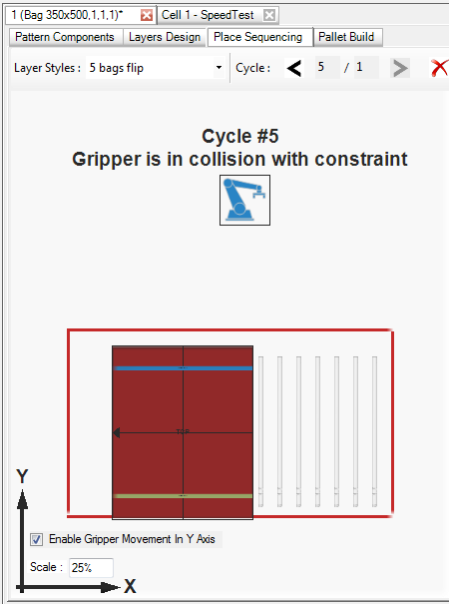
Note: PalletSolver-PC display is relative to the station frame which in this case is turn by 180° from the layout drawing.

On the build stations, the place approach is also considered. The Max. Approach Magnitude is used to validate that there is no potential interference between the gripper/packages and the build station interference zone on the placement approach. This maximum value will be used on the actual system to restrict the allowable approach vector magnitude; the actual approach vector used on the real system could be set to a smaller value.
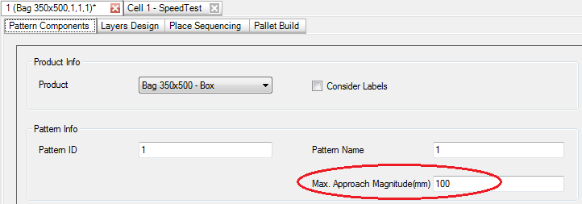

Define Minimum Clearance Height
PalletSolver dynamically optimized the robot path height according to the current height of each station it needs to pass over.
But for some station, regardless of the current height of the stack of product, you may need to define a minimum height to clear rails or side wall. So, for each station, you should set the proper minimum clearing height the in the Cell Setup Pendant application:
Note: The clearance height is relative to the user frame, not the floor.

Define Home Position
Whenever the system is reset the robot will move directly up to clear all stations, move backward or forward to be on the same radius as the Home position, and then swivel around to the Home position. Pay attention when defining the Home position so that it is on a radius that allows moving around the whole cell without hitting any obstacles or fences.
The Home_User_Set variable (P700) is the position where the robot returns to when the system is not palletizing. This position is defined in pulse coordinates so that it is not affected by tool changes. To prevent an accidental change of this position, the position is set in the USER_ADJUSTMENTS job. To set the values, the operator can move the robot to the desired position and display the robot current position and write down the values, then enter those values as the last argument of the SETE instruction.
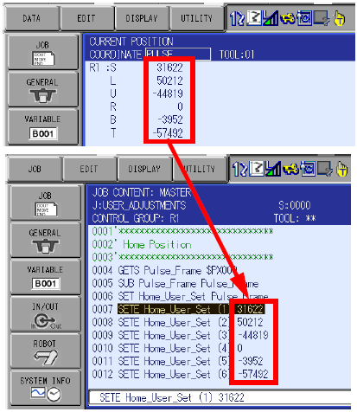
Once the home position is determined, the Interference Area 64 should be defined in Axis Interference method (pulses) so the Home Position is inside the Interference Area 64. Please refer to the Controller Instructions Manual for further detail on defining the Interference Areas.

Define Via-Points (version 1.5 or later)
The standard robot motion between stations consist of radial motion. In some irregular shaped cell layout, this may cause collision with fencing or some other components in the cell. Via-points can be defined to modify the path of the robot between stations.
When a via-point is defined between stations, the robot path will be modified so that the package Grip TCP of the gripper passes by the via-point X, Y coordinates with the set Rz rotation. The Z coordinate will be the same or above the define via-point. Up to 6 via-points can be defined in the USER_ADJUSTMENT job. Via-points are considered defined when the X or Y value of a via-point is non-zero. Via points define the robot base frame (X, Y, Z, Rz) using the package Grip TCP. To set the appropriate values, set the current tool to the package grip TCP and move the robot in the desired position. Display the robot current position in the Base frame and record the values. Then go to the USER_ADJUSTMENT job and modify the values set for the via-point to those recorded. All the digits should be entered but without the decimal points because the values of the SETE instructions are in microns (0.001 mm) or 0.0001 degrees.

Reviews User Jobs
User jobs are job templates that can be customized to meet the user requirements:
- USER_ADJUSTMENTS: Defines the Home Position, Minimum Clearance, Basic Motion Speed (with and without parts), Timers…
- USER_TASK_CONTROL: Used to write logic to control the system flow when there is no PLC running the system.
- USER_CLEAR_IO: Used to reset user I/O set by other user jobs when restarting the system.
- USER_MOVE_REJECT: Template job to move product to a reject station when a pick/place cycle is aborted while there are products in the gripper.
- USER_GRIPPER_*: Several job templates to control the gripper when picking/placing products, pallets or slipsheets.
- USER_AUTO_DISPENSE: Template job used when the robot is not handling the pallets or slipsheets to signal an external device to place a pallet or slipsheet.
To prevent using USER job template without first reviewing critical information like taught positions, some template generates alarms:
- 8020: UNTAUGHT MOTION IN TEMPLATE (USER_MOVE_REJECT)
- 8021: UNREVIEWED USER TEMPLATE (USER_ADJUSTMENT)
Once the template has been reviewed, the user must delete the SETUALM section from the job.
NOP
' Delete the lines below after
' teach the reject station path
SETUALM 8020 "UNTAUGHT MOTION IN TEMPLATE" 0
PAUSE
RET -1
' Delete End
'
DOUT OT#(Reject_Active) ON
…

Testing

Run tests at low speed
When you start running PalletSolver for the first time, make sure to run at low speed. There are various ways to adjust speed on PalletSolver.
PalletSolver have a global speed override function setup. If in PLC control mode, then the speed override can be set from the PLC by setting the Speed % to byte #6. If you are operation the cell in Robot control mode, you can set the Speed Override from the PalletSolver Pendant HMI:
You can set SPEED LIMIT special playback mode on the Teach Pendant.
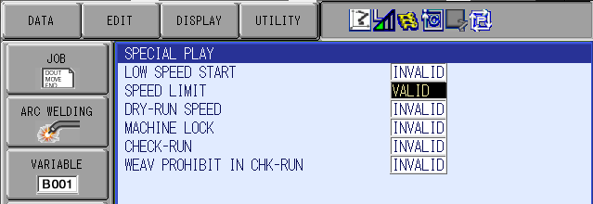
You can also set Speed values in the USER_ADJUSTMENT job but those settings are more intended to adjust speed based on the product being carried and the type of motion. Note that the changes will only take affect when restart from the top of the MasterJob.
'******************************
' Motion Settings
'******************************
' Speed for empty gripper:
' Aircut joint speed in %
SET UsrEmptyAirVel% 100
' Approach linear speed
' % of maximum linear speed
SET UsrEmptyApprVel% 100
' Accel/Decel %
SET UsrEmptyAcc% 100
'
' Speed for gripper loaded
' with boxes:
' Aircut joint speed in %
SET UsrLoadedAirVel% 100
' Approach linear speed
' % of maximum linear speed
SET UsrLoadApprVel% 100
' Accel/Decel in %
SET UsrLoadedAcc% 100
'
' Speed for gripper loaded
' with pallet:
' Aircut joint speed in %
SET UsrPalletAirVel% 100
' Approach linear speed
' % of maximum linear speed
SET UsrPaletApprVel% 100
' Accel/Decel in %
SET UsrPalletAcc% 100
'
' Speed for gripper loaded
' with slipsheet:
' Aircut joint speed in %
SET UsrSlipAirVel% 100
' Approach linear speed
' % of maximum linear speed
SET UsrSlipApprVel% 100
' Accel/Decel in %
SET UsrSlipAcc% 100
'
You can also manually run in Teach mode (speed is then limited to 25%) but note that PalletSolver has multiple tasks running in parallel which might require more advance knowledge to operate in this fashion. The basic operation for playing back in Teach mode is:
- Select Teach mode
- Select the Master Job (!PalletSolver_MasterJob!)
- Turn on the SERVO
- Press INTERLOCK + TEST START

Preliminary Testing
In some cases, you may want to start testing before having the whole system wired up or having completed your PLC program. This can be done by putting the system in Robot Control Mode (using the Cell Setup Pendant Application) and setting up a few basic signals in the USER_TASK_CONTROL job.
WARNING: When implementing this modification, the robot will start palletizing the moment the Start Palletizing is given, regardless of the presence of product on the infeed or pallet in the build station.
If the Pallet Present sensors are operational, then delete the “Force Pallet Presence” section.
/JOB
//NAME USER_CONTROL_TASK
//POS
///NPOS 0,0,0,0,0,0
//ALIAS
///IN 4
0321 Nfd1_Pick_Ready
0337 Nfd2_Pick_Ready
1121 uNfd1_Pick_Req
1137 uNfd2_Pick_Req
///OT 4
1062 uBld1_PaletPrsnt
1070 uBld2_PaletPrsnt
1121 uNfd1_Pick_Ready
1137 uNfd2_Pick_Ready
///LVARS 0,1,0,0,0,0,0,0
LI000 User_Loop_Delay
//INST
///DATE 2016/06/20 09:53
///COMM PalletSolver Montreal Demo
///ATTR SC,RW,CJ
///LVARS 0,1,1,0,0,0,0,0
NOP
SET User_Loop_Delay 10
'
' Force Pallet Presence
SET uBld1_PaletPrsnt ON
SET uBld2_PaletPrsnt ON
'
*UserLoop
'--------------------
' Put user code here
'--------------------
'
' Automatic Box Ready
' Infeed 1
IFTHEN IN#(uNfd1_Pick_Req)=ON
IFTHEN IN#(Nfd1_Pick_Ready)=OFF
DOUT OT#(uNfd1_Pick_Ready) ON
ENDIF
ELSE
DOUT OT#(uNfd1_Pick_Ready) OFF
ENDIF
'
' Infeed 2
IFTHEN IN#(uNfd2_Pick_Req)=ON
IFTHEN IN#(Nfd2_Pick_Ready)=OFF
DOUT OT#(uNfd2_Pick_Ready) ON
ENDIF
ELSE
DOUT OT#(uNfd2_Pick_Ready) OFF
ENDIF
'
TIMER T=User_Loop_Delay
JUMP *UserLoop
END

Motion Path Verification
PalletSolver has a Planner Task and a Motion Task that constantly interact together.
- The planner selects the next station, calculates the pick path and stores the information in the 800 range variables.
- The motion task starts moving to pick the package
- The planner calculates the place path and stores the information in the 850 range variables.
- The motion task starts moving to place the package
The user frame of the Pick station with associated offsets are used to calculate the Pick frame (UF#62). The P-var for the Pick Path are relative to the UF#62.
P | 0800 | Pik_Aircut_1
P | 0801 | Pik_Aircut_2
P | 0802 | Pik_Approach_1
P | 0803 | Pik_Approach_2
P | 0804 | Pik_Approach_3
P | 0805 | Pik_Pick
P | 0806 | Pik_After_1
P | 0807 | Pik_After_2
P | 0808 | Pik_Clear
P | 0809
P | 0810 | Pik_DispensrTop
P | 0811 | Pik_DispensrBotm
P | 0812 | Pik_DispensrLast
P | 0813
P | 0814 | Pik_UF_Org

The user frame of the Place station with associated offsets are used to calculate the Place frame (UF#63). The P-var for the Place Path are relative to the UF#63.
P | 0850 | Plc_Aircut_1
P | 0851 | Plc_Aircut_2
P | 0852 | Plc_Approach_Ruf
…
P | 0858 | Last_Path_End
P | 0859 | Plc_UF_Org
P | 0860 | Plc_1_Approach_1
P | 0861 | Plc_1_Approach_2
P | 0862 | Plc_1_Approach_3
P | 0863 | Plc_1_Place
P | 0864 | Plc_1_After
P | 0865 | Plc_2_Approach_1
P | 0866 | Plc_2_Approach_2
P | 0867 | Plc_2_Approach_3
P | 0868 | Plc_2_Place
P | 0869 | Plc_2_After

Frame and Tool Adjustment

Check the Tool Definition Orientation
With the gripper on top of the conveyor, switch the pendant to “Teach” and select the tool coordinate system corresponding to the gripper. Square the gripper with the conveyor (or box on the conveyor). Jog the gripper in the tool X+, the gripper should move along the conveyor X+ axis and not drift away. If the gripper drifts sideways, adjust the Rz value of the Tool definition. If the gripper drifts up or down, adjust the Ry value of the Tool definition. Jog the gripper in the tool Y-, the gripper should move along the conveyor Y+ axis. If the gripper drifts up or down, adjust the Rx value of the Tool Definition.

Check the Infeed Conveyor Frame Orientation
Start running the pattern and stop it (pressing the hold button on the pendant) when the gripper is above the box in the infeed. Switch the pendant to “Teach” and select the user coordinate system corresponding to the infeed station. Pick a point on the gripper that can easily be tracked and manually jog the gripper along the X and Y axes. The X+ button should move the gripper along the conveyor in the direction opposite to the box feed flow and the Y+ across the conveyor. Make sure that the gripper is moving properly along the X and Y axis and not drifting sideways or up and down. If the gripper is drifting, the infeed user coordinate is twisted and needs to be retaught before proceeding.

Check the Build Station Frame Orientation
In similar way as the Infeed Conveyor Frame Orientation check, run the pattern and stop it (pressing the hold button on the pendant) when the gripper is above the pallet. Switch the pendant to “Teach” and select the user coordinate system corresponding to the build station. Pick a point on the gripper that can easily be tracked and manually jog the gripper along the X and Y axes, the gripper should move parallel to the sides of the pallet. Make sure that the gripper is moving properly in the X-Y plane of the pallet and not drifting up and down. If the gripper is drifting, the build station user coordinate is twisted and needs to be retaught.

Create a Simple Pick/Place Patterns
The first step is to create with the “PC Pattern Generation Tool” a simple pattern with two layers with one box on each.

- For the first layer, pick a single box in the infeed and put it down in the pallet corner where the build station frame is defined. Center the grip area with the center of the box, if possible.
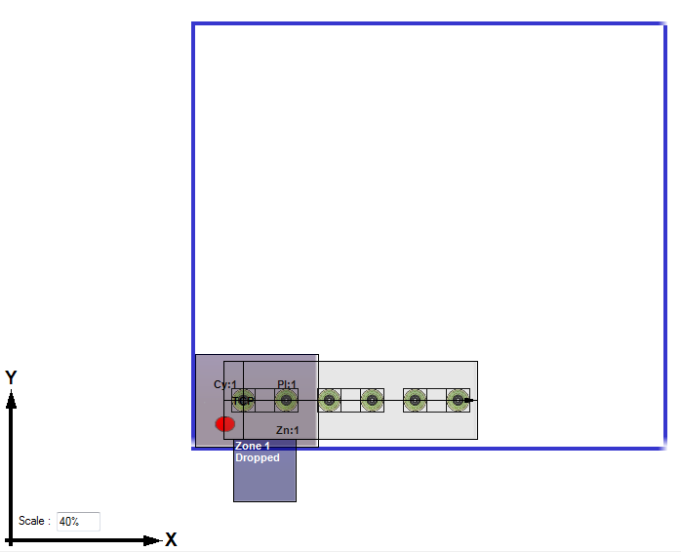

- For the second layer, pick a single box but turn it 180 degrees and place it down in the pallet corner where the build station frame is defined. Center the grip area with the center of the box, if possible.
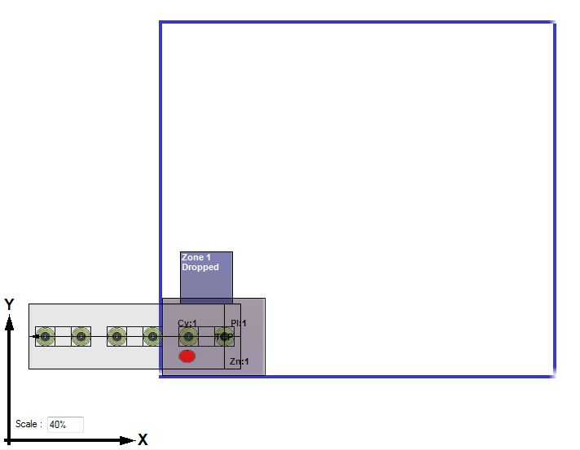
- Once both layers are defined, create a build pattern with the two layers. You should end-up with 2 boxes, one on top of the other, in the corner of the pallet.
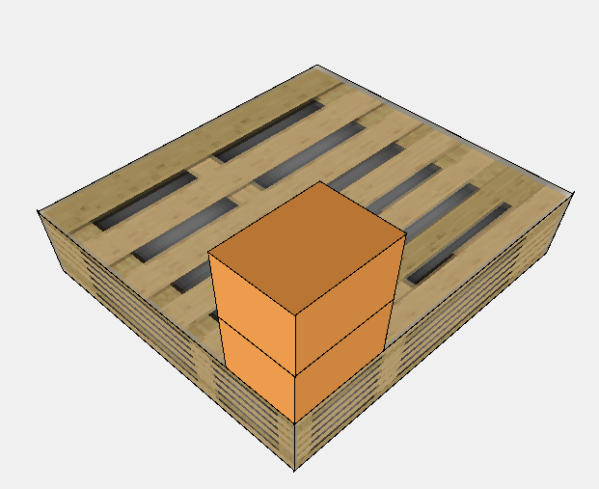

Then generated the pattern output and load it on your system.

Check the Infeed Conveyor Frame Position
Run through the pattern, placing the box 1 and 2 on the pallet. If the boxes are not aligned, measure the difference between the 2 boxes along the X axis. An adjustment of half that distance will be required.
Measure the difference between the 2 boxes along the X axis.
- For most grippers, the box doesn’t move along the X-axis when picked up, so the adjustment needs to be made on the infeed user frame, using the PalletSolver – CellSetup, offset the infeed frame along the X axis by half the X dimension.
Measure the difference between the 2 boxes along the Y axis.
- If the gripper doesn’t move the box laterally when it picks it up, like a vacuum gripper, then the adjustment needs to be made on the infeed user frame, using the PalletSolver – CellSetup, offset the infeed frame along the Y axis by half the Y dimension.
- If the gripper repositions the box as it closes, like a clamp gripper, then the adjustment needs to be made on the tool definition, using the pendant interface offset the tool along the Y-axis by half the Y dimension.
Save the change and restart the system from the top of the master job. Test again and if the difference increased, then the adjustment was applied in the wrong direction. Make the correction in the opposite direction and test it again.

Check the Build Station Frame Position
After adjusting the infeed, run through the pattern and check that the corner of the box 1 lines up with the corner of the pallet. If this is not the case, then using the PalletSolver - CellSetup, adjust the build station frame offset to align the corner of the box with the pallet. Save the change, restart the system from the top of the master job and test again. Another alternative is to reteach the user coordinate. Note: If you reteach the user coordinate, don’t forget to reset the offset adjustments before retesting.)

Check the Tool Definition Position
People tend to think that when there are undesirable gaps between boxes in the pattern it is caused by a bad tool center definition. But that is actually false, an error on a pick cause by a bad TCP position actually cancels out with the same error introduce in the place. That being said, it is still important to get a proper tool definition so that the grip area line up properly on the boxes and that interference check done in the PC Pattern Generation Tool be valid and prevent collision. So, make sure that conveyor user frame has been properly adjusted before making final tool definition adjustment.
Start running the pattern and stop it (pressing the hold button on the pendant) when the gripper is above the box in the infeed. Check that the alignment of the grip area with the box matches the one defined in the PC Pattern Generation Tool. If it doesn’t match, then adjust the controller tool definition X and Y values to make it match.

Tool Correction
Tool correction can become complicated if the tool definition has a Rz component in it, especially when it is not a multiple of 90 deg. Furthermore, you have to take into account that the tool Z-axis is pointing downward whereas the user frame Z-axis is pointing up and the gripper might be turned relative to the user frame.
The following equations takes into account for all those variables and coverts the measured correction in the station user frame to the required tool definition modification:
Tool_X_{corr} = -UF_X_{corr}*COS(Tool_Rz + Gripper_Orient) - UF_Y_{corr} *SIN(Tool_Rz + Gripper_Orient)
Tool_Y_{corr} = -UF_X_{corr}*SIN(Tool_Rz + Gripper_Orient) + UF_Y_{corr} *COS(Tool_Rz + Gripper_Orient)
Where the Gripper_Orient is defined as:

And the UF_X_{corr} and UF_Y_{corr} as:
X
Y

UF_Y_{corr}
UF_X_{corr}

To make it more convenient, you can use the “Tool Correction.xlsx” Excel file that already have the calculation preprogrammed.

Check Pick/Place Height
The pick/place height of a box can be adjusted by either the adjusting the tool definition Z or the station user frame offset. Adjustment to the tool definition will affect all the stations, so it should only be done when the same error is found at all stations. When adjusting the Z of the tool, if you want to move the pick/place point higher, you need to increase the tool Z. If the pick/place height needs to be adjusted for a specific station then adjust the Z offset for that station user coordinate.
Note: When making adjustments using a box, make sure that the box size matches the nominal dimension of the box define in the pattern file.

PalletSolver-PC Settings

Gripper Orientation Restriction
In PalletSolver-PC, Gripper Orientation Restriction can be added for infeed and build station. The gripper orientation is the determined by the gripper X-axis relative position to the station frame X-axis:

Will you always be picking on the infeed in the same orientation? Determine that orientation then restrict the other angles for the infeed by set the Gripper Orientation Restriction in PalletSolver-PC.
If boxes label is not considered, then determine the shortest T-axis rotation to get product in the 0 and 90 degrees orientations for each station and then in PalletSolver-PC set the gripper orientation restriction for each station.
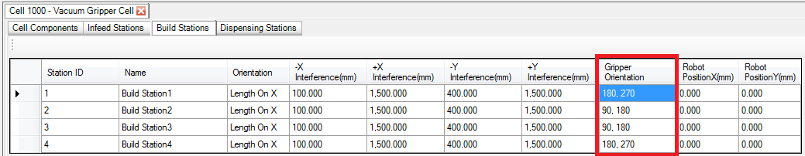

Robot Position (PalletSolver-PC ver 1.5 or later)
Robot relative position to the infeed and build stations can be define to help the user plan the placement sequencing.
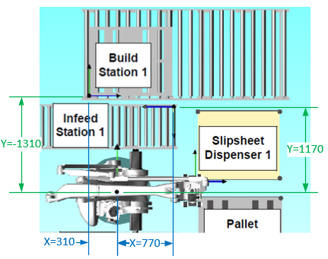
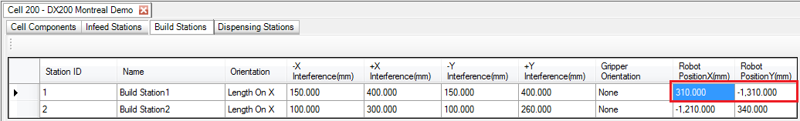
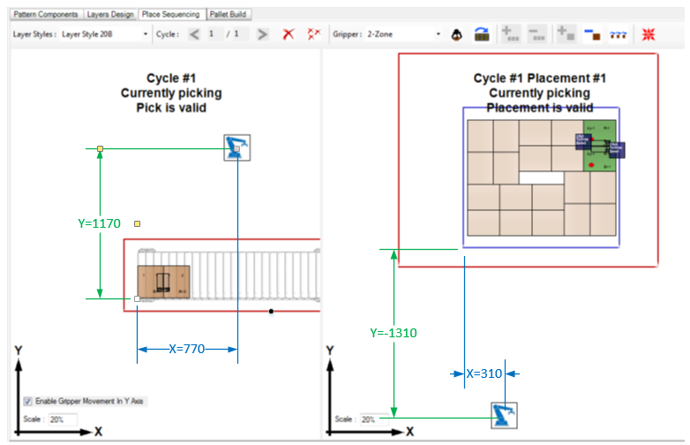
Note: PalletSolver-PC display is relative to the station frame which in this case is turn by 180° from the layout drawing.

ProductID and PatternID settings
Selection of Product ID and Pattern ID types to a Numeric value between 0 and 32767 or an Alphanumeric 16 character string. Consideration should be made when selecting the data type used in PalletSolver-PC based on your specific system.
There are many ways to do things and naming convention vary between companies. PalletSolver should be able to accommodate customer needs but it should be something to review and validate ahead of time. Especially when the product and pattern selection is to be done from a PLC/HMI. Communication of alphanumeric values between the controller and PLC is not standardize and some customization will be required. Another option is to uses lookup table in the PLC/HMI that convert more explicit names to numeric index transferred to the controller.

Speeding things up

Ready Position
The Ready_Position variable (P743) is the position where the robot returns to when the system is idle because no stations are ready. It is recommended to place the Ready position close to the infeeds to improve cycle time.
To use this position, set the output #248 Ready_Exists to ON in the USER_ADJUSTMENT job. The usrIdleTimeLimit (R756) can be set to adjust the time in second to wait in idle before sending the robot to the Ready Position.
In the same way as the Home position, the Ready position is defined in pulse coordinates so that it is not affected by tool changes. To prevent an accidental change of this position, the position is set in the USER_ADJUSTMENTS job. To set the values, the operator can move the robot to the desired position and display the robot current position and write down the values, then enter those values as the last argument of the SETE instruction.
Once the Ready Position is determined, the Interference Area 1 should be defined in either Cubic or Axis Interference method so that the Ready is inside the Interference Area 1. Please refer to the Controller Instructions Manual for further detail on defining Interference Areas.

Single Infeed Setup
If your system is composed of a single infeed, you can preemptively send the robot to that infeed for the next pick even if the PickReady signal is not ON. The robot will move ahead of time and stop just above the pick point if the PickReady signal is still not ON by the time it gets there. At that time, Job Warning 4 will be set but it can be disregarded and the motion will continue as soon as the PickReady signal turns ON.
Set the sequencing mode to PLC and have the PLC always preselect infeed 1 by doing the handshaking as per section 7.2.1.5 Set Next Infeed Pick of the PalletSolver Controller Setup and Operation Manual. Or, if the system is not controlled by a PLC, add the following code to the USER_CONTROL_TASK to complete the handshake and send the robot to the infeed 1.
/JOB
//NAME USER_CONTROL_TASK
//POS
///NPOS 0,0,0,0,0,0
//ALIAS
///IN 2
1013 uNxtNfedIdEchob1
1121 uNfd1_Pick_Req
///OT 1
1013 uNxt_infeedID_b1
///LVARS 0,1,0,0,0,0,0,0
LI000 User_Loop_Delay
//INST
///DATE 2016/06/20 09:53
///COMM PalletSolver Montreal Demo
///ATTR SC,RW,CJ
///LVARS 0,1,0,0,0,0,0,0
NOP
SET User_Loop_Delay 10
'
*UserLoop
'--------------------
' Put user code here
'--------------------
'
' Set PLC selected infeed 1
IFTHEN IN#(uNxtNfedIdEchob1)=OFF ANDIF IN#(uNfd1_Pick_Req)=ON
DOUT OT#(uNxt_infeedID_b1) ON
ELSE
DOUT OT#(uNxt_infeedID_b1) OFF
ENDIF
'--------------------
'
TIMER T=User_Loop_Delay
JUMP *UserLoop
END

Motion Optimization
Motion job are already fairly optimized for most cases, and as much as possible, we prefer that MOTION job not be changed. But if needed, it can be done. Depending on the specific application and gripper timing, you might be able to optimize further by adjusting timers and PL values on some of the motion.
The following job could potentially be reviewed:
- MOTION_PICK_BOX_BAG.JBI
- MOTION_PICK_BOX_CLAMP.JBI
- MOTION_PICK_BOX_FORK.JBI
- MOTION_PICK_BOX_VAC.JBI
- MOTION_PICK_DISPENSER_STACK.JBI
- MOTION_PICK_DISPENSER_FIX.JBI
- MOTION_PLACE_BOX.JBI
- MOTION_PLACE_BOX_SUB.JBI
- MOTION_PLACE_DISPENSER.JBI

Removing motion to center of pallet to reorient gripper

Prorated rotation on via-points

